3.G.4—Identify the faces on a three-dimensional shape as two-dimensional shapes.

Identify the polygons that makes up the faces of the following 3-dimensional shapes.

1) 2) 3)
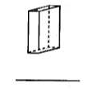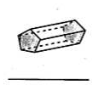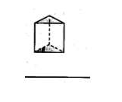

4) 5)


 

