3.S.8 Formulate Conclusions and make Predictions from a graph.

Look at the Graph Below.

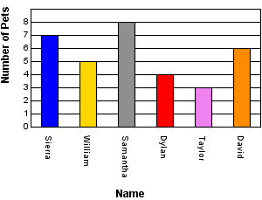
Number of Pets

1) What question could you answer by looking at the graph?
- Does Dylan have dogs or cats?
- How many pets does Maria have?
- Who has more pets – David or Taylor?
- Does William have a sister?

Look at the vertical bar graph. Then answer the questions.

Color of Cars in a Parking Lot
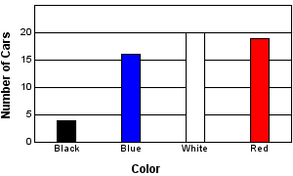

2) What question could you answer by looking at the graph?
- How many people like blue cars?
- Does Jack like red cars?
- Do people like Chevrolets or Fords?
- How many people like pink cars?
Predictions

Use the Graph below to answer questions 1 and 2.

Color of Cars in a Parking Lot in Week One

- If the same number of each colored car was parked there next week how many blue cars would be in the parking lot?
  - 16
  - 15
  - 30
  - 20

- In week three if there were double the amount of white cars in this parking lot how many white cars would there be?
  - 20
  - 40
  - 18
  - 10

Use the line Graph below to answer questions 3 and 4.

Temperature at 12:00 pm

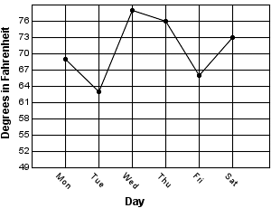

3) How much hotter was the high temperature on Saturday that it was on Friday? ______

4) What day of the week was the coolest?____________________________________________

5) If the temperature continues to go up the same amount as it did from Friday to Saturday what will the temperature be on Sunday? ____________________________

