3.S.7 Read and Interpret data from a bar graph and pictograph

1) Look at the frequency table.

Favorite Characters in a Book
Flat Stanley | 25
Arthur | 10
Franklin | 9
Clifford | 3

Which graph below shows the same information as the frequency table above?
a b

c d

2) Use the graph below to answer the questions.

- How many students liked Arthur and Franklin? _________________

- How many students did not like Clifford and Flat Stanley?_________

- How many more students like Flat Stanley than Franklin? _________

- How many students were asked this question?_________________

- Which character do you like best?__________________________

3) Look at the vertical bar graph. Then answer the questions.

Points Scored

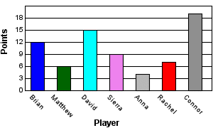

a. How many more points did Rachel score than Anna? _____________

b. How many points did David and Connor score together? ________

4. This picture graph shows the number of ice cream cones that were sold at Mel's Ice Cream Shoppe last week.
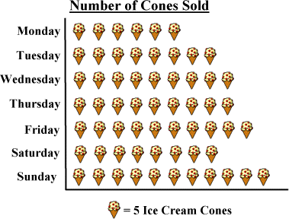

- What day did they sell the most ice-creams?
  - Monday
  - Wednesday
  - Sunday
  - Saturday

- How many more ice creams did they sell on Friday than they did on Tuesday?
  - 10
  - 20
  - 5
  - 2

- What were the total number of ice-cream sold in one week?
  - 300
  - 215
  - 315
  - 61

