3.N.4—Understand the place value structure of the base ten number system:
10 ones=1 ten
10 tens=1 hundred
10 hundreds=1 thousand.

1) What is another name for 300?
a) 30 hundreds
b) 30 tens
c) 3 tens
d) 3 thousands

2) What is the value of the digit 6 in the number 964?
a) 6 ones
b) 6 tens
c) 6 hundreds
d) 6 thousands
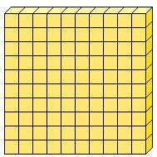

3) What number is the same as ?
a) 2 ones
b) 20 ones
c) 2 tens
d) 20 tens

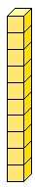

4) is the same as how many ?

- 20
- 10
- 5
- 1

5) What is the value of the digit 9 in 984?
a) 9 ones
b) 90 ones
c) 9 tens
d) 90 tens

