3.N.25 | Estimate numbers up to 500

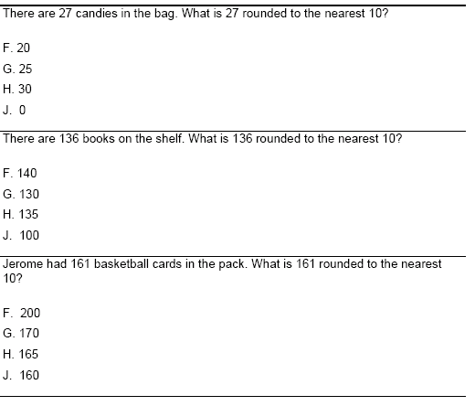

3)

