3.N.2 Read and Write whole numbers to 1000.

1) The amusement park in Middlebury has 1,123 visitors every year. Which of the following models represents the number 1,123?
Top of Form
Bottom of Form
 | A | 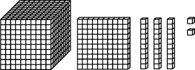
 | B | 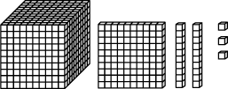
 | C | 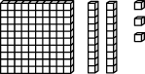
 | D | 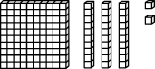

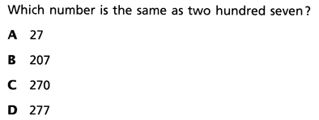
2)

3) A toothbrush factory produces 8,731 toothbrushes in one day. Which of the following models represents the number 8,731?
Top of Form
Bottom of Form
 | A | 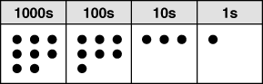
 | B | 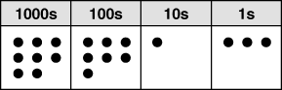
 | C | 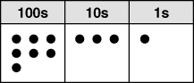
 | D | 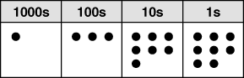

4) Draw a model of the number 5,532

- What is the number represented by this model.

