3.N.11—Use maniuplatives, visual models, and illustrations to name and represent unit fractions as part of a whole or set of objects.

1) Shade in 1/4 of the boxes below.

2) Shade in ½ of the circle below.

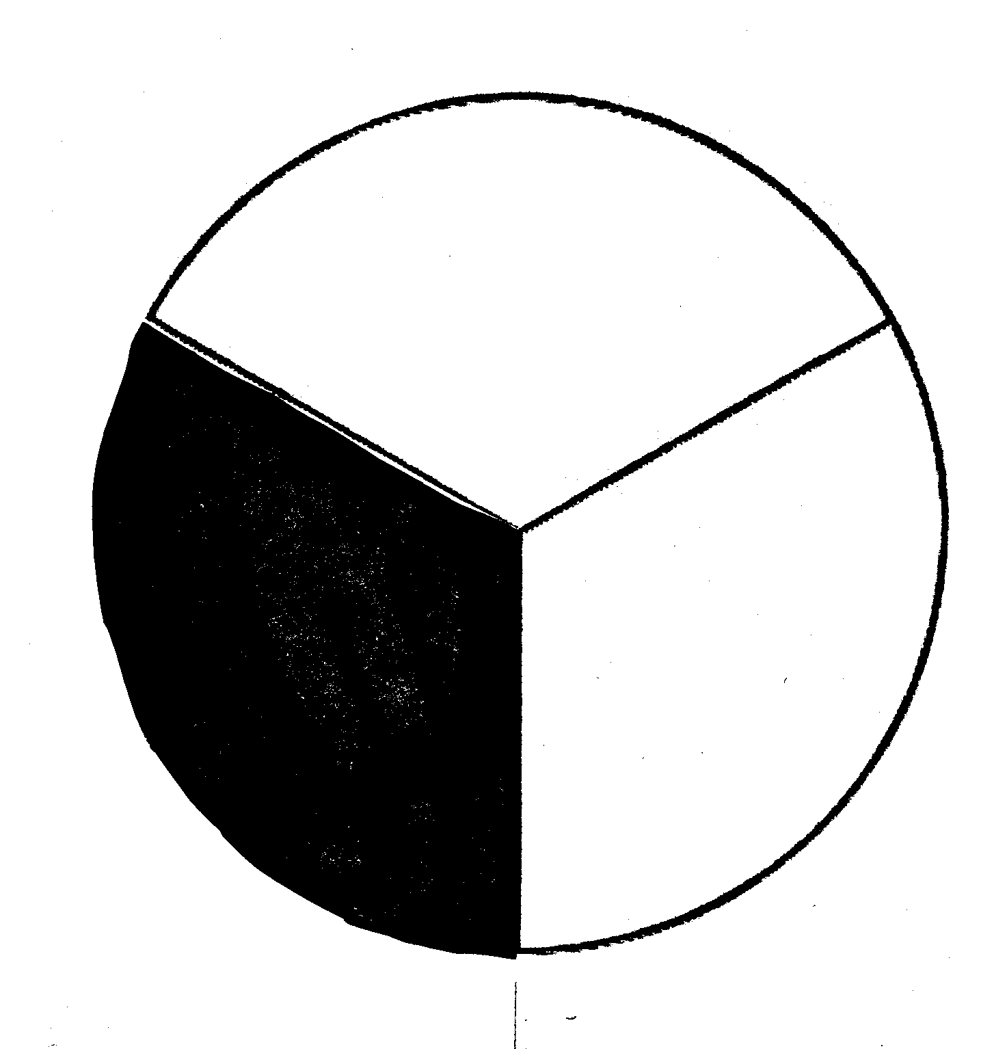
3) What fraction of this circle is shaded?

Answer:__________

4) Shade in 1/10th of the box below.

5) Circle 1/6 of the stars.

- What fraction below shows two out of three shaded?

a. b.

c. d.

- What fraction below shows 2 out of 8 unshaded?

a. b.

c. d.

