3.N.1: Skip Count by 25, 50, 100, to 1000.

1) Look at the number pattern in the box. Find the number that is missing.
57, 59, 62, 64, 67, 69, ___, 74, 77
Top of Form
Bottom of Form
 | A | 70
 | B | 71
 | C | 72
 | D | 73

2) Look at the number pattern. Find the number that is missing from the box.
10, 20, 30, 40, 50, 60,
Top of Form
Bottom of Form
 | A | 62
 | B | 65
 | C | 67
 | D | 70

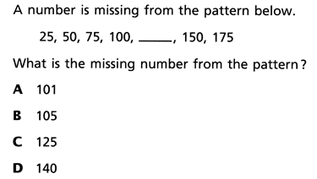

Fill in the blank.

Complete the number sequence

150, 250, 350, ____,____,____

125, 100, 75,____,____,_____

800,900,1000,____,____,____

