3.M.9—Tell time to the minute, using digital and analog clocks.

- What time does this clock show?
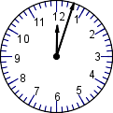

_________:__________

- What time does this clock show?

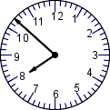
_________:_________

- Lisa walked for a half an hour outside. How many minutes did she walk?

- Write the hands of the clock in to show the time 12:47.
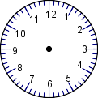

- Write in the hands of the clock to show thirty-three minutes after six.

