3.M.7—Count and represent combined coins and dollars, using currency.

Count the combinations of coins and dollars in the pictures below and write the total amount in the line next to the picture.
1)
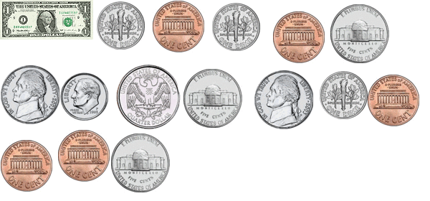
_________________
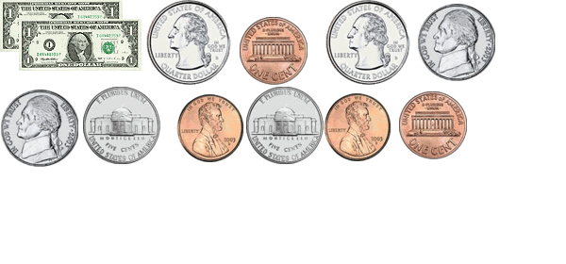
2)

_______________

3) Write out 4 dollars and seventeen cents in dollar and cents notation.

4) Write out thirty-seven cents in dollars and cents notation.

_____________________________________________________________________

- Draw dollars, quarters, dimes, nickels, and pennies to show $6.02.

_____________________________________________________________________

- Draw dollars, quarters, dimes, nickels, pennies to show $10.56.

- Allen has 3 quarters, 5 dimes, 6 nickels, and 2 pennies. Jane has the same amount of money, but has different coins. What coins might Jane have?

_____________________________________________________________________

