3.M.10—Select and use standard (customary) and non-standard units to estimate measurements.

1) Circle the best estimate.
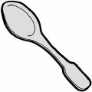
6 inches | 1 foot

2) Circle the best estimate.

11 inches | 2 feet

3) Circle the answer that gives the best estimate.



5 meters | 15 meters

4) About how tall is your desk?

Answer:__________

5) About how tall is your teacher?

Answer:__________

6) About how much does your science book weight?

Answer:__________

7) . Circle the best estimate.
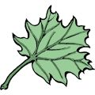
5 ounces | 1 ounce

8) Circle the Best Estimate

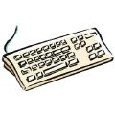
6 pounds | 6 ounces

7) About how much water can fit inside a coffee mug?

Answer:__________

