Name: _________

I’m on my way to being a math master! In Unit 2, I learned:

Standards I learned | Questions | Score
 | 1,2,3 | ___/3
  3.N.2 | Read and write whole numbers to 1,000
3.N.3 Compare and order numbers to 1,000 | 6,7,8 | ___/3
 | 4,5,9 | ___/3
  3.N.4 | Understand the place value structure of the base ten number system:
  3.N.4 | 10 ones = 1 ten
  3.N.4 | 10 tens = 1 hundred
  3.N.4 | 10 hundreds = 1 thousand
 | 10,11,12 | ___/3
  3.N.5 | Use a variety of strategies to compose and decompose three-digit numbers
3.N.26 Estimate numbers up to 500. | 13,14,15 | ___/3
UNIT 2 TEST: PLACE VALUE Name:____________________

1.
The amusement park in Middlebury has 1,123 visitors every year. Which of the following models represents the number 1,123?
Top of Form
Bottom of Form
 | A | 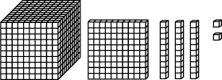
 | B | 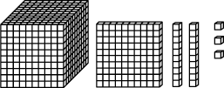
 | C | 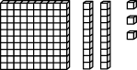
 | D | 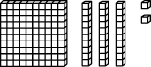

2. Which number is the same as three thousand, two hundred and eighty nine?
 | A | 2,398
 | B | 298
 | C | 3,289
 | D | 3,389

3. 500 + 8,000 =
 | A | 8,500
 | B | 5,800
 | C | 580
 | D | 8,050

Directions: Write the missing number.

4. 2658: _______is in the tens place

5. 6397: _______is in the thousands place

Directions: Write < , >, = .

6. 8926 _____ 826

7. 10,006 _____ 10, 106

8. 2,890 _____ 2,809

Directions: Choose the value of the underlined number

9. 65,924
 | A | 2 ones
 | B | 2 tens
 | C | 2 hundreds
 | D | 2 thousands

10. What equals to 892
 | A | 800 + 9 + 2
 | B | 8 + 9 + 2
 | C | 700 + 190 + 2
 | D | 800 + 90 + 9

11. What number is 18 ones and 4 tens: _________________

12. What number is 7 ones and 16 tens:__________________

13. Round 450 to the nearest tens place: ______________

14. What number is a thousand less than 5,429?
 | A | 429
 | B | 4, 429
 | C | 6, 429
 | D | 5,329

15. What is the closest hundred to 289?
 | A | 100
 | B | 200
 | C | 300
 | D | 400

