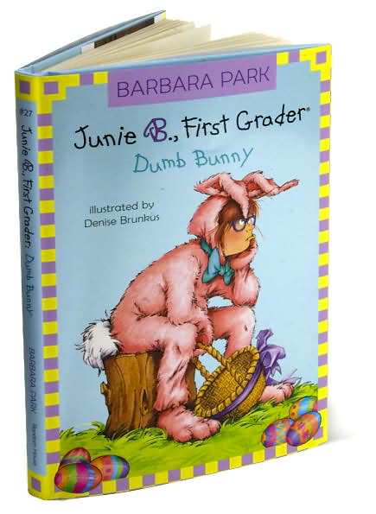
C
F
E
D
B
A

Match the letter to the word.

______ Title
______ Author
______ Cover Illustration
______ Illustrator
______ Spine
______ Front Cover

Name: _________________________________________ Date: _______________

