Tell time to the hour and half hour using analogue and digital time.

Write the time shown on the clocks below

  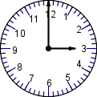
  ___ o'clock
  2.
    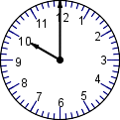
    ___ o'clock
  3.
    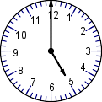
    ___ o'clock
 |  | ___ o'clock
  4.
    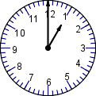
    ___ o'clock
  5.
    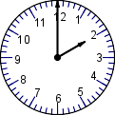
    ___ o'clock
  6.
    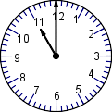

Tell the time in two ways below:

 |  | half past ___  ___ : ___
  7.
    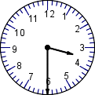
    half past ___
    ___ : ___
  8.
    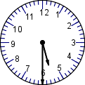
    half past ___
    ___ : ___
  9.
    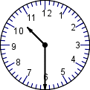

- Draw in the hands in the clock for 6:00.

