29

- Directions: Identify the penny, nickel, dime, and quarter.

Name:___________________________
Coins
Circle the quarter. Color the penny purple. Put an X on the nickel. Put a triangle around the dime.

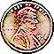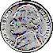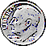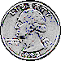

- Directions: Identify the value of a penny, nickel, dime, and quarter.

Name:___________________________
Coins
Write the value of the coin (with the cent sign) under the matching coin.

