C.S. 57
The Crescent School
Edsel Philip, Principal
Diane Danay-Caban, Asst. Principal • Greta Gallas, Asst. Principal

Date: _7/30/26_
Dear Parent:

Your written consent is required for your child’s participation in the school trip described below:

Student’s Name: ____________ Official Class: ____________

Home Address: ____________________________________________________________

Telephone Number: ______________________________________________________ Teacher: ___________
Trip Date: ____/____/____

Destination:_______________________________________________________________

Address: _________________________________________________________________ ________________________________________________________________________

Mode of Transportation: _____________________________________________________

Purpose of Trip: ________________________________________________________________________________________________________________________________________________________________________________________________________________________

Specific Activities Planned: ________________________________________________________________________
________________________________________________________________________

Adult/Student Ratio: ____1:10_____ (Minimum Requirement: 1 Adult: 10 Students).

Additional Comments:
________________________________________________________________________________________________________________________________________________

Yours truly,

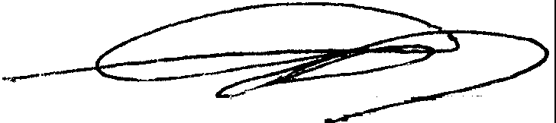

Edsel Philip, Principal

PARENT CONSENT

I, the parent/guardian of the student named above, hereby give my permission for my daughter/son (circle one) to take part in the trip described above. I understand that the following conditions apply:

a) My child is expected to travel to the trip destination accompanied and return to school when the trip activity is completed.
b) I agree not to hold the school or any of its employees responsible for any expenses, including damages incurred as a result of my child's behavior, or injuries that my child may incur while engaged in this trip.
c) I understand that my child is responsible for her/his actions and behavior at all times.
d) I agree that in the event of injury or illness, the staff member(s) in charge of the trip may act in my
behalf and at my expense in obtaining medical treatment for my child. I have indicated here any

Permanent or temporary medical or other condition(s) including special dietary and medication needs, or the need for visual or auditory aids, which should be known about my child:
____________________________________________________________________________________________________________________________________________________________________________

(If your child has no permanent or temporary medical or other conditions of which the adult advisor(s) of the trip need be informed, please write "NONE" above, and initial your response.)
e) After reading the scheduled activities listed above, I have here indicated any and all activities my child should not participate in: (Please include use of physical fitness equipment, if applicable.)
____________________________________________________________________________________________________________________________________________________________________________

for the following reasons:
____________________________________________________________________________________________________________________________________________________________________________

(If your child can participate in all scheduled activities listed on the consent form, please write "NONE" and initial your response.)

f) I understand that if as a parent I believe it is necessary to limit my child's activity to a great extent, the school may not be able to accommodate my child on this trip and that I and my child will be informed of this decision as soon as possible upon the receipt by the school of this completed consent form.
g) I understand that students who have violated the school's discipline code may be excluded by the school from participating in a trip.

i) In an emergency I can be reached at:

Day phone: ( ________________________________ )

Evening Phone: ( _________________________ ) Additional Contact: ( ________________________ )

j) I understand that my child can not participate in this trip or any other school trip without my express written permission to do so which I give signing this notification and consent form.

__________________________________________________________ _____________________
(Signature of Parent/Guardian) (Date)

