The Stem cell debate: A Persuasive Essay
What’s your opinion?

Stem cells are unspecialized cells from a recently fertilized egg that have the ability to differentiate (change) into any type of cell. Once a cell specializes it cannot become any other type of cell. For example, brain cells remain brain cells, and heart cells remain heart cells. This can be problematic if your cells are ever damaged, especially brain and spinal cord cells. Damage to these cells can result in paralysis.
Recent research suggests that cells from embryos (un-born babies) have the ability to repair damaged injured nerve cells in mice. Scientists hope the same will be possible in humans. Not everyone agrees that this should be done. Some people are against stem cell research because they feel it ends a life. Other people argue that the potential benefits to those already living far outweigh the costs to those that are unborn.
Over the break it is your job to research this ongoing debate and choose a side. Get stared by reading page 253 in your text book.
Once you complete your research you must choose to be either for or against stem cell research. No in-between. Using your research you will provide evidence to write a persuasive essay arguing either for or against stem cell research. Opportunities to research stem cells may be given during class before break and during lab.

Paper requirements
- All papers must have a proper FDA III heading
- All paper must be 2 – 3 typed pages.
- If you do not have access to a computer your paper must be 4 – 5 written pages.
- Papers may not be longer than the required lengths; doing so will result in the loss of 5 points.

Projects are due Tuesday 11/29. This project will be the first grade of the 3rd marking period.
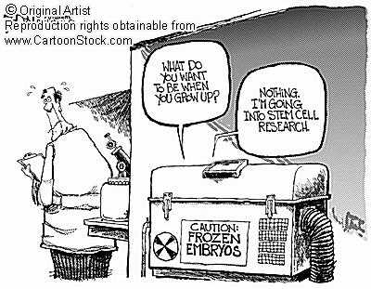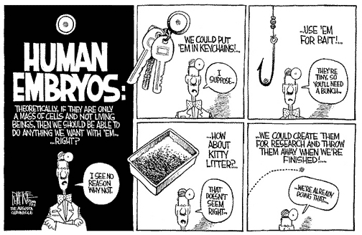
Name ________________________________________ Class _____________
This sheet must be turned in with your paper for full credit, a failure to do so will result in the loss of 10 points.
 | Extremely persuasive  (5) | Persuasive  (4) | Almost there  (3) | Not quite  (2) | Part score | Score
Purpose | You clearly met the requirements and provide ample support. | You met the requirements and provided some support. | You did what you had to do, but parts are unclear because you put in some things that have nothing to do with the topic or not enough. | You wrote a few sentences about the topic, but everything else had nothing to do with it. | X 6 | / 30
Structure/ Organization | Your writing is organized with an intro, body and conclusion. Appropriate paragraph structure is used. | Your writing is organized with beginning, middle and end. There are some errors in paragraph structure. | Your writing has no beginning, middle, or end, and/or there are too many paragraph breaks misplaced. | It is difficult to read the report because of poor organization. | X 4 | / 20
Language/ Word Choice | You varied you word choice by using synonyms and avoided weak words such as like, a lot, so, good, and nice. | You varied you word choice but used some weak words | You used many weak words and did not vary your word choice enough. | You used the same word over and over (rather than synonyms) and relied heavily on weak words. | X 2 | / 10
Spelling | There are no spelling errors. | There are one or two spelling errors. | There are four or fewer spelling errors. | It is difficult to understand the report because there are five or more spelling errors. | X 2 | / 10
Capitalization | There are no capitalization errors. | There are one or two capitalization errors. | There are four or fewer capitalization errors. | It is difficult to understand the essay because there are five or more errors. | X 2 | / 10
Punctuation | There are no errors in punctuation. | There are one or two errors. | There are four or fewer errors. | It is difficult to understand the essay because there are five or more errors. | X 2 | / 10
Presentation | Your work is very neat. It fully complies with paper requirements. | Your work is neat. It complies with most paper requirements. | Your work is generally readable, but does not comply with most paper requirements. | Your work is sloppy. It does not comply with paper requirements. | X 2 | / 10

Total:

