Table #1
Dragonflies and birds both have wings.

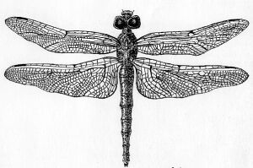

Table #2
Cats have five toes and horses have hooves (that were once separate toes). They are both mammals.
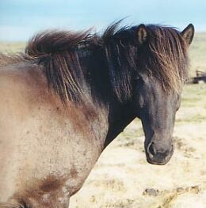

Table #3
Whales have hipbones (hip bones in most animals are where the log bones attach to the mid-sections of the body at the hips). However, whales do not have legs.
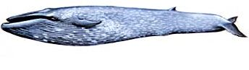
Table #4
Humans, cows, whales, and bats are all very different looking mammals. Take a look at the bone structures in their front limbs (hands and arms).
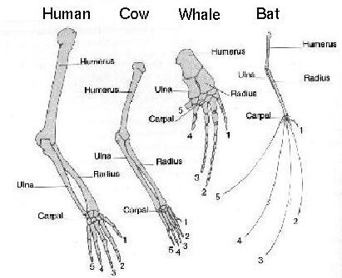

Table #5
Dogs have whiskers, which they use to sense the environment around their mouth. Lobsters have large antennae, which they use to sense their environment.
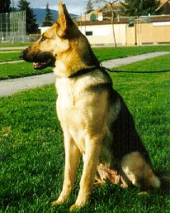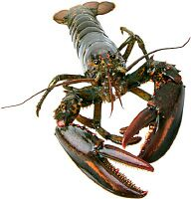

Table # 6
Cats and dogs both have femurs—a large leg bone. They are also both mammals.


Table #7
The appendix is a dead-end pouch on the human intestine that has no major role in the human body. In fact, in many people it becomes infected and is removed through surgery (those people usually return to 100% health shortly after the surgery).


Table #8
Humans developed legs to that help with movement from one place to another. Ladybugs also have legs that help them move from one place to another.
