Acitivity: Variation in Crazy Almonds!
BACKGROUND INFORMATION: The process of evolution begins with genetic variation among individuals in a population. Genetic variation means that there are differences in the characteristics of the individuals in a species. Those differences can be seen in the physical, physiological or behavioral characteristics of an individual. When resources are scarce, there is a struggle for survival. Those individuals having advantageous variations are more likely to survive and reproduce (their fitness). This process is called natural selection. The inherited variation that increases survival chances is called an adaptation. Variation exists with the genes of every species. This variation comes about in one of two ways: 1) sexual reproduction and 2) mutation.

PURPOSE: In this activity we will study the subtle genetic variations that occur within a population of almonds. On first glance all peanuts look pretty much the same, but using the power of observation, we will identify those fine variations that occur between almonds. Observations are collected by using your five senses and with various tools in the lab.

MATERIALS:
almonds string ruler Post-It notes

PART A:
- Search through the cup of almonds and remove any that are cracked.
- Select an almond and carefully observe it to determine the distinguishing characteristics that identify your almond. DO NOT MARK OR CRACK YOUR ALMOND.
- Record as many observations as you can make about your almond below (include the size, shape, color, and dimensions). You many use the equipment provided to help with your observations.
- Return each table member’s almond to the bowl. Mix up the almonds.
- Use your observation notes to find your almond again.
- Indicate below if you are absolutely certain you found your own almond by circling YES.
YES MAYBE NO
- Using the data from the class, calculate what percent of the class was able to absolutely identify their own almond.
Percent of the class = # of scholars absolutely certain / total number of students X 100%

- What evidence did you use to locate your almond and distinguish it from the others in the cup?

- Exchange your table’s cup of almonds and observation notes with those from another table. Now, work individually with one set of observations from another student and try to find the particular almond it describes.

- Indicate below if you are absolutely certain you found the other student’s almond by circling YES.
YES MAYBE NO

- Using the data from the class, calculate what percent of the class was able to absolutely identify another student’s almond (use the same formula from above). How does this number compare to the percent able to find their own almond? Why did it change?

- Why was it more difficult to find some else’s almond rather than your own? Why or why not?

This activity shows that there are very subtle differences in individual almonds. On first glance, every almond looks similar, but actually, there are unique genetic characteristics on each almond, which makes them unlike any other.

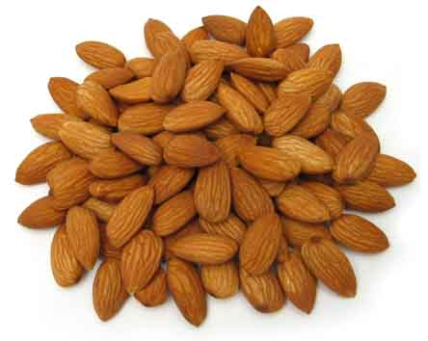

PART B: Although all the almonds in your bowl looked pretty similar, we have seen that there are subtle, unique characteristics that distinguish one almond from one another. This is true for most characteristics within most populations of organisms. The majority of individuals are pretty similar, with a few individuals with more extreme characteristics. In Part B, we will look at one characteristic, almond length and compare that characteristic for a number of almonds and graph the information from the class.

- Choose an almond at random from the cup. Using the ruler, measure the length of your almond in millimeters. Record the length of you almond below.

length of almond: ____________mm

- Take one of the Post-It notes and write a symbol on it that you will remember (no names or numbers please).
- Place your Post-It on the board above the number that corresponds to the length you measured.
- Plot the class data in the graph below. Be sure to label your graph. X, Y, and Title.

- Calculate the average length of almonds for your class.

Average Length _______ mm

- Explain what your graph tells you about the length of your population of almonds.

