Name:,,,,,,,,,,,,,,,,,,,,,,,,,,,,,,,,,,,,,,,,,,,,,,,,,,,,,,,,,,,,,,,,,,,,,,, Period:…………………………….. Date: ……………

DIGGING FOR FOSSILS. (part 1)

In this activity your group will act as paleontologists at an African location where recent erosion has exposed many fossil bones. It appears that the fossils come from two different species but are mixed together. Your job is to carefully examine the fossil bones and properly classify them into either the human species (Homo sapiens) or the chimpanzee (Pan troglodytes).

Materials: Fossils envelope #1, identification sheet.

Procedures: Empty the bones from envelope #1 and sort them into two columns on your desk: chimpanzee or human.

Leave plenty of space between the two columns. Then fill in the chart below with the proper catalog # of each fossil bone:

Species: |  | Species:
Catalog # | Fossil type | Catalog #
 | Skull-side view
 | Skull-underneath view
 | Teeth
 | Jaw
 | Trunk-Rib Cage
 | Finger
 | Hand
 | Pelvis and Femur
 | Foot

DIGGING FOR FOSSILS. (part 2)

Your team has just stumbled across another set of fossils which is neither human or chimpanzee. Using your expert knowledge of humans and chimps, analyze these new bones.

Materials: Envelope #2

Procedure:
- Open envelope #2
- Compare each of the new fossils to the chimpanzee and the human.
- Rate each new bone as either: similar to chimpanzee, similar to human, or similar to both..

Fossils type | Species (Chimpanzee or Human)
Skull – side view
Skull – underneath view
Teeth
Jaw
Finger
Hand
Pelvis & Femur
Foot

Analysis: Describe the new fossil to the scientific community.

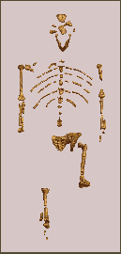
SCIENTIFIC REPORT ABOUT A NEW HOMINID SPECIES
Write an essay that includes:

- NAME OF THE NEW HOMINID SPECIES
- Suggest a name for this fossil. It was found in southern Africa and it seems to be related to both apes and humans.

- DESCRIPTION
- Describe the new fossil. Compare each of the new fossil bones to the chimpanzee and the human.

- HYPOTHESIS
- Write one or two paragraphs about the significance of this new fossil species and what it might mean to the evolution of the hominids and Homo sapiens.
- Construct an evolutionary tree that relates Humans, Chimps and the new hominid species

- PICTURE
- Draw a picture recreating what the new species may have looked like when alive. Use bone shapes as clues to help you make your drawings.
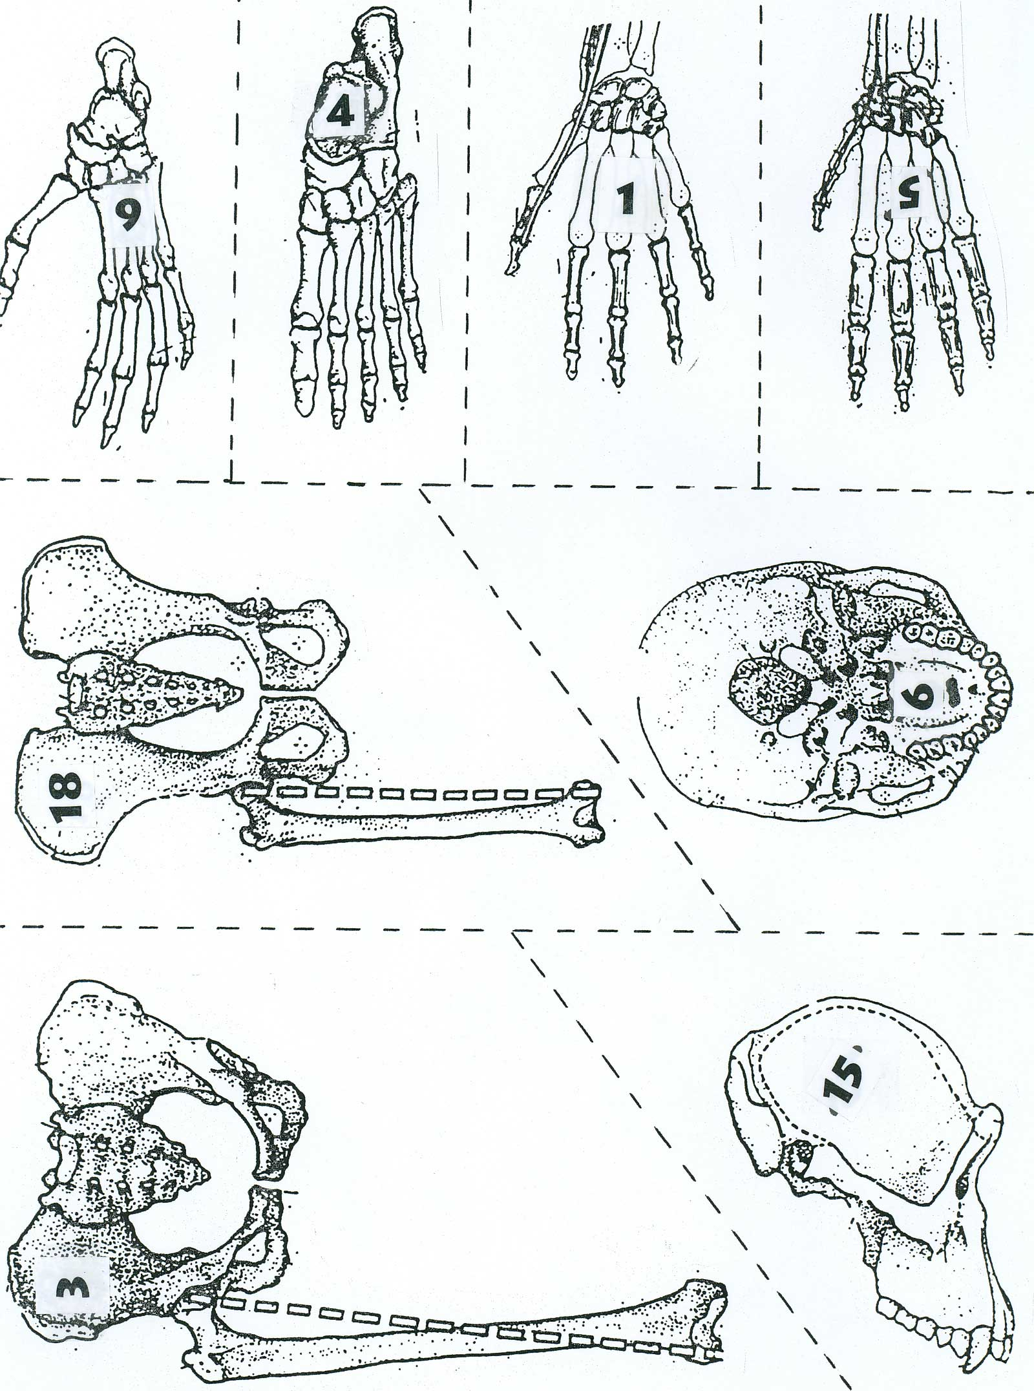
ENVELOPE #1
ENVELOPE #1
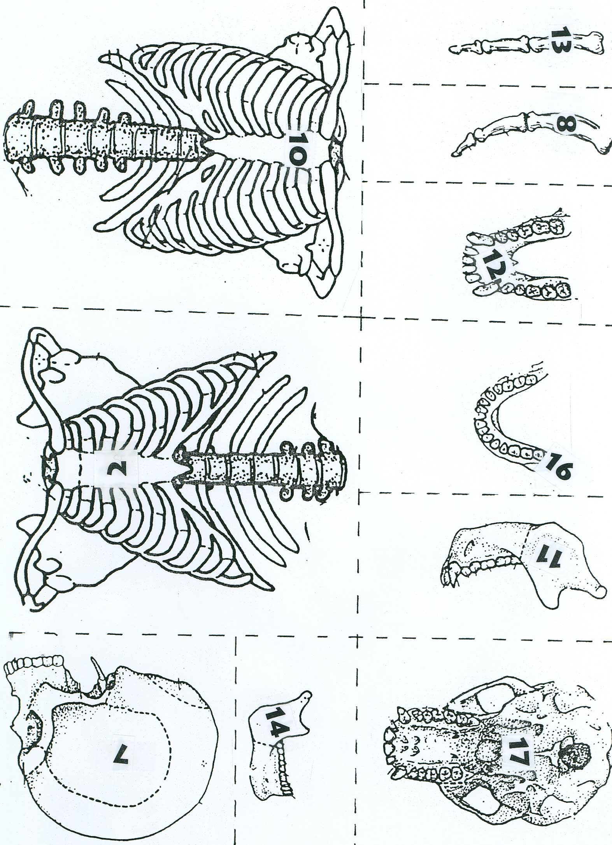
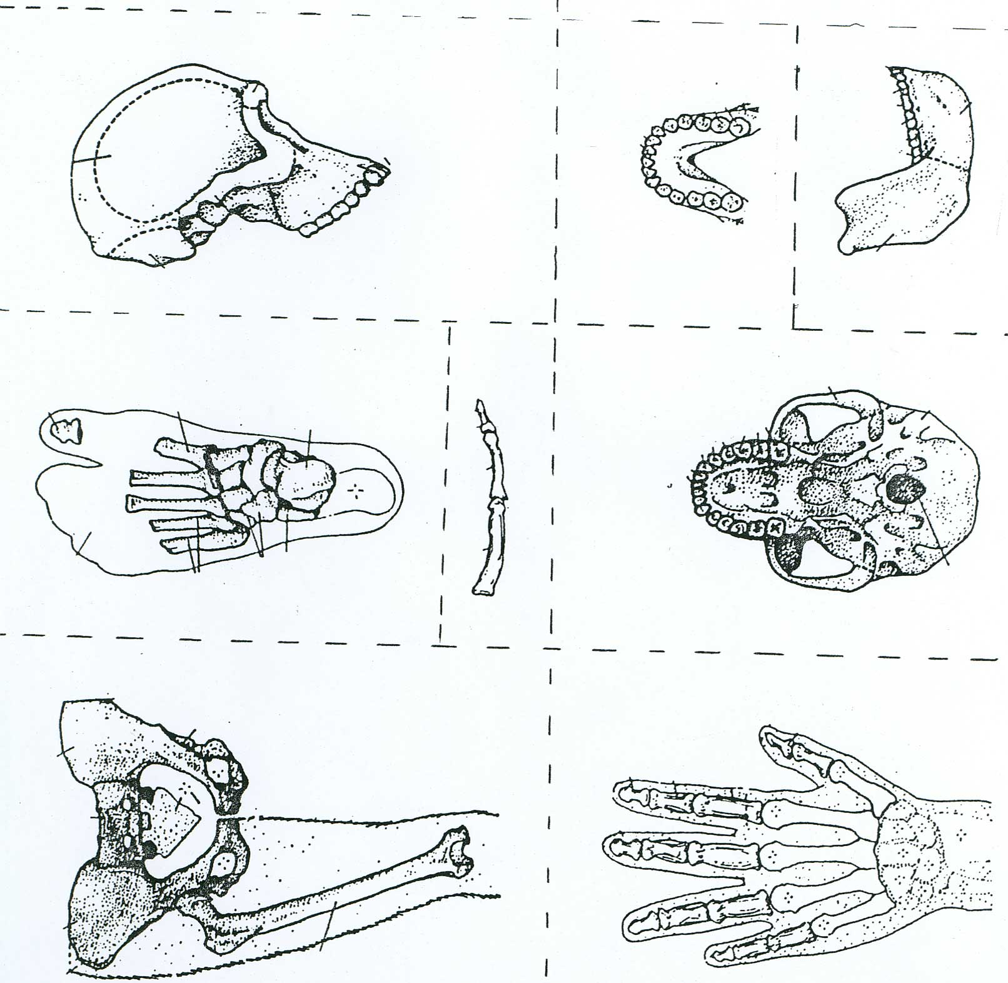
ENVELOPE #2

