Marshmallow Meiosis:
Explore genetics by raising reebops in the classroom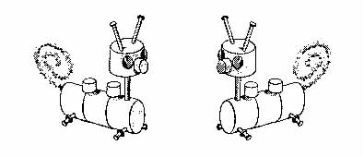
Adult Reebops
This idea came from an article out of The Science Teacher written by Patti Soderberg.
This is an activity that I found as a college student for an assignment in my Science Methods class. I liked it then, but love it now that I have used it both years I have taught Biology. It is a good introduction to genetics to get students curious about how we pass traits on to the next generation. But I like it better as an end of the unit activity. Students can then use the vocabulary that they have learned to describe how genes are passed on. It seems to put a tangible true understanding to words they were just learning because it is "on the test." Either way, I am sure Reebops can be a hit in your classroom! [Especially if you save some fresh marshmallows to eat after the lab!]
Reebops are the imaginary organisms that are prolific and require minimal care. These creatures are made out of marshmallows and other inexpensive materials that can be found around the house. By chromosome analysis we know that reebops have seven pairs, or 14 total chromosomes.
Summary of Reebop activity:
During this activity, your students will have the opportunity to observe all of the offspring produced by one set of reebop parents. Your students will sort Mom and Dad reebop chromosomes, select the new baby reebop chromosomes, decode the secret code found on the baby reebop chromosomes, and construct the baby reebop according to the code. I like to tell students that we will be observing meiosis, fertilization, development and birth..all in just one class hour! Each group of students will be in charge of "assembling" one offspring. After all the babies are born, the reebop family will be put together so that the offspring can be compared to one another.
Getting Started:
Step One: Before class, you will need to assemble the reebop parents (See figure below). For a list of materials. Mom and Dad reebop each have a marshmallow head, two antennae (small nails), two eyes (thumb tacks), an orange nose (a colored miniature marshmallow), three body segments (large white marshmallows), two green humps (green miniature marshmallows), four blue legs (blue push pins), and a curly tail (a pipe cleaner). Use toothpicks as "unseen" tendons and ligaments to assemble the reebops. Assembling is made easier if marshmallows are left out overnight to harden a bit. The reebops tend to be too floppy to stand properly if fresh marshmallows are used.
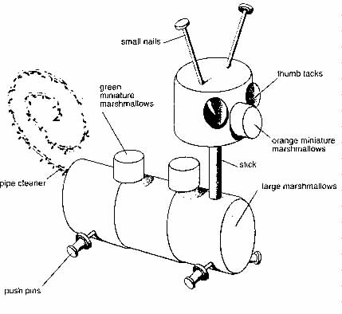

Step Two: Construct identical sets of Mom and Dad reebop chromosomes for the students to sort.
- Use construction paper to make strips of paper that will represent the chromosomes. It is good to use different colors for each parent. For example purple for Mom and Green for Dad. (You could use your school colors for this!)
- Cut 4 strips 13 inches long (2 purple and 2 green). Cut 4 strips 11 inches long (2 purple and 2 green). Cut 4 strips 9 inches long (2 purple and 2 green). Cut 4 strips 7 inches long (2 purple and 2 green). Cut 4 strips 5 inches long (2 purple and 2 green). Cut 4 strips 3 inches long (2 purple and 2 green). Cut 4 strips 1 inch long (2 purple and 2 green).
- Both parents are heterozygous (have a big and small letter) for all of the traits. Label each set of the chromosomes with letters that represent this. See figure below.
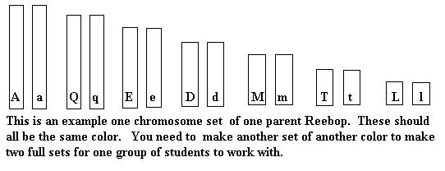
- Put a full set of Mom and Dad chromosomes in a folder or envelope for each group of students. (It is best to have no more than 2-3 students in a group) Each envelope should have 28 pieces of paper in them.
- There are 128 chromosome combinations possible from an organism that has seven pairs of chromosomes. This seems to be a large enough number to insure that no two offspring produced by a class will appear identical. However remember that even if two look alike be sure to have students look at the reebop's chromosomes. Students will not be able to tell by looking the difference between LL and Ll because both code for blue legs.

Step 3: Put meaning to the traits. Make an overhead or a handouts of the chart below. If you are doing this as a unit introduction you may leave out phenotype and genotype and treat this section as more of a "secret code."
Phenotype | Genotype
1 antenna | AA
2 antenna | Aa
No antenna | aa
1 green hump | MM
2 green humps | Mm
3 green humps | mm
Red nose | QQ
Orange nose | Qq
Yellow nose | qq
Curly tail | TT or Tt
Straight tail | tt
2 eyes | EE or Ee
3 eyes | ee
Blue legs | LL or Ll
Red legs | ll
3 body segments | DD or Dd
2 body segments | dd

Reebop Breeding Day!
Begin the class by asking questions that lead students into asking themselves questions. For example: Have you ever wondered, why no one looks exactly alike, yet relatives can look similar? Why are some babies born with diseases, missing limbs or retardation? What goes wrong when a fetus is miscarried? How does a developing body "know" what color hair, skin, eyes to make?
Then introduce the lab saying, "Today, we are bringing the high tech. process of meiosis, fertilization, development and birth all in this class period.
Introduce the Mom and Dad reebops. Have students observe the traits that the parents have. What conclusions could you make about them? (They look exactly alike)
Divide students into small groups, no more than three, and pairs work best. Hand out the envelopes that contain the chromosomes for the future reebops. Have one person in charge of one color. Have them spread out their chromosomes same lengths together with the letters facing down. (At this point you can ask students why can the chromosomes be sorted into pairs of similar length and why each pair differs in length from the other pairs.)
Next ask each student to arbitrarily take one chromosome of each length from their set and place them together in a new baby pile. (What is happening now? What does this represent? Students get a kick out of this part!) The extra chromosomes can be put back into the envelope to avoid confusion. Each reebop baby should have 14 chromosomes, half one color and half another. (Why is it important that the parents chromosomes split in half? What would happen if they didn't?)
Students will discover what their baby will look like by turning over their baby's chromosomes and decoding them by referring to the key, on the overhead or the handout. I like to have the materials on a table in the front of the room and have just one student from the group come get what is needed.
As the reebop babies are being completed have the proud parents put them in a designated nursery. When everyone is completed, have students study the offspring. How do they all compare? Do any look alike?
If none of the groups of students missorted their chromosomes, you may wish to have a preconstructed baby that has extra parts or missing parts. This baby will be a perfect lead-in to a discussion on non-disjuction and the importance of complete sets of chromosomes in offspring.
I like to have a handout that can also guide students to think through what they have just done. I also have them write down the phenotype for each trait of their baby reebop. And many students like to name them. You may want to include questions you discussed in class and some that you didn't.

The sky is the limit with Marshmallow Meiosis!
Reebops could be for any age from elementary to college level! The goals of these lessons would be different but they all would be memorable. It could teach young children the concept of generation. With older students could teach concepts like linkage and multiple alleles.
I wish you luck with this project. I hope that you have as much fun with it as I have!

Here are photographs of my students on Reebop Breeding Day!

Reebop used with permission from Patti Soderberg: Director, BioQUEST Curriculum Consortium, Department of Biology, Beloit College, 700 College Street, Beloit, WI 53511. Visit the BioQUEST Curriculum Consortium Web Site.
Original Article "Marshmallow Meiosis" came from The Science Teacher November 1992 pp 28-31.

Back to other Science Ideas / Back to Mrs. Harland's Home Page

