How to Extract DNA from Anything Living

Name ______________ Class _____
At the end of today’s lab we will be able to see DNA! Lots of DNA. Let’s get started, but before we begin… What does DNA look like? What is DNA made of?
First, you need to find something that contains DNA. Since DNA is the blueprint for life, everything living contains DNA.
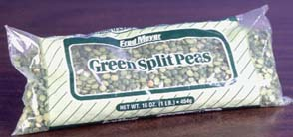
For this experiment, we’ll use green about 100 mL (1/2 cup) of split peas as our DNA source and…
- A large pinch of table salt (less than 1ml or 1/8 teaspoon)
- Twice as much cold water as the DNA source (about 200ml or 1 cup)
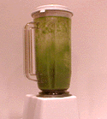
Blend on high for 15 seconds.
The blender separates the pea cells from each other, so you now have a really thin pea-cell soup.
And now, 3 easy steps:
1. Pour your thin pea-cell soup through a strainer into another container (like a measuring cup).
Add about 1/6 of liquid detergent of the amount of peas soup you have (about 30ml or 2 tablespoons) and swirl to mix. Let the mixture sit for 5-10 minutes. During this time start looking over you post-lab questions.
Pour some of the mixture into a test tube. Fill it 1/3 of the way.
2. Add a pinch of enzymes to each test tube and stir gently. (Ask me for a stirrer.) Be careful! If you stir too hard, you'll break up the DNA, making it harder to see.
Use meat tenderizer for enzymes.
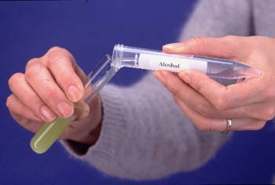
3. Tilt your test tube and slowly pour rubbing alcohol (70-95% isopropyl or ethyl alcohol) into the tube down the side so that it forms a layer on top of the pea mixture. Pour until you have about the same amount of alcohol in the tube as pea mixture.
DNA will rise into the alcohol layer from the pea layer. You can use your stirrer to draw the DNA into the alcohol.
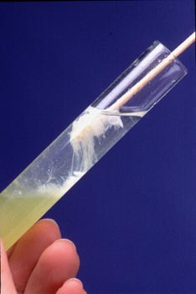
Alcohol is less dense than water, so it floats on top. Since two separate layers are formed, all of the grease and the protein that we broke up in the first two steps and the DNA have to decide:
"Hmmm...which layer should I go to?"
This is sort of like looking around the room for the most comfortable seat. Some will choose the couch, others might choose the rocking chair.
In this case, the protein and grease parts find the bottom, watery layer the most comfortable place, while the DNA prefers the top, alcohol layer.
DNA is a long, stringy molecule that likes to clump together.

Congratulations! You have just completed a DNA extraction! Now answer the following questions on a loose-leaf piece of paper with a proper heading.

1. What do you think adding detergent does? Hint: Think about what detergent is used for and which one of the four organic compounds cell membranes are made of. Look up what cell membranes are made of in a text book if you don’t remember, I will not tell you the answer.
2. What is an enzyme? What does it do? Again, use your text or notes for help.
3. Describe the 3 step process of how DNA is extracted from the peas.
4. What does it mean for alcohol to be less dense than the pea soup mixture.
5. What is the source of the DNA in this experiment?
6. Which one of the four organic compounds is DNA made up of?

