Dog Lab from Wolf to Woof:

http://www.nationalgeographic.com/xpeditions/lessons/08/g912/dogsevolution.html

Step 1.

Wolves and Dogs: Fact and Fiction quiz link

http://www.pbs.org/wgbh/nova/wolves/wolfdog.html#ten

Follow up questions to quiz.
- What is the genetic relationship between dogs and wolves? How closely is Canis lupus related to Canis familiaris?
- Approximately how long ago were dogs domesticated?
- Question number five states that there are many dog breeds "because dogs have undergone a number of changes due to natural selection—and have also changed drastically through artificial selection for hair color, size, and temperament." What does this mean? What is the difference between natural and artificial selection?
Step 2: Fill in map with wolf species

Link: http://www.wolf.org/wolves/learn/intermed/inter_sci/wolf_subspecies.asp

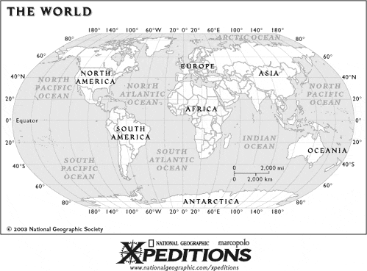

Step 3: Wolf to woof article

Article link: http://www7.nationalgeographic.com/ngm/data/2002/01/01/html/ft_20020101.1.html

Discuss the two scenarios by which dogs may have become domesticated. Ask them to hypothesize how dogs could have become so different from wolves in terms of their appearance but retained the vast majority of wolves' genetic makeup.

