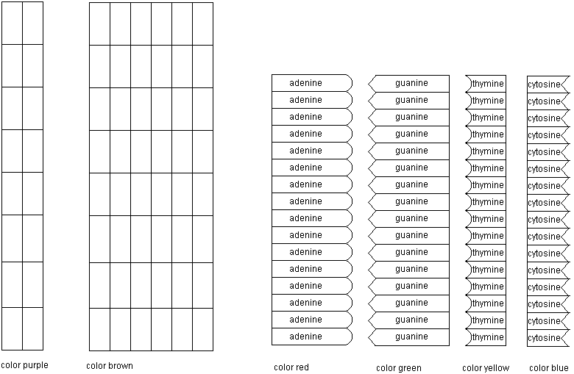

- Use markers to color the phosphate and 5-carbon sugar backbone and the nitrogenous bases.
- Cut the purple backbones into two long strips. Cut all the rest of the pieces individually.
- Make two complimentary strands of DNA using the purple backbones and 4 of each type of base. Put the bases in any order you want.
- Assemble individual nucleotides using the brown-backboned pieces and the rest of the bases.
- Stop working and wait for the notes on DNA replication.
- “Unzip” your blue-backboned DNA molecule.
- Pair up complimentary brown-backboned bases and use tape to form backbone bonds and complete the replicated strand.
- Repeat steps 7 and 8 with your new DNA molecules so that you finish with 4 completely identical DNA strands!
- You did it!! Great job!!!!

