HOW DO THINGS GET INTO CELLS?

Diffusion: the random movement of a molecules form areas of high concentration to areas of lower concentration.
Osmosis: the special name applied to the diffusion of water.

A living cell has a membrane around it. In this activity you will explore this membrane’s functions.

The problem:
When starch and iodine are separated by a plastic membrane, they still combine to form a blue-black solution.
Is the membrane is allowing iodine to move across?
Or is the membrane allowing starch, a larger molecule than iodine, to move across?

Hypothesis:
- Write a prediction about the movement of starch and iodine across this membrane

Experiment:
Design an experiment that will test your prediction.
When you plan your experiment, be sure to consider how you will know whether starch and/or iodine cross the membrane.
- Write out your plan. Draw and label your experiment.

Develop the experiment

Observation

- Has anything changed inside the beaker holding the iodine solution?

- Has anything changed in the plastic bag set aside?

- Did the iodine molecules move across the membrane? Explain how you know and why you believe this occurred.

- Did the starch molecules move across the membrane? Explain how you know and why you believe this occurred.

Conclusion
- Are your observations different from your prediction? What does it means?

- The plastic bag membrane is a SEMIPERMEABLE membrane or SELECTIVE membrane . Write what you think this means.

The plastic bag acted like the membrane of a cell. It is a semipermeable membrane. The iodine molecules are small enough to pass through the pores of the plastic bag but the cornstarch molecules are too big to pass outside of the bag.

- Write a definition for passive diffusion or passive transport.

- If a cell needed something form outside of the cell that could not enter via passive transport… what would it have to do?

- What would you call this kind of transport or diffusion?

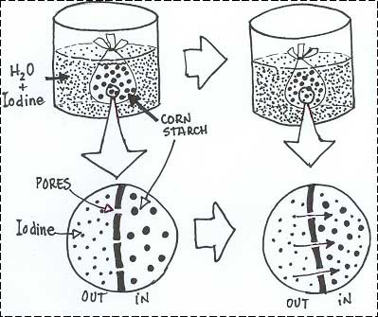
Iodine in,
because it is smaller than pores.
Cornstarch out,
because particles too big to escape

