USING THE MICROSCOPE

Name…………………………………………………. Period: …………………………….. Date: ………………..

A magnifying glass is really a simple microscope. Any microscope that has two or more lenses is called a compound microscope. The microscope that you have in front of you is a compound microscope.
Review the parts of the microscope and identify the names of the following parts of the microscope.
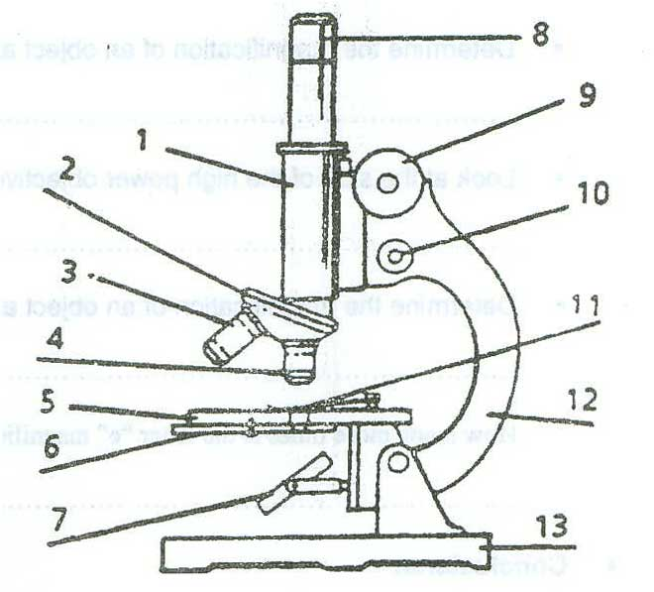
1.- ……………………………………………
2.- ……………………………………………
3.- ……………………………………………
4.- ……………………………………………
5.- ……………………………………………
6.- ……………………………………………
7.- ……………………………………………
8.- ……………………………………………
9.- …………………………………………..
10.- …………………………………………
11.- …………………………………………
12.- …………………………………………
13.- …………………………………………

- State the function of each of the following parts.
- Fine adjustment ……………………………………………………………………………………………………..
………………………………………………………………………………………………………………………...
- High Power Objective ………………………………………………………………………………………………
…………………………………………………………………………………………………………………………
- Mirror or lamp……………………………………………………………………………………………………….....
- Diaphragm …………………………………………………………………………………………………………..
………………………………………………………………………………………………………………………...

HOW DOES A MICROSCOPE WORK?

- Procedure
- Draw a diagram of the letter “e” as seen under low power.

- How does the letter “e” appear to move in the microscope when you
- Move the letter “e” to the right?

…………………………………………………
- Move the letter “e” to the left?

…………………………………………………

- Move the letter “e” towards you?

…………………………………………………

- Move the letter “e” away from you?

…………………………………………………

  - Cut out a small piece of newspaper that contains a lower case letter “e.”
  - Place the letter “e” in the center of a glass slide.
  - Place a coverslip over the letter “e”
  - Place the prepared slide of the letter “e” on the stage of the microscope with the letter “e” over the opening in the stage. Use the stage clips to hold the slide in place.
  - Focus on the letter “e” under low power. Answer all the questions in the box to the right…..
  - Now switch to high power and focus on the letter “e”.
  - How does the image of the letter “e” under low power differ from the image under high power?

…………………………….………………………………………

……………………………………………………………………

- Determine Magnification

  - Look at the magnification of the ocular (eyepiece). What is the magnification?

……………………………………………………

  - Look at the side of the low power objective. What is its magnification?

……………………………………………………

  - Determine the magnification of an object as seen under the low power objective and the eyepiece.

…………………………………………………

  - Look at the side of the high power objective. What is its magnification?

…………………………………………………

  - Determine the magnification of an object as seen under the high power objective and the eyepiece.

…………………………………………………

How many more times is the letter “e” magnified under high power than under low power?

………………………………………………….

- Conclusions:

  - Compare and contrast the appearance of the letter “e” under low and high power.

……………………………………………………………………………………………………………………..

  - Why can a compound microscope achieve higher powers of magnification than a simple microscope which contains only a single lens?

……………………………………………………………………………………………………………………..

  - Check off what you have learned or done:

ٱ Identified the parts of the compound microscope.
ٱ Listed the function of each of the parts of the compound microscope.
ٱ Found an object under low power.
ٱ Focused on an object using high power.
ٱ Located and observed the letter “e” under the compound microscope.
ٱ Determined the magnification of the compound microscope.

  - What else would you like to learn about this topic?

……………………………………………………………………………………………………………………..

