Frederick Douglass Academy III Name __________________

Living Environment, Class ____ Date __________________

Unit 2 Exam (200 points)
Organization and Patterns in Life

Directions: Complete the following questions to the best of your ability. Good Luck!

Vocabulary – Directions: Define the following words. (40 points)

1. Cell membrane - ______________________________________________________________________

______________________________________________________________________________________

2. Osmosis - ___________________________________________________________________________

______________________________________________________________________________________

3. ATP - ______________________________________________________________________________

______________________________________________________________________________________

4. Acitve Transport - _____________________________________________________________________

______________________________________________________________________________________

5. Catalyst - ____________________________________________________________________________

______________________________________________________________________________________

Multiple Choice: (20 points)

Directions: Write the letter that best answers the question or completes the statement next to the number of the question.

6. What would most likely happen if the ribosomes in a cell were not functioning?

1. The cell would undergo uncontrolled cell division.
2. The creation of enzymes would stop.
3. The cell would produce disease fighting antibodies.
4. The rate of glucose transport in the cytoplasm would increase.

7. The process of active transport requires the most direct use of
(1) carbon dioxide (3) ATP
(2) amino acids (4) glucose

8. The diagram below shows the same type of molecule in area A and area B. With the passage of time, some molecules move from area A to area B.

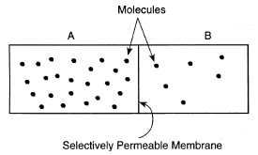
The movement is the result of the process of

1. Active transport 3. Diffusion
2. Cyclosis 4. Pinocytosis

Matching: (40 points)

Directions: Correctly pair the listed organelle with its proper function. Write the letter that you choose for each question next to the number of the question.

Your Choice | Organelle | Function
 | 9. Chloroplast | a. synthesizes (creates) proteins
 | 10. Mitochondria | b. storage site
 | 11. Ribosome | c. provides energy for the cell. The “powerhouse”
 | 12. Nucleus | d. storage of genetic information.
 | 13. Vacuole | e. where photosynthesis occurs.

Short Answer: (60 points)

Directions: Complete 5 of the 6 following questions to the best of your ability. You do not have to use complete sentences.

14. How does the sun provide energy for life on earth?

15. What are 2 factors that influence enzyme activity?

1.

2.

16. List, from largest to smallest, the levels of organization in a multicellular organism.

17. What are the three functions of the cell membrane?

1.

2.

3.

18. What is the difference between an Autotroph and a Heterotroph?

18a. Give an example of each.

Autotroph: Heterotroph:

19. What are the four types of organic compounds in living things?

1. 2.

3. 4.

19a. What is the function of each?

1. 2.

3. 4.
Essay: (40 points)

Plants and animals produce energy for their life processes in different ways. On the following two pages;

Write a paragraph of at least three sentences each on…
1. How the energy producing processes of plants and animals are dependent upon each other for survival.
2. Compare and contrast the use/creation of glucose in each process
3. What life would be like on earth if there were no plants.

The equation below is for ____________________________
Carbon dioxide (CO₂) + water (H₂O) + sunlight → glucose (C₆H₁₂O₆) + oxygen (O₂)

The equation below is for _____________________________
Oxygen (O₂) + glucose (C₆H₁₂O₆) → carbon dioxide (CO₂) + water (H₂O)

Essay continued.

Extra Credit (5 points) REGENTS QUESTIONS.
1. To determine which colors of light are best used by plants for
photosynthesis, three types of underwater green plants of similar mass
were subjected to the same intensity of light of different colors for the
same amount of time. All other environmental conditions were kept
the same. After 15 minutes, a video camera was used to record the
number of bubbles of gas each plant gave off in a 30-second period
of time. Each type of plant was tested six times. The average of the
data for each plant type is shown in the table below.
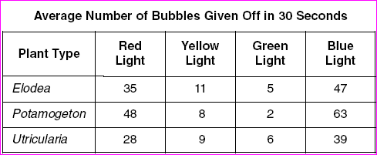
Which statement is a valid inference based on the data?
(1) Each plant carried on photosynthesis best in a different
color of light.
(2) Red light is better for photosynthesis than blue light.
(3) These types of plants make food at the fastest rates with
red and blue light.
(4) Water must filter out red and green light.
2. An iodine test of a tomato plant leaf revealed that starch was present at 5:00 p.m. on a sunny afternoon in July. When a similar leaf from the same tomato plant was tested with iodine at 6:00 a.m. the next morning, the test indicated that less starch was present. This reduction in starch content most likely occurred because starch was
(1) changed directly into proteins
(2) transported out of the leaves through the guard cells
(3) transported downward toward the roots through tubes
(4) changed into simple sugars

3. A student measures his pulse rate while he is watching television
and records it. Next, he walks to a friend’s house nearby and when
he arrives, measures and records his pulse rate again. He and his
friend then decide to run to the mall a few blocks away. On arriving
at the mall, the student measures and records his pulse rate once again.
Finally, after sitting and talking for a half hour, the student measures and
records his pulse rate for the last time. Which graph below best illustrates
the expected changes in his pulse rate according to the activities described above?
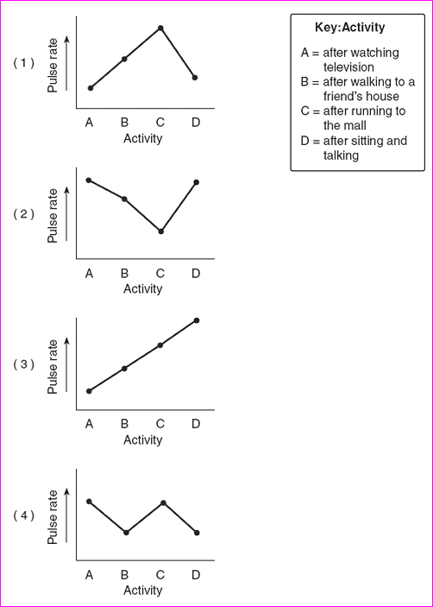
4. An investigation was set up to study the movement of water
through a membrane. The results are shown in the diagram below.
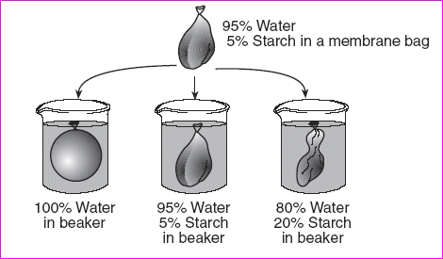
Based on these results, which statement correctly predicts what will
happen to red blood cells when they are placed in a beaker containing a
water solution in which the salt concentration is much higher than the
salt concentration in the red blood cells?
(1) The red blood cells will absorb water and increase in size.
(2) The red blood cells will lose water and decrease in size.
(3) The red blood cells will first absorb water, then lose water
and maintain their normal size.
(4) The red blood cells will first lose water, then absorb water,
and finally double in size.
5. Which statement describing the cells in a body system is correct?
1 Each cell in the system is identical to the other cells in the system, and each cell works independently of the other cells.
2 Some cells in the system may be different from the other cells in the system, but all cells are coordinated and work together.
3 Each cell in the system is different from the other cells in the system, and each cell works independently of the other cells.
4 All cells in the system are identical to each other and work together.

