Everything you need to know about Ecology
Ecology – the study of the living and non-living things around us
Ecological Levels:
Organism – one living thing
(Ex: one fish)
Population – all the members of one species in one area
(Ex: all the cod in the Hudson River
Community – all the living things in one area
(Ex: all the fish, crabs, algae, bugs, etc. in the Hudson River)
Ecosystem – all the living and non-living things in one area
(Ex: all the fish, crabs, algae, bugs, etc. in the Hudson River, plus the water, oxygen, carbon dioxide, sunlight, and climate)
Biosphere – all of the ecosystems put together
(Ex: Earth, including all the rivers, ponds, meadows, deserts, mountains, etc.)
Parts of an Ecosystem
Everything in an ecosystem is divided into two categories: biotic factors (living things) and abiotic factors (non living things).

Abiotic Factors
- Air – oxygen, carbon dioxide
- Water
- Rocks
- Minerals and chemicals
- Climate – rainfall, sunlight, temperature
- Soil
- Shape of land

Biotic Factors
Type of organism | Definition | Examples | Synonyms and types
Producer | Makes its own food | Plants, algae | Autotroph
Consumer | Feeds on other organisms | Cows, sharks, bears, humans | Heterotroph  Herbivore – eats producers  Carnivore – eats consumers  Omnivore – eats producers and consumers  Scavenger – eats dead, decaying animals
Decomposer | Eats dead organisms and returns nutrients to the soil | Bacteria, fungi
Relationships between organisms
Predator-Prey: A predator is a consumer that eats its prey. Energy is transferred from prey to predator.

Competition: There is a limited amount of materials available in the ecosystem. Organisms must compete with each other in order to survive.

Carrying Capacity: the number of organisms an ecosystem can support. The carrying capacity depends mostly on the availability of abiotic resources, as well as how quickly decomposers can return nutrients to the soil. If the carrying capacity is exceeded, organisms begin dying until the carrying capacity is reached again.

Niche: The role a species plays in a community. Only one species at a time can occupy a niche. Competition occurs when two species try to occupy the same niche. For example, birds that feed in spruce trees have a different niche than birds that feed off of berries in shrubs.

A food web shows the transfer of energy between many organisms in an ecosystem. Arrows point to the organism that gets the energy (the one that eats).
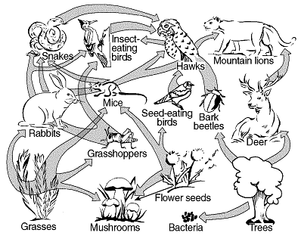
This food web shows
- producers (trees, grasses, flower seeds) – a producer has all arrows pointing out of it
- consumers (hawks, mountain lions, grasshoppers, mice, etc.) – a consumer has arrows pointing into it, and may have some pointing out of it too
- decomposers (bacteria, mushrooms) – a decomposer has all arrows pointing into it and usually appears at the bottom of the food web

A food chain is simpler than a food web but shows the same type of relationships:
Trees → bark beetles →hawks → mountain lions

An energy pyramid is a diagram that shows the relationship between organisms in an ecosystem. The bottom level represents organisms with the most energy – the producers. The top level represents organisms with the least energy – the carnivores. Energy decreases up the food chain because energy is lost at each level when the organisms use it or lose it as heat.
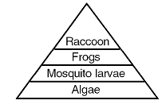

Stable Ecosystems
A stable ecosystem must have enough materials to support its living organisms. Materials such as water, oxygen, carbon dioxide, and minerals are not added to the biosphere but must be continuously cycled between living and non-living things.

Water Cycle Carbon-Oxygen Cycle
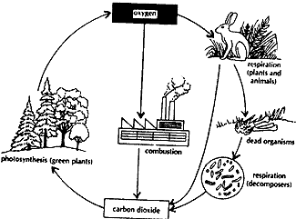
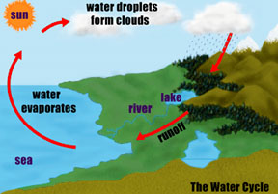

A stable ecosystem also has a lot of biodiversity. Biodiversity is the differences between living things. For example, a forest would have more biodiversity than a cornfield because a forest has many types of living things (types of trees, animals, bugs, grass, etc), but a cornfield only has one type of living thing (corn). More biodiversity makes an ecosystem more stable, provides genetic variation, and is good for humans who use living things for medicine and technology.

A stable ecosystem must be able to change if it is destroyed by natural disasters or by human destruction. Ecological succession is the gradual process of an ecosystem returning to its original state after destruction. This process is illustrated below.
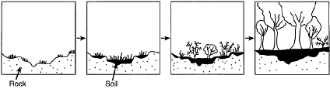
Human Impact on the Ecosystem

Humans have made the greatest impact on the ecosystem due to overpopulation, using too many resources and land, damaging biodiversity, using technology and machinery that causes pollution, and importing new species into different habitats.

Resources
- Renewable resources – resources that can be replaced if given enough time. Ex: trees, food sources
- Non-renewable resources – resources that cannot be replaced; limited or finite. Ex: metals, minerals, and fossil fuels like gas and coal

Human actions that damage biodiversity:
- Direct harvest – destruction or removal of a species from an ecosystem. Ex: hunting animals for food, or fur. Decreases biodiversity by removing a species and affecting the food web.
- Pest control – eliminating insects from an ecosystem. Some methods are more harmful than others. Ex: Spraying insecticide (very damaging to an ecosystem), Increasing the number of natural enemies of the pest (some damage), or Using natural scents, sex hormones, to attract or repel the insect (little or no damage).
- Deforestation – cutting down forests for development. Destroys entire ecosystems, decreases biodiversity, increases carbon dioxide in the atmosphere.
- Imported species – bringing new species into an ecosystem (often by accident). New species can destroy a food web because they use up resources and often do not have natural predators, therefore damaging biodiversity

Industrialization
- Water pollution
  - toxic waste in water can be dangerous because it can make it to water supplies. Even in small amounts, toxic waste is dangerous because it gets concentrated up the food chain. This means that at each level of the food chain, more toxin is in each organism. People can then also get the toxin by eating fish from this water.
  - Thermal pollution – Some factories use water to cool down their machines. The warm water gets released back into the river or lake it causes the temperature of the body of water to rise. Warm water does not hold as much oxygen as cold water and organisms start to die of suffocation.
- Air pollution – when fossil fuels are burned by cars, factories, and power plants, carbon dioxide and other gases are released into the air. Some of these gases are combined with water, creating acid rain, which damages plants and animals. Other pollutants remain in the air and form smog, which can cause problems for people with respiratory diseases, and can lead to asthma.

Global Warming
Global warming is an increase in the average temperature of the earth. This is caused when greenhouse gases such as carbon dioxide trap the sun’s rays in the earth’s atmosphere, increasing the temperature. Too many greenhouse gases are produced from burning fossil fuels and carbon dioxide cannot be removed as well due to deforestation. Global warming can cause climate changes which may disrupt food supplies and could cause polar ice caps to melt, flooding coastal areas.

Ozone Depletion
The ozone layer prevents harmful ultraviolet rays from reaching the earth. Chemicals called CFC’s are creating holes in the ozone layer. These holes will allow more UV rays to enter the earth, which can cause an increase in genetic mutations and skin cancer, as well as destroy many producers in the ocean.

Making Ecological Decisions
When humans make decisions we should consider how the decision will impact the environment first, pass laws to decrease pollution and waste, and then lastly consider cost and convenience.

