Frederick Douglass Academy III Name ______________________

Living Environment ______ Date _____________

The American Museum of Natural History
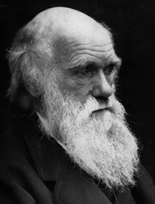

Welcome to the Darwin exhibit where you will discover how one of the greatest scientific minds of all time used careful observation and analysis of evidence to develop the Theory of Evolution.

Directions: This entire packet is to be completed before you leave the exhibit. Feel free to skip from section to section if it is too crowded at one station.
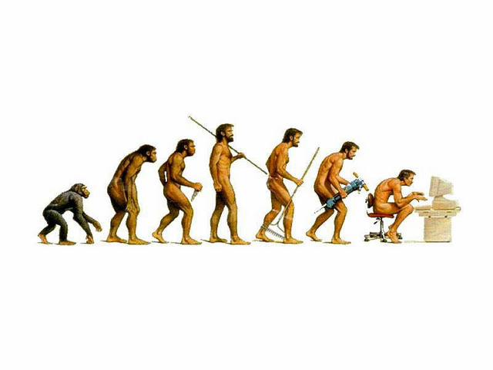
Before beginning did you get a chance to see the tortoises right before you entered the exhibit? No? See if you can go back and take a quick peek at them.

Introductory Hall

Take a few moments to look at all of the skeletons in the case. Take note at how many of the structures look similar to one another.

Now look at the skeleton… wait, did you really look at them all? Really? O.K. Now check out the chimpanzee skeleton.

1. How is its skeleton similar to ours? How is it different?

Similar: 1.

2.

3.

Different: 1.

2.

3.

Now look at the skeleton of the snake. Can you see the little bones towards the back? These are an example of a vestigial structure. Or something that once had a purpose, but is no longer used.

What do you think the purpose of this structure was?

Why is it no longer used?

Bonus: Can you name a vestigial structure in humans?
Bonus: What is a homologous structure?
First Video: Darwin’s Life (Young Naturalist)

Watch the first video. During the viewing answer the following questions.

Who is the narrator?

What is natural selection?

After viewing the video list three interesting facts about Darwin.

1.

2.

3.

A Trip around the World

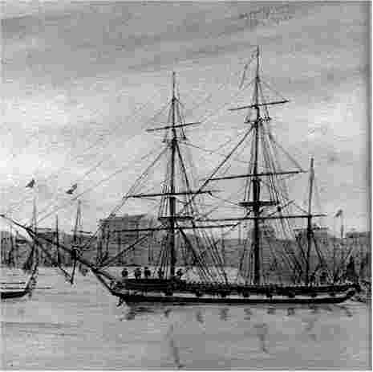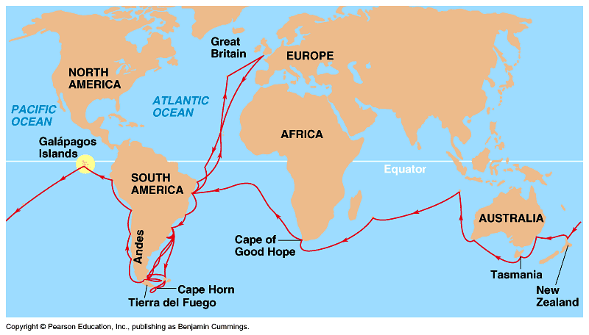

What was the name of the ship Darwin sailed around the world on?

How long did it take to complete the voyage?

What was Darwin’s role aboard the ship?

Check out the route Darwin traveled. Choose 3 places he visited and write down what he did there and what he discovered.

1. Place __________________ Date _________

2. Place __________________ Date _________

3. Place __________________ Date _________

Nice Work! Now pick a specimen that Darwin collected during his five year voyage and sketch it on the following page. Label four features that make it well adapted to live in its environment and tell why they help.

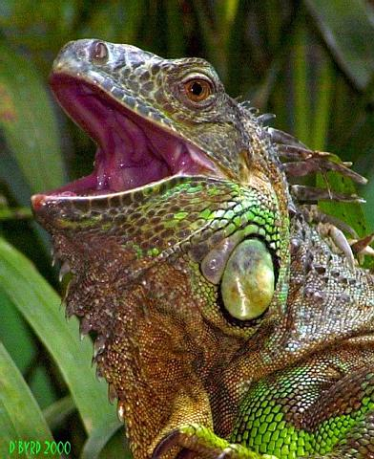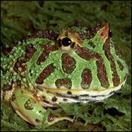
Iguana Horned Frog

This is a sketch of a _________________

Don’t forget to label four features and how they help it survive in its environment.

Nice Sketch! You are now coming to one of the most important parts of the exhibit. In the next room you will not only see a live iguana and horned frogs (look carefully can you spot them?), but you will also learn about three pieces of evidence Darwin used to shape his Theory of Evolution based on natural selection.

An ever changing earth

Evidence #1: The earth is really really old. What convinced Darwin that change occurred over a very long time?

Evidence #2: Fossils. What evidence do fossils provide for evolution?

Evidence #3: Neighboring and island species. What evidence do these types of species provide for evolution?

Bonus: What is a species?

Live Animals: Look at the Iguana or Horned frogs. (Circle your choice)

Name two adaptations and how they help your choice reproduce.

1. Adaptation _______________

2. Adaptation _______________

Great detective work! Let’s move on to the I Think section

I think
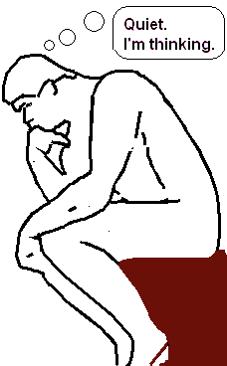 | What are three pieces on the wall that Darwin used as evidence of evolution?  1.  2.  3.  Choose one and give a brief summary telling what it is.  I choose ___________________

O.K. Now read “Adding it up”, ”Like Confessing a Murder,” and “At Last.”

Why did Darwin wait so long to reveal his ideas?

Would you have waited so long back then? Why or why not?

The World Reacts
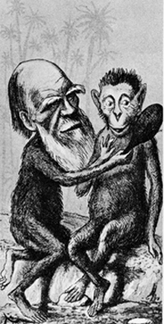 | What were the reactions of other scientists to Darwin’s ideas?  How would you have reacted?

Answer these questions: 1. How do we know living things are related and 2. How long does it take for evolution to take place?

Phew. You made it to the final room, excellent work so far. Darwin would be proud. In this room you should spend some time watching all the videos and answering the questions below.

Natural Selection video

What does V.I.S.T.A. stand for?

V. I. S.__________________

T. A.__________________

Embryo Video  How do embryos support evolution?  Bonus: What is an embryo? | 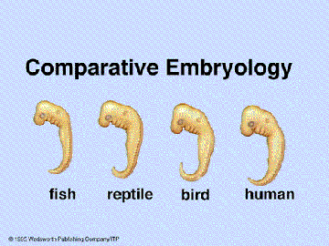
Bacteria Video: Why are bacteria a good organism to use to study evolution?

Scientific Faith Video: What is intelligent design?

What’s your opinion about intelligent design?

Fun Fact: Mr. Sheahan went to high school with Niles Eldridge who now works at the museum as a paleontologist (someone who studies the earth’s age.) Dr. Eldridge came up with an explanation for how species evolve. It’s called punctuated equilibrium.

What’s a Theory video? After watching the video explain the difference between a hypothesis and a theory.

Hypothesis Theory
Use the space below to take notes on the evidence for natural selection that you can use in your letters to Ms. Wolf. (Mr. Fox’s class only).

Embryology:

Homologies:

Vestigial Organs:

Tree of Life:

Congratulations. You’ve finished please return this worksheet to Mr. Fox and ask him what’s next. Once we get enough people together we might be able to go check out the Hall of Biodiversity.

Use the space below for further note taking if necessary.

