PEPPERED MOTHS

- Place the twelve “moths” on the dark “tree bark.”

- Imagine that you are a bird that eats insects…
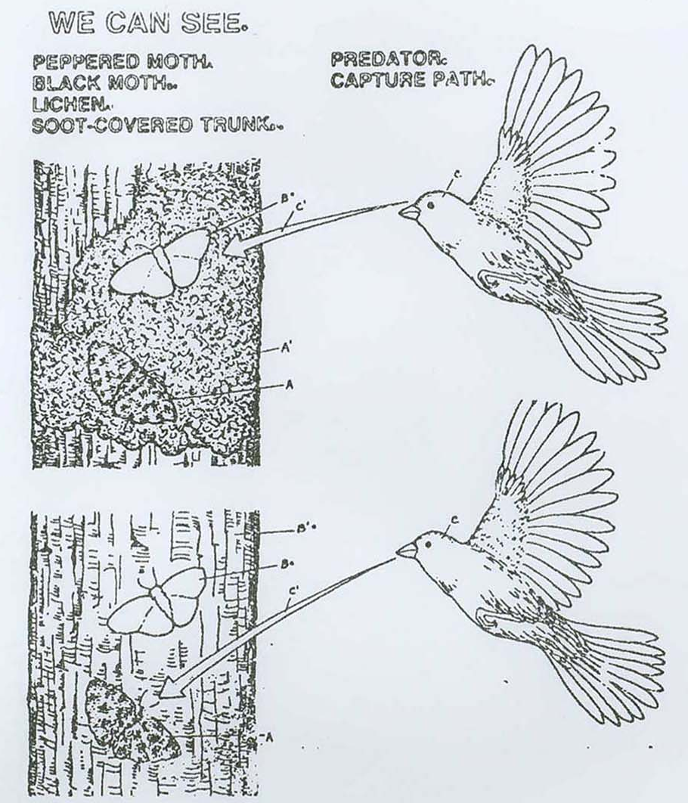
Which moth would you capture first?
Describe its appearance:……………………………….……………………
………………………………………………………………………………

- Continue doing this until all but the last moth is gone.
Describe the appearance of the last moth:…………….…………………….
……….………………………………………………………………………

- Is there any trend or sequence in the color of moths that you captured? Describe the trend:………………………………………………………….
………………………………………………………………………………

- Which of the moths were better “adapted” (suited to survive) to the environment of the dark tree trunk?………………………………………
………………………………………………………………………………
………………………………………………………………………………

- Now place all of the moths on the light “tree bark.”

- You are a bird. Which moths will you capture first this time?…………………………………………………………………………
………………………………………………….……………………………
………………………………………………………………………………

- Continue doing this until all but the last moth is gone.
Describe the appearance of the last moth:……………………………………
………………………………………………………………………………..
………………………………………………………………………………..

- What would you say would be the color characteristic of future generations of moths living on the light colored tree trunks? Why?…………………………
………………………………………………………………………………..
……………………………………………………………………………………………………………………………………………………………
PEPPERED MOTH SURVEY

Industrial melanism is the term used to describe the adaptation of an organism in response to a type of industrial pollution. One example of rapid industrial melanism occurred in the peppered moth, in the area of Manchester, England from 1845 to 1890.

Before the industrial revolution, the trees in the forest around Manchester were light grayish-green due to the presence of lichen on their trunks. The peppered moths that lived in the area were light with dark spots. Their coloring served as protective camouflage against predators, especially birds. As the industrial revolution progressed, the trees became covered with soot, turning the trunks dark. Over a period of 45 years, a change in the peppered moths took place.

In this investigation, you will observe the effects of industrial melanism on the peppered moths over a period of 10 years. You will then determine the relationship between the environmental changes, brought on by industry, and the color variation of the peppered moths. You will use your research data to graph the effects of environmental adaptation.

The table contains data from a 10 year study of two varieties of the same species of peppered moth. The numbers represent the number of moths captured in each of 10 consecutive years. The traps were located in the same area each year.

Years | Number of Light Moths Captured | Number of Dark Moths Captured
2 | 550 | 100
3 | 500 | 200
4 | 400 | 210
5 | 250 | 300
6 | 225 | 350
7 | 200 | 400
8 | 150 | 500
9 | 100 | 600
10 | 50 | 650
Number of moths captured | 600
Number of moths captured | 500
Number of moths captured | 400
Number of moths captured | 300
Number of moths captured | 200
Number of moths captured | 100
Number of moths captured | Years
- Construct a line-graph showing the number of each variety of peppered moth that was captured years 1 through 10.
- Use two different symbols: light and • dark

Answer the following questions on a separate piece of loose leaf paper (no ridges allowed)

- What do you think eats peppered moths?

- If the bark of the tree is dark and light colored moths come to rest on it, what do you think will happen?

- What caused the trunks of many trees to turn from light to dark in Manchester, England?

- Which variety of moths increased over the 10 year period of the study?

- What is the word we use to describe a change that makes its owner more likely to survive and reproduce?

- Write something about how and why the population of peppered moths changed in Manchester, England.

- Explain the reason for the increase in the number of dark colored moths.

- What effect would cleaning up the environment have on the moths?

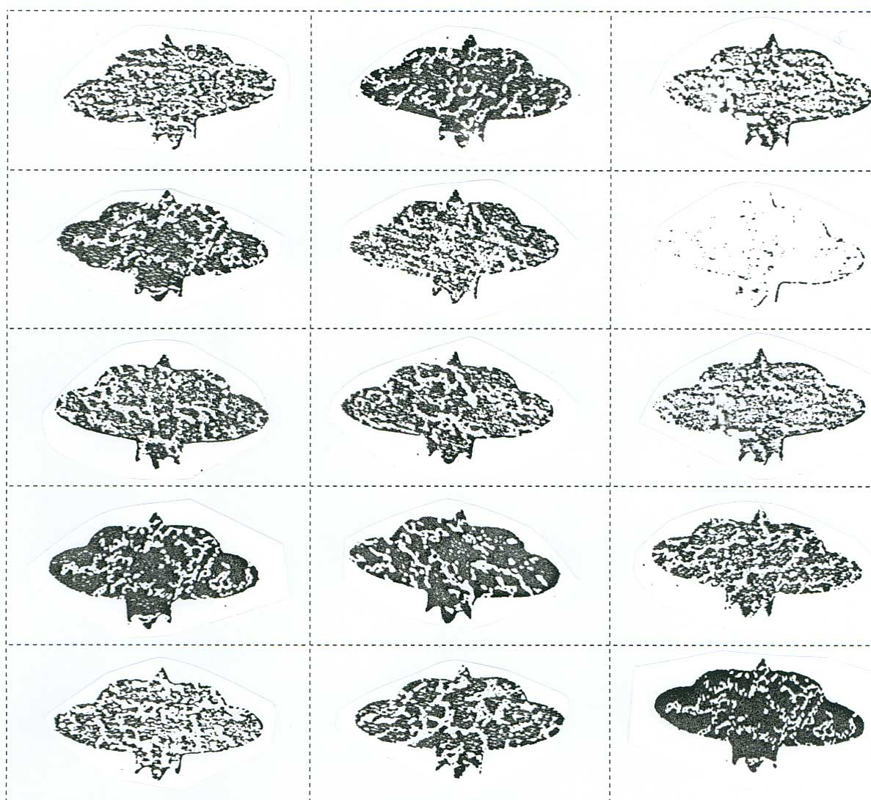
MOTHS

LIGHT TREE BARK

DARK TREE BARK


