FDA III Name ________________

Living Environment ____ Date ____________

Breeding Bunnies
In this activity, you will examine natural selection in a small population of wild rabbits. Evolution, on a genetic level, is a change in the frequency of alleles in a population over a period of time. Breeders of rabbits have long been familiar with a variety of genetic traits that affect the survivability of rabbits in the wild, as well as in breeding populations. One such trait is the trait for furless rabbits (naked bunnies). This trait was first discovered in England by W.E. Castle in 1933. Why do you think the furless rabbit is rarely found in the wild?
Note: In this activity, F represents the dominant allele for normal fur, and the recessive allele for no fur is represented by f.

- Gather the materials: 50 red beans, 50 white beans, 1 paper bag, and 3 sheets of blank paper.
- The red beans represent the allele for fur (F), and the white beans represent the allele for no fur (naked) (f). The container represents the south Bronx, where the rabbits randomly mate.
- Label one of the pieces of paper FF for the homozygous dominant (fur) genotype. Label another Ff for the heterozygous (fur) condition. Label the third ff for those rabbits with the homozygous recessive genotype (naked).
- Place the 50 red and 50 white beans (alleles) in the bag and shake up (mate) the rabbits.
- Without looking at the beans, select two at a time, and record the results on the data form next to "Generation 1." For instance, if you draw one red and one white bean, place a mark in the chart under "Number of Ff individuals." Continue drawing pairs of beans and recording the results in your chart until all beans have been selected and sorted. Place the "rabbits" onto the appropriate piece of paper: FF, Ff, or ff.
- The ff bunnies are born furless (naked). The cold south Bronx weather kills them before they reach reproductive age, so they can't pass on their genes. Place the beans from the ff paper aside before beginning the next round.
- Count the F and f alleles (beans) that were placed on each of the "furred rabbit" pieces of paper in the first round and record the number in the chart in the columns labeled "Number of F Alleles" and "Number of f Alleles." (This time you are really counting each bean, but don't count the alleles of the ff bunnies because they are dead.) Total the number of F alleles and f alleles for the first generation and record this number in the column labeled "Total Number of Alleles."
- Place the alleles of the surviving rabbits (which have grown, survived and reached reproductive age) back into the container and mate (shake the container) them again to get the next generation.
- Repeat steps five through nine to obtain generations two through ten. If working as a team, make sure everyone in your group has a chance to either select the beans or record the results.
- Determine the gene frequency of F and f for each generation and record them in the chart in the columns labeled "Gene Frequency F" and "Gene Frequency f." To find the gene frequency of F, divide the number of F by the “total number of alleles”, and to find the gene frequency of f, divide the number of f by the “total number of alleles.” Express results in decimal form. The sum of the frequency of F and f should equal one for each generation.
- Graph your frequencies. Prepare a graph with the horizontal axis as the generation and the vertical axis as the frequency in decimals. Plot all frequencies on one graph. Use a solid line for F and a dashed line for f.
- Complete the Discussion Questions form with your group.

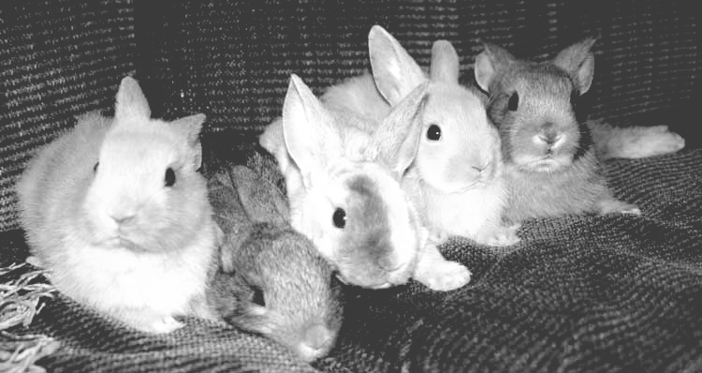
Gene Frequency Data

Generation | Number of FF Rabbits | Number of Ff Rabbits | Number of ff Rabbits | Number of F Alleles | Number of f Alleles | Total Number of Alleles | Gene Frequency of F | Gene Frequency of f
1

2

3

4

5

6

7

8

9

10

Graph your frequencies. Prepare a graph with the horizontal axis as the generation and the vertical axis as the frequency in decimals. Plot all frequencies on one graph. Use a solid line for F and a dashed line for f.

Discussion Questions: To be answered and attached on a separate piece of paper.

1. How does natural selection affect gene frequency over several generations?

2. State what you would predict about the frequency of F alleles and f alleles in the population of rabbits after 10 generations, where ff bunnies are selected against (do not survive).

3. In a real rabbit habitat new animals often come into the habitat (immigrate), and others leave the area (emigrate). How might immigration and emigration affect the gene frequency of F and F in this population of rabbits?

4. How would you simulate immigration and emigration if you did this activity again?

5. How are the results of this simulation an example of evolution?

6. Why are some traits naturally selected for over others?

