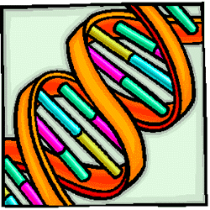
Name……………………………….………………..… Period……… Date…………..

MAKING A DNA MODEL
Introduction:

In 1953, using x-ray diffraction studies obtained by M.H. Wilkins, J. D. Watson and F.H.C. Crick proposed a model to explain the structure of DNA. In this model, a segment of which you will build in this Lab Aids kit, each DNA molecule consists of two strands twisted about one another to form a double helix.

Figure # 1
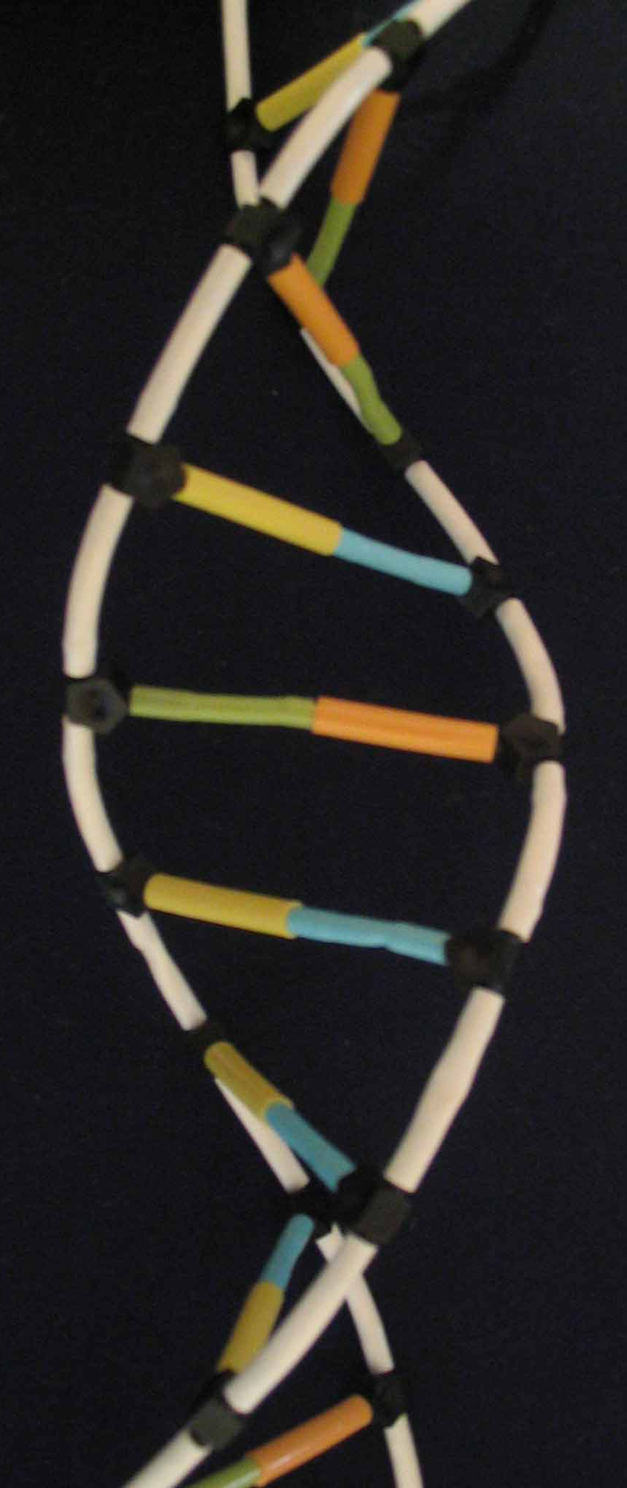
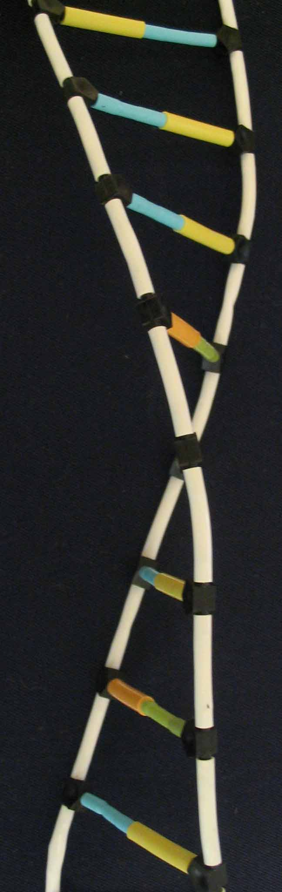
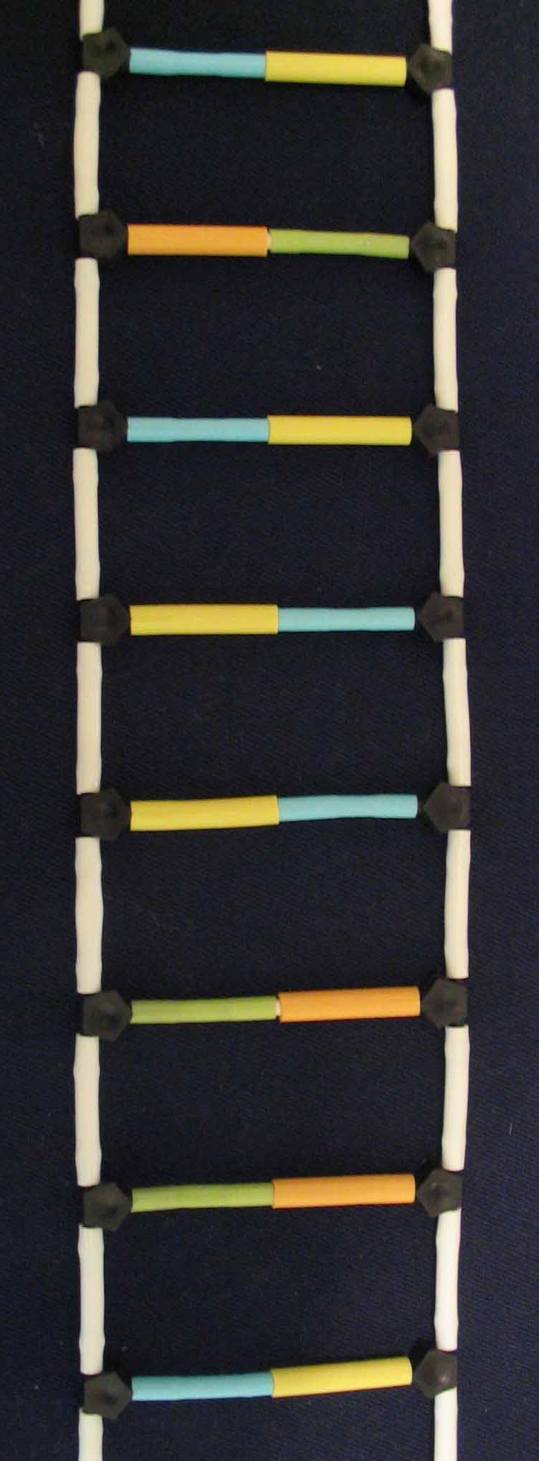

Procedure A: We shall represent each base by a color coded plastic tube as follows:
Materials  - 30 pieces of :  - green tube  - yellow tube  - blue tube  - orange tube  - 3 pieces of white tube  - blank linkage  - white rod  - scissors | Color coded | Bases | Structure
 | Blue tube | C (cytosine) | 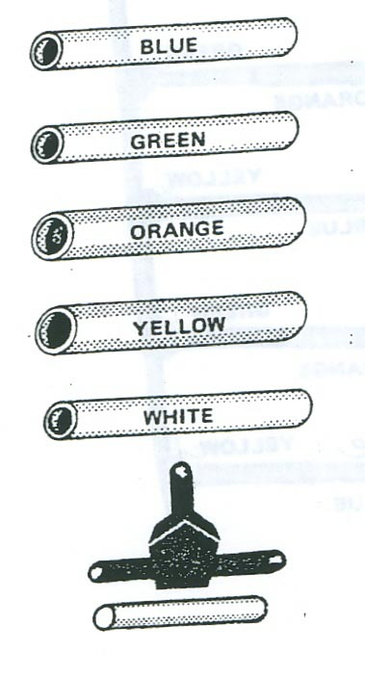
 | Green tube | T (thymine)
 | Orange tube | A (adenine)
 | Yellow tube | G (guanine)
 | White tube | Phosphate group
 | Black linkage | Sugar
 | White rod | Hydrogen bond  (links nitrogen bases)

Procedure B

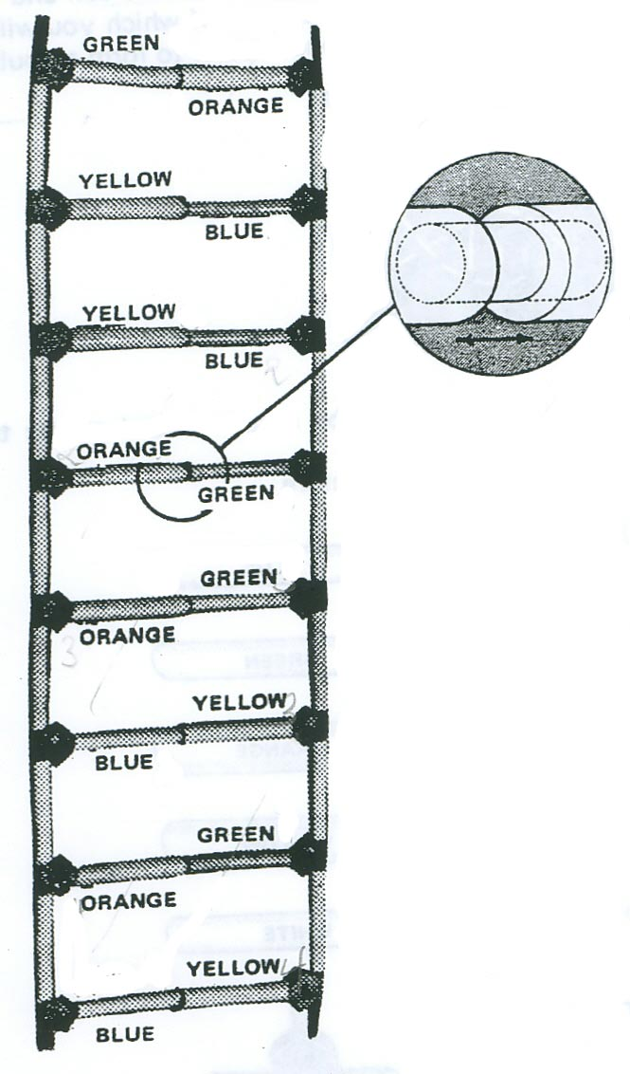
- Assemble the parts to make this DNA ladder:

- When your DNA “Ladder” is completed, twist it into the helix shape. This is the shape that DNA has in real life.
White rod represents hydrogen bond which links the nitrogen bases

Write in the names of the bases in your DNA LADDER ( A, T, G, C )
Fill in the missing names:
Model | DNA
Yellow tube
Green tube
 | C
Orange tube
Blank linkage
 | phosphate

The model of DNA on the left is ready to be copied. The copies on the right labeled 1-3 show the resulting molecules as drawn by several students.

DNA to be copied
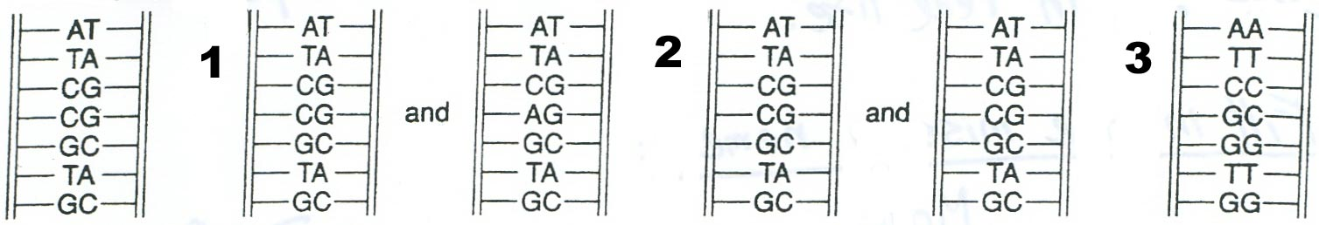

- Explain why number 1 is incorrect:

- Explain why number 2 is correct:

- Explain why number 3 is incorrect:

- How does the genetic message compare in the original cell and the two new cells that form after the cell reproduces?

