Everything you need to know about Genetics!!

DNA
- Stands for Deoxyribose Nucleic Acid
- Gives instructions for the cell to make proteins
- Determines what traits an organism has
Location
Cell → Nucleus → Chromosomes → Genes → DNA
(larger) (smaller)
Gene-Chromosome Theory
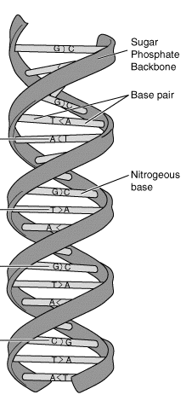
A gene has one piece of information that can determine a trait. More than one gene can control if a trait is expressed. There are many genes on each chromosome.
Structure
- Subunits (building blocks) called nucleotides
- Sugar-phosphate backbones
- Nitrogenous bases (A, T, C, G)
- Two backbones with bases paired in the middle
- A-T and C-G
- Strands are “complementary” to each other (A with T, C with G)
- Double helix (like a spiral staircase)
- The sequence of bases determines what each DNA strand “says”
- Ex: DNA strand ATCGTATCCC
Complementary strand TAGCATAGGG
Replication
- DNA copies itself during cell division (both mitosis and meiosis)
- Step 1 : DNA unzips – double strand becomes two single strands with bases out in the open
- Step 2: New subunits of DNA are attached to each old strand. Old strand acts as a template and a new complementary strand forms from it. A goes with T, C goes with G.
- Replication results in two double strands. Each is half old, half new.
Protein Synthesis
- DNA codes instructions to make proteins.
- First, the instructions from DNA are put into a new molecule called RNA.
- Then, RNA brings the instructions outside the nucleus, to the ribosomes where proteins are made from their subunits (amino acids).
- A codon is three bases that “code” for one amino acid.
- An example is given below.

DNA Sequence: CAAACCTTATACGGGGGTACG

DNA Sequence broken into codons: CAA ACC TTA TAC GGG GGT ACG

Amino Acid sequence:
(based on chart below)
Valine-Tryptophan-Asparagine-Methionine-Proline-Proline-Cysteine

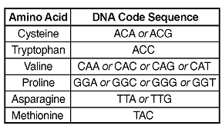
Mutations
- A random change in DNA
- If DNA changes, then a protein will be changed
- Happen during DNA replication – a mistake during copying!
- If it happens during mitosis in a body cell – individual body cell changes. Usually not very serious, except if the mutation is cancer
- If it happens during meiosis – a sex cell is changed. The mutation will then be passed down to offspring and every cell in the offspring will have the mutation!!
- Types of mutations:
  - Insertion – a base gets added; entire protein is changed
  - Deletion - a base gets deleted; entire protein is changed
  - Substitution – one base is swapped for another; protein may be changed
- Causes of mutations
  - Random act of nature
  - Mutagens: X-rays, UV rays (sunlight), Radioactive materials, some chemicals, some drugs (alcohol, LSD, marijuana)
Genetic Diseases
- Inheritable diseases that are passed down from parent to offspring
- Not all diseases are always expressed; expressed when both parents have given the mutated gene to the child, or when one parent gave the mutated gene and the disease is dominant
- PKU – a mutation that effects an enzyme in the liver; body cannot break down proteins correctly; results in mental retardation if not treated. Can be diagnosed by a blood or urine test
- Sickle Cell Anemia – a mutation that effects hemoglobin – a protein in red blood cells that carries oxygen; results in red blood cells that are rigid and crescent shaped, which cannot carry oxygen as well and get stuck in blood vessels. Most common in people of African descent. Having one sickle trait gene is beneficial in Africa because it causes resistance to Malaria. Can be diagnosed by a blood test
- Down Syndrome – a disease in which there is an extra copy of chromosome 21; results in distinct facial features, mental retardation and shorter life expectancy. Diagnosed by karyotype – a process that gives a visual of all the chromosomes present in an organism.
Genetic Engineering
- DNA can be extracted (taken out) of cells by a simple chemical process
- DNA can be cut into smaller pieces at specific base sequences using restriction enzymes
- DNA pieces can be separated by size using gel electrophoresis. Identical sequences of DNA will separate identically. This process is used to match DNA from a crime scene to a suspect, or for a paternity test.
- A small amount of DNA can be copied by a process called PCR. This allows scientists to use the DNA for the other genetic engineering procedures.
- Two pieces of DNA from different cells can be put together. This is called recombinant DNA.
- DNA from one cell can be put into another cell. This process, called transformation, allows scientists to use bacteria cells to produce other proteins. For example, human insulin is made by putting the gene for human insulin into a bacteria cell and letting the bacteria cells reproduce and produce human insulin. The insulin can then be used by diabetes patients.
- Scientists can clone cells and organisms by putting the DNA of one organism into an empty egg cell from another organism. The egg cell is allowed to divide and then placed into the uterus of a “foster mother” where it develops into a new offspring. Clones have identical DNA sequences.
- Selective breeding is when organisms with desired traits are chosen to breed in order to produce offspring with those desire traits. For example, a plant that produces good tomatoes may be bred with a plant that produces natural insecticide. The offspring will then be plants that produce good tomatoes AND natural insecticide.

