Name: ___________________________________ Period: ________

Directions: Use the 6 Rules of Graphing to correctly complete the following questions at each station.

Station 1 (Rule #1)
- Give each graph an appropriate title. Remember to use the form from our rules.

- _________________________________________________________________

- _________________________________________________________________

Station 2 (Rules #2 & 3)
- For each description, determine what should go on the x-axis and what should go on the y-axis for a graph. Then, give each axis a label that includes the units.

  - X-axis: __________________________ Y-axis:________________________

  - X-axis: __________________________ Y-axis:________________________

Station 3 (Rule #4)
- Using the data tables given, make a scale for each axis on each graph. (Do NOT plot any points).

Station 4 (Rules #5 & 6)
- Using the data tables and the scales given below, plot the points and circle them. Then connect your points with a line.

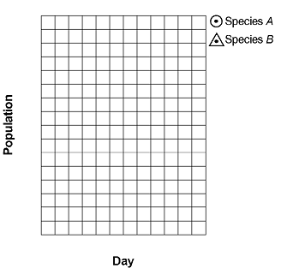
0 1 2 3 4 5
64

56

48

40

32

24

16
8

0

Name: ____________________________ Period: __________

Directions: Using the information below and the 6 Rules of graphing, make a COMPLETE graph.

A student added two species of single-celled organisms,
Paramecium caudatum and Didinium nasutum, to the same culture
medium. Each day, the number of individuals of each species was
determined and recorded. The results are shown in the data table
below.

