Station 1

1. A student performed a laboratory investigation to determine the effect of temperature on the heart rate of Daphnia (water flea). The following temperatures and heart rates were recorded:

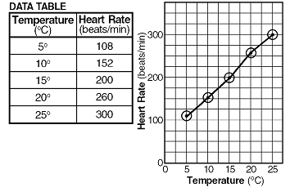
20DC -- 260 beats/min;
10DC -- 152 beats/min;
25DC -- 300 beats/min;
5DC -- 108 beats/min;
15DC -- 200 beats/min

2. A student studied the effect of gibberellin (a plant hormone) on the growth of corn seedlings of the same height and species. A different concentration of gibberellin in a fixed volume of water was applied to 7 groups of 10 plants each maintained under the same environmental conditions for the duration of the experiment. At the end of this period, the height of each plant was measured. The data are shown in the graph below.
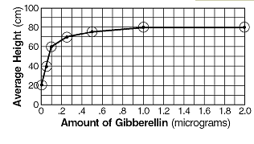

Station 2

- The rate of respiration of a freshwater sunfish was determined at different temperatures. The rate of respiration was determined by counting the number of times the gill covers of the fish opened and closed during 1-minute intervals at the various temperatures. The following data were collected and recorded in the table below.
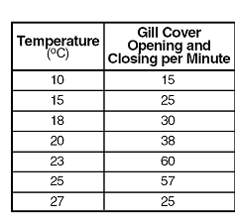

- A biology student performed an experiment to determine which of two species of single-celled organisms would survive best when cultured together in a certain environment. The student placed 10 organisms of each species into a large test tube. Throughout the experiment, the test tube was maintained at 30DC. After the test tube was set up, the population of each species was determined each day for 5 days. The data collected are shown in the table below.
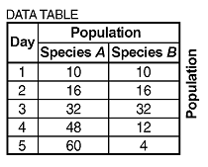

Station 3

- A class poll was taken to see the effect of studying on exam scores. Each student reported how many minutes they studied for an exam. The results are shown in the table below.

Time (minutes) Spent Studying | Exam Score (percent)
0 | 35
5 | 43
15 | 60
30 | 72
45 | 87
60 | 93
90 | 98

2. The effect of temperature on the action of pepsin, a protein-digesting enzyme present in stomach fluid, was tested. In this investigation, 20 milliliters of stomach fluid and 10 grams of protein were placed in each of five test tubes. The tubes were then kept at different temperatures. After 24 hours, the contents of each tube were tested to determine the amount of protein that had been digested. The results are shown in the table below.

Station 4

A biology student performed an experiment to determine which of two species of single-celled organisms would survive best when cultured (grown) together in a certain environment. The student placed 10 organisms of each species into a large test tube. Throughout the experiment the test tube was maintained at 30° C. After the test tube was set up the population of each species was determined each day for 5 days. The data collected are shown in the table below.

Plot the data for species A. Circle your points and connect those points with a line.
Plot the data for species B. Draw a triangle around the points and connect those points with a line.


