Part A
Answer all questions in this part.
Directions (1–30): For each statement or question, write on the separate answer sheet the number of the word or expression that, of those given, best completes the statement or answers the question. Some questions may require the use of the Reference Tables for Physical Setting/Chemistry.
For each question, eliminate the answer choices you think are incorrect and include a brief reason why you eliminated that choice.

1 Which list consists of elements that have the most similar chemical properties?

(1) Mg, Al, and Si (3) K, Al, and Ni
(2) Mg, Ca, and Ba (4) K, Ca, and Ga

2 Which type of bonding is found in all molecular substances?

(1) covalent bonding (3) ionic bonding
(2)hydrogen bonding (4)metallic bonding

3 A sample of oxygen gas is sealed in container X. A sample of hydrogen gas is sealed in container Z. Both samples have the same volume, temperature, and pressure. Which statement is true?

(1) Container X contains more gas molecules than container Z.
(2) Container X contains fewer gas molecules than container Z.
(3) Containers X and Z both contain the same number of gas molecules.
(4) Containers X and Z both contain the same mass of gas.

4 Given the reaction system in a closed container at equilibrium and at a temperature of 298 K:
N2O4(g) 2NO2(g)
The measurable quantities of the gases at equilibrium must be

(1) decreasing (3) equal
(2) increasing (4) constant

5 What is the total number of moles of NaCl(s) needed to make 3.0 liters of a 2.0 M NaCl solution?

(1) 1.0 mol (3) 6.0 mol
(2) 0.70 mol (4) 8.0 mol

6 Which subatomic particle has a negative charge?

(1) proton (3) neutron
(2) electron (4) positron

Part B
Answer all questions in this part.
Directions (7-13): Record your answers in the spaces provided in your answer booklet. Some questions may require the use of the Reference Tables for Physical Setting/Chemistry.

Base your answer to questions 7 through 8 on the potential energy diagram below.
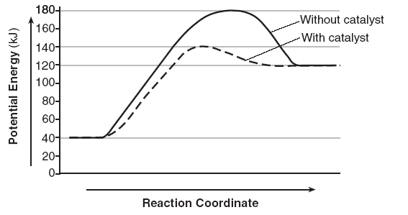

- Is this diagram and endothermic or exothermic reaction? Support your answer with information from the diagram.

8. Explain, in terms of the function of a catalyst, why the curves on the potential energy diagram for the catalyzed and uncatalyzed reactions are different.

9 A sample of oxygen gas in one container has a volume of 20.0 milliliters at 297 K and
101.3 kPa. The entire sample is transferred to another container where the temperature is 283 K and the pressure is 94.6 kPa. In the space below, show a correct numerical setup for calculating the new volume of this sample of oxygen gas. (Hint, just like converting to STP, only now you are converting to 283K and 94.6 kPa)

- In the space below, draw a Lewis electron-dot diagram for a molecule of phosphorus trichloride, PCl3.

Base your answers to questions 11 through 13 on the information below.

The decomposition of sodium azide, NaN3(s), is used to inflate airbags. On impact, the NaN3(s) is ignited by an electrical spark, producing N2(g) and Na(s). The N2(g) inflates the airbag.

11 Write and balance the equation below, using the smallest whole-number coefficients. (If you are having a hard time writing the equation, raise your hand and I will give it to you for 2 points.)

12 What is the total number of moles present in a 52.0-gram sample of NaN3(s) (gram formula mass = 65.0 gram/mole)?

13 An inflated airbag has a volume of 5.00 . 104 cm3 at STP. The density of N2(g) at STP
is 0.00125 g/cm3. What is the total number of grams of N2(g) in the airbag?

