SAMPLE DIFFERENTIATED WRITING LESSON PLAN

Each Wednesday my entire grade (3rd grade) would meet and discuss our unit plans and any issues that may have come up. During one November planning session we sat together and brainstormed how we could complete the how-to/functional writing piece before Christmas break. This was the general education schedule that I had to work with and differentiate in order for my students to be able to participate in the grade publishing party celebration. On the following page you will find a sample differentiated lesson, which includes each child’s IEP goals for the lesson as well. The lesson I have included from this unit should give you a better sense of how I used this schedule to help guide me.
~Julie Rafal, NYC ’04 Corps Member

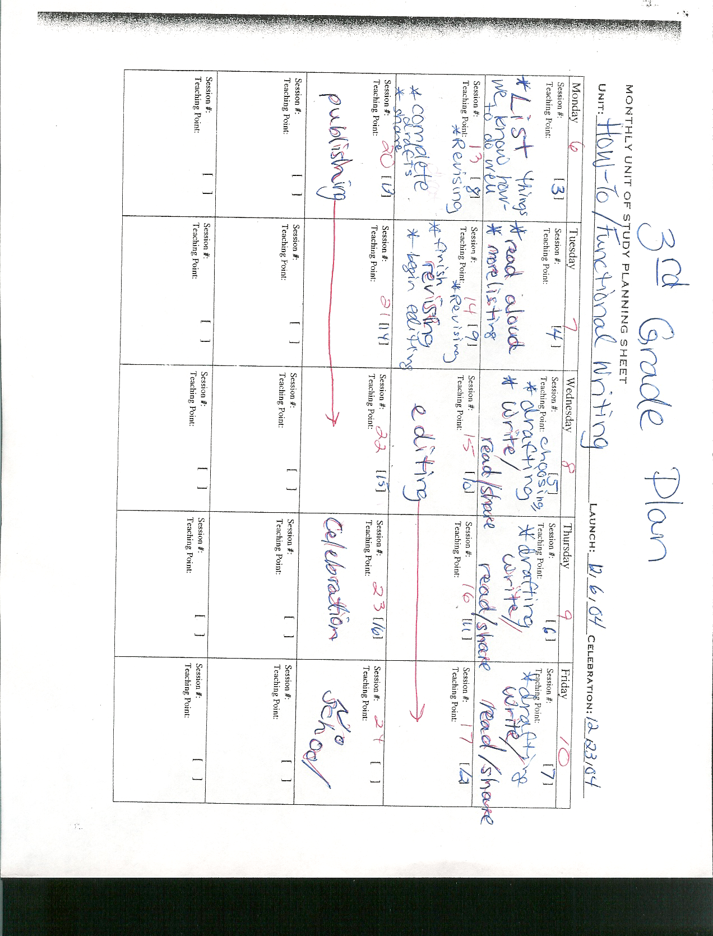
Ms. Rafal
Lesson Plan: Tuesday, December 7, 2004

Writing: Session 3 and 4

Aim: What are some of the steps involved in choosing, sequencing, and explaining a how-to topic?

Objective: The students will be able to use their brainstormed lists of how-to topics to explain and plan the necessary steps for how-to make/do at least three of those items.

Do Now: Students will be asked to take no more than five minutes to list in sequential order the steps that are involved in getting to school in the morning.

Motivation: The students will listen to the brief story of Henry M. (H.M.) and his life suffering from anterograde amnesia. They will then try and come up with at least one modern day invention that they could write down to explain to Henry the steps for using. As a class, we will talk about all the steps involved in using the invention. We will also discuss what it feels like to not know how to do something that everyone else knows how to do and why directions are helpful.

Procedure or Transition: The students will need their writing notebooks, graphic organizers about the how-to essay, and pencils. The students will also need to have prior knowledge as to what they feel they know how to do as well as what time-order words are for sequencing events. The students will be given the assignment to choose at least three items from their brainstormed lists of things they know how-to do, and to complete a sequencing graphic organizer for each one. The graphic organizer will help lay out for the student what their topic is, what materials are needed, and what each step is. Before beginning this, the students will review time-order words for sequencing the steps.

Pivotal Questions:
- If someone was writing you directions for how-to do things, what words would you want them to use to explain it best to you? How do transitional words help us with instructions, words such as first, next, after, that, and finally?
- Do you believe someone should write instructions for how-to do something if they are not a master in it? Why or why not? What might happen if someone who was not familiar with how-to fly a plane tried to write instructions for writing a plane?
- Can you design a way for Henry to learn how to do something from your brainstormed list? How do you know which you should choose?
- After talking with your partner, what questions would you want to ask of them about their how-to graphic organizer? Did it make sense? Were you able to picture each step-by-step instruction or did the person need more details? Did the person appear to be a master at what they were writing about?

Evaluation/Summary: I will be evaluating what my students have learned from this lesson by their graphic organizers, the classroom discussions and their understandings of the how-to concept, and their ability to begin incorporating transitional sequencing words into our discussions and their work. The lesson will be differentiated in the following ways (1st indent) and IEP goals that need to be met are listed (2nd paragraph):
  - For Joseph, Izahia, Orosmar, Jocelyn, Louis, James, Ernest, Malcolm, and Terrance: They will be given separate graphic organizers that have additional lines for each step. These organizers must include time order words, transitional words, at least 3 word wall words, and proper punctuation. They will be required to complete more than one graphic organizer and to pair up as they finish looking over one another’s organizers and determining if they feel they could follow the directions. Partners will be given drawing paper and crayons to illustrate the steps their partner has described in their organizer.
    - Jocelyn: Will use correct margins, headings and punctuation in her daily written work with 80% accuracy.
    - James: Will use self-editing techniques to edit his own work for mistakes in spelling, punctuation, grammar, and capitalization with 80%accuracy.
    - Malcolm: Will use correct punctuation, capitalization, and grammar with 80% accuracy.
  - For Orlando, Tony, Natasha, Adonis, Brian F.: These students will work in a small group with Mrs. Green in order to receive extra attention and to ensure they stay on track at this point. They will be given the graphic organizer with fewer sentences and with boxes to illustrate each step as well. The students are not required to have perfect spelling, but they must have correct capitalization and periods at the end of their sentences. They will take turns reading their organizers to the group once they finish. The group will use drawing paper and crayons/colored pencils to illustrate the steps the person is describing in their organizer.
    - Brian F.: Will create at least 10 original sentences using known words with 85% accuracy as measured by teacher tests and student portfolio.
    - Orlando: Will write at least 5 descriptive sentences using correct capitalization, punctuation, and grammar, with 80% accuracy.
  - For Victor, Brian M., Stanley, Nataly: These students will work with Mrs. Albritton in order to receive extra attention to bring them up to the same track as the other students who were not absent yesterday. They will be working on listing at least 10 things they know how-to do well (well enough to be experts). They will choose one of these to fill out the graphic organizer with. They will receive the graphic organizer that has pictures for each step with only one sentence line under each picture and a checklist to remind them that their sentences must be complete and should have a capital letter to start the sentence and a period to finish it. Their goal is to be detailed in their list and pictures.
    - Brian M.: Will be able to (with teacher assistance) dictate a sentence about experiences, stories, people, objects, or events 9 out of 10 times as measured by teacher observations and assessments.
    - Nataly: Will capitalize first letter of names, proper nouns, first words in sentences, and the word “I” with 85% accuracy.
  - For Anthony, Raymi, Kevin, Elvis: These students will be working with me today. We will focus on using descriptive words and time-order words when filling out our organizers. We will be working on the topic we chose last time we met (how-to make French toast) and begin to chart our graphic organizer for this topic as a group. Once we finish, the students will work on their own organizers. All 3 of these students need to be watched carefully to make sure they stay on task and do not begin writing about something completely random. Repeat modeling as a group if they are off again.
    - Elvis: Will sequence sentences and use transitions between sentences and paragraphs with 80% accuracy.
    - Anthony: Will use complete sentences containing subjects and predicates and correct word order 8 out of 10 times as measured by teacher assessments.
    - Kevin: Will write complete sentences that include descriptive words with 85% accuracy.

Follow-up: I will follow up this lesson on Thursday by building on the use of the graphic organizer. I will continue to use the students’ organizers to have them add more details, work with partners to receive peer feedback, and to then choose one piece that they will focus on for drafting on Friday. I will also ask the students to fill out an exit slip before they leave at the end of the day about the lesson. The exit slip will ask the students what they enjoyed the most about the writing activity? What was the most difficult aspect of the writing activity for them? What are some time-order/transitional words they know how to use now? What would they like to learn how-to do?
