Special Education Student Tracking Form

Teacher: ___________________

Name | OSIS | Annual Review Date | Type 1, 2, or 3 | Triennial Date | Testing Mods | Counseling | Speech | OT | PT | ESL | Mainstream

Special Education Student Tracking Form

Teacher: ________Ms. Rafal___________

Name | OSIS | Annual Review Date | Type 1, 2, or 3 | Triennial Date | Testing Mods | Counseling | Speech | OT | PT | ESL | Mainstream
Nataly R. | XXX-XXX-XXXX | 2/16/05 | 2 | None | 1 ½ time, separate location | 2x a week, 30 minutes each session | 1x a week, 30 minutes | No | No | No | No
Brian M. | XXX-XXX-XXXX | 6/17/05 | 2 | None | 1 ½ time, separate location, questions read aloud |  | 1x a week, 30 minutes | 1x a week, 30 minutes | 1x a week, 30 minutes | No | No
Orlando C. | XXX-XXX-XXXX | 3/1/05 | 1 | None | 1 ½ time, separate location |  |  | No | No | No | No
Anthony R. | XXX-XXX-XXXX | 6/1/05 | 2 | None | 1 ½ time | 2x a week, 30 minutes each session |  | No | No | 1x a week 50 minutes | No
Brian F. | XXX-XXX-XXXX | 6/1/05 | 1 | None | 1 ½ time |  |  | No | No | No | No
Jocelyn S. | XXX-XXX-XXXX | 2/2/05 | 1 | None | 1 ½ time, questions read aloud | 2x a week, 30 minutes each session | 1x a week, 30 minutes | No | No | No | No
Elvis V. | XXX-XXX-XXXX | 3/15/05 | 1 | None | 1 ½ time |  |  | No | No | No | No
James M. | XXX-XXX-XXXX | none | 2 | 9/20/04 | 1 ½ time, separate location | 2x a week, 30 minutes each session | 1x a week, 30 minutes | No | No | 1x a week, 50 minutes | No
Kevin | XXX-XXX-XXXX | 6/15/05 | 1 | None | 1 ½ time |  |  | No | No | No | No

This is a sample of how I would take the information from above and chart it onto a monthly and weekly calendar so that I always knew which students would be out receiving services each day. This would also help me to plan my mini-lessons and centers for that week based on when students would be in/out of the room.
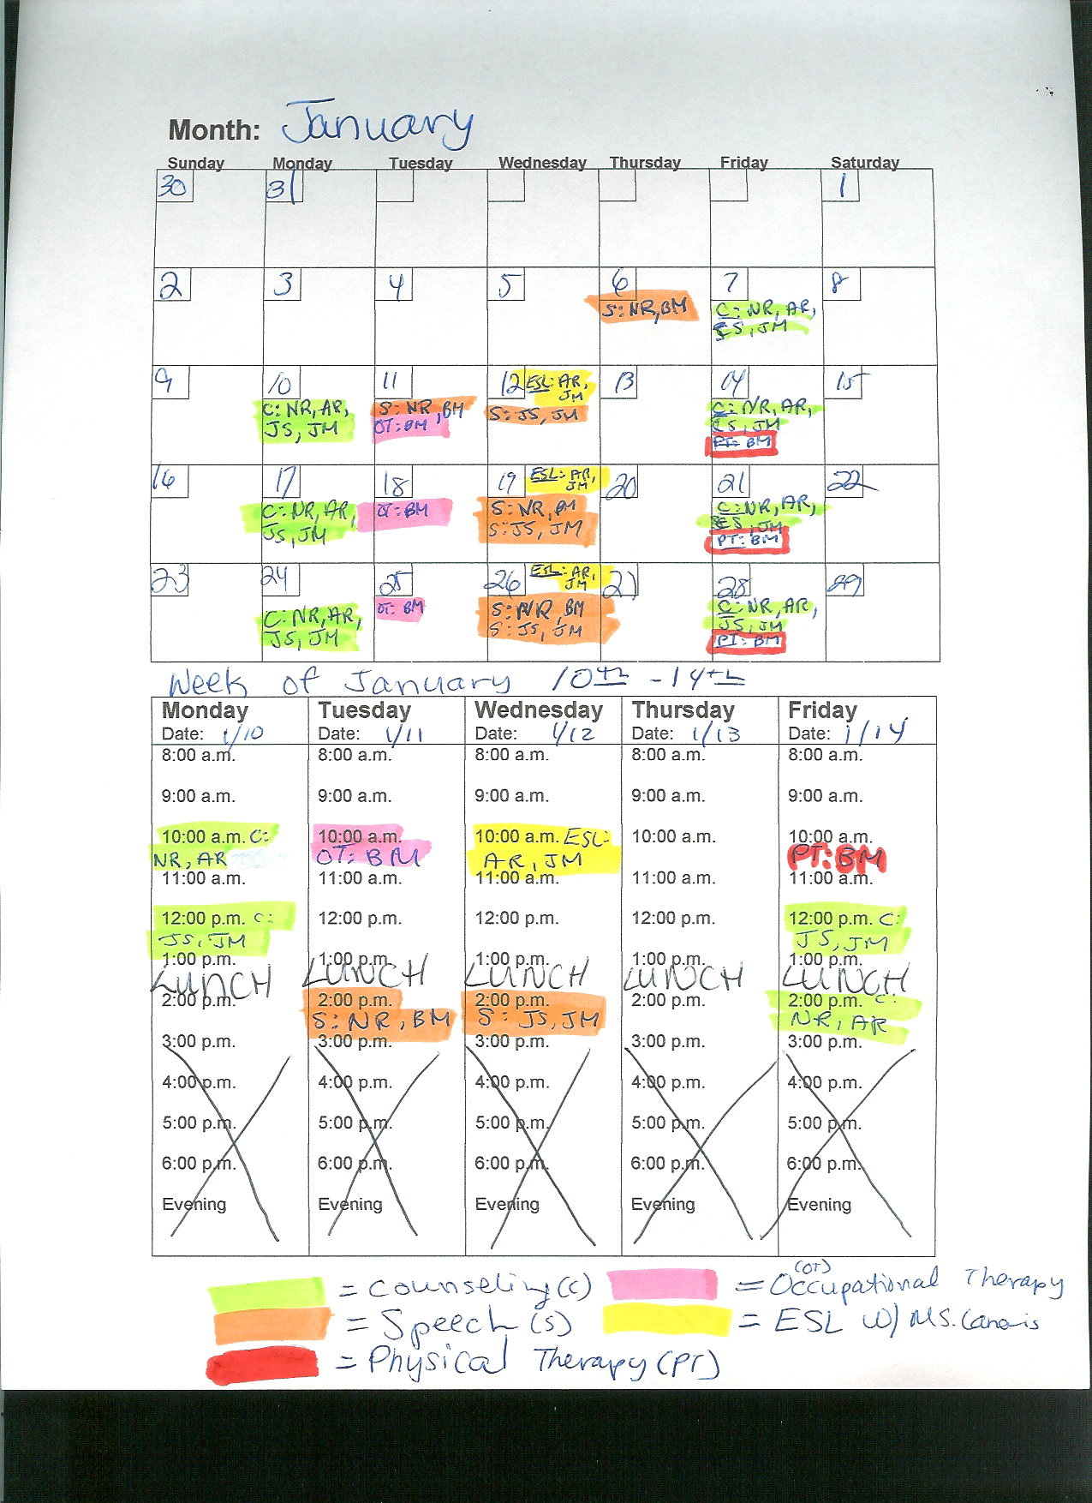
Month:
Monday  Date: | Tuesday  Date: | Wednesday  Date: | Thursday  Date: | Friday  Date:
8:00 a.m.  9:00 a.m.  10:00 a.m.  11:00 a.m.  12:00 p.m.  1:00 p.m.  2:00 p.m.  3:00 p.m.  4:00 p.m.  5:00 p.m.  6:00 p.m.  Evening | 8:00 a.m.  9:00 a.m.  10:00 a.m.  11:00 a.m.  12:00 p.m.  1:00 p.m.  2:00 p.m.  3:00 p.m.  4:00 p.m.  5:00 p.m.  6:00 p.m.  Evening | 8:00 a.m.  9:00 a.m.  10:00 a.m.  11:00 a.m.  12:00 p.m.  1:00 p.m.  2:00 p.m.  3:00 p.m.  4:00 p.m.  5:00 p.m.  6:00 p.m.  Evening | 8:00 a.m.  9:00 a.m.  10:00 a.m.  11:00 a.m.  12:00 p.m.  1:00 p.m.  2:00 p.m.  3:00 p.m.  4:00 p.m.  5:00 p.m.  6:00 p.m.  Evening | 8:00 a.m.  9:00 a.m.  10:00 a.m.  11:00 a.m.  12:00 p.m.  1:00 p.m.  2:00 p.m.  3:00 p.m.  4:00 p.m.  5:00 p.m.  6:00 p.m.  Evening

