Tracking and Assessment in Special Education
Tracking is arguably the most important part of your job as a teacher, and it is the only way you will know if you have achieved significant gains with your students.
It does not matter if you are a general education teacher, a special education teacher, an inclusion teacher, a resource room teacher, or a cluster teacher you will still be using some form of a tracking system. If a student has an IEP then they will need to have daily tracking logs kept to be sure they are meeting the goals of their IEP. The data you collect will help you to choose appropriate interventions for your students and to make changes in your instruction. Therefore, the ongoing assessment of your students is truly essential to the instructional process and for looking at progress in an objective way.

~ Julie Rafal, NYC ’04 Corps Member
This is an example of a daily IEP objective tracking sheet that I used in my classroom this year. Each student had their own data sheet and each day during centers they would work on their IEP goals with my paraprofessional or me. This information would then be used in three different ways. The first way would be as a means for me to quickly determine whether or not my student was making progress, and if they were not I would then modify my plans and instructional approaches accordingly. The second way would be for me to have a record of any progress and/or trends that occurred over a given month. The final way I would use this data would be as documentation that I could bring to my students annual or tri-annual reviews. I have included one of my student’s actual tracking sheets from this year on the next two pages.

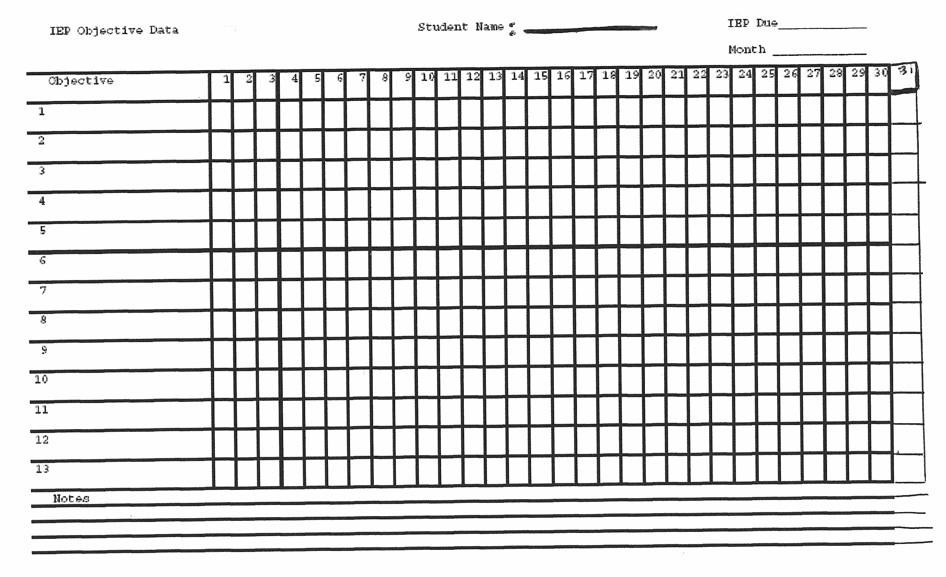

Key: (F) Full Assistance (VP) Visual Prompt (I) Independent
(SA) Some Assistance (VR) Verbal Prompt (A) Attempts
(RA) Refused to Attempt
Here is what a tracking sheet looked like for one of my students this year.
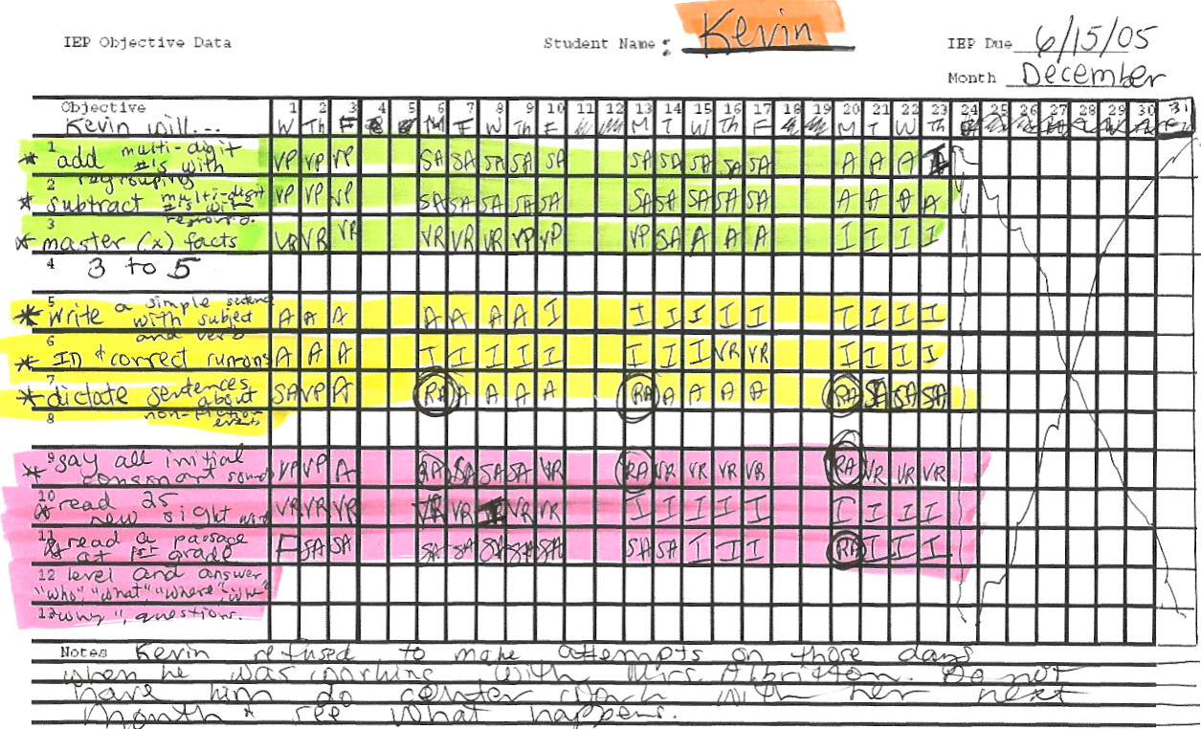
This is what a weekly tracking sheet looked like for Kevin’s IEP goal of, “Kevin will be able to read 25 new sight words with 80% accuracy.”
Name: Kevin Goal: Will read 25 new sight words. Month(s): December/January
 | 12/3 | 12/10 | 12/17 | 12/23 | Off | Off | 1/13 | 1/20 | 1/27
Big | 1p | 1p | 1p | 1p |  |  | 1 | 1 | 1
With | 1p | 1p | 1p | 1p |  |  | 1 | 1 | 1
Apple | 1p | 1p | 1p | 1p |  |  | 1 | 1 | 1
Spoon | 0 | 1p | 0 | 1p |  |  | 1 | 1 | 1
My | 0 | 1p | 1p | 1p |  |  | 1 | 1 | 1
Pencil | 1p | 0 | 0 | 1p |  |  | 1p | 1p | 1p
Red | 0 | 0 | 0 | 0 |  |  | 1 | 1 | 1
Banana | 1p | 1p | 1p | 1p |  |  | 1p | 1 | 1
Cow | 0 | 1p | 1p | 1p |  |  | 1 | 1 | 1
Find | 0 | 0 | 0 | 0 |  |  | 1p | 1p | 1
Egg | 1p | 0 | 0 | 0 |  |  | 1p | 1p | 1p
Water | 1p | 0 | 1p | 1 |  |  | 1p | 1 | 1
Blue | 1p | 1p | 1 | 1 |  |  | 1p | 1 | 1
Go | 0 | 0 | 0 | 1p |  |  | 1p | 1 | 1
Candy | 1 | 1p | 1p | 1 |  |  | 1 | 1 | 1p
Mother | 0 | 0 | 0 | 1p |  |  | 1 | 1 | 1
Has | 1p | 1p | 1p | 1p |  |  | 1p | 1p | 1p
Chicken | 1 | 1 | 1 | 1 |  |  | 1 | 1 | 1
Yellow | 1p | 1p | 1 | 1 |  |  | 1 | 1 | 1
Airplane | 1 | 1 | 1 | 1 |  |  | 1 | 1 | 1
Horse | 1p | 1p | 1p | 1p |  |  | 1 | 1 | 1
Fish | 1p | 1 | 1 | 1 |  |  | 1 | 1 | 1
Box | 1p | 1p | 1 | 1 |  |  | 1 | 1 | 1
Green | 1 | 1p | 1p | 1p |  |  | 1 | 1 | 1
Put | 1p | 1p | 1p | 1p |  |  | 1 | 1p | 1
P= prompt
0= incorrect 1= correct

