School: Name:
Class: Date:

Ecology Assessment

Part 1: Fill in the Blank
Directions: Use the words below to fill in the blanks.

Population Community Ecosystem Pollutants Balance Energy

1. All organisms need _________________________________________________________________ to survive.

2. All individuals of the same species found together at a given time and place is a(n)________________________.

3. All populations living in one place form a(n)______________________________________________________.

4. The community along with the physical factors such as sun, soil, and water compose a(n) __________________.

5. In ecosystems, the interactions between community members and their environment produce _______________.

6. Substances that are harmful to organisms are called ________________________________________________.

Part 2: Multiple Choice
Directions: Read each question an then circle the correct answer

7. Which of the following is true?

- all organisms obtain nutrients in the same way
- the methods for obtaining nutrients vary among organisms
- organisms obtain nutrients in one of two ways, eating producers or eating consumers

8. If you had a pet that ate seeds and insects, what would you call it?

a. a carnivore b. an herbivore c. an omnivore d. a decomposer

9. Which of the following statements is a correct example of the way energy flows through an ecosystem?

- from the sun to the grass to rabbits to hawks
- from the sun to grass to hawks to rabbits
- from the sun to hawks to grass to rabbits
- from the grass to the sun to rabbits to hawks

For questions 10-12, use the food web to the right. 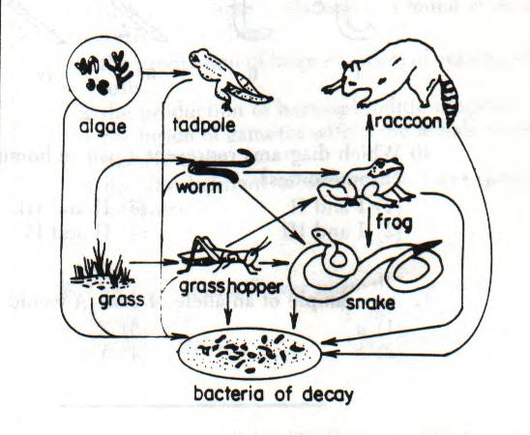

10. What organism represents a producer?

a. grasshopper b. bacteria c. frog d. grass

11. What organism represents a consumer?

a. Raccoon b. bacteria c. algae d. grass

12. What organism represents a decomposer?

a. worm b. bacteria c. frog d. grass

13. How do animals obtain the nitrogen they need to make proteins?

a. by breathing air b. by eating plants c. by drinking water d. by consuming minerals

14. What makes up the majority of Earth’s atmosphere?

a. water vapor b. oxygen c. carbon dioxide d. nitrogen

15. What is the process by which green plants produce their own food?

a. photosynthesis b. chlorophyll c. decomposers d. respiration

16. The major source of oxygen in the atmosphere is:

a. cellular respiration b. transpiration c. photosynthesis d. evaporation

17. What gas do plants take in during photosynthesis?

a. carbon dioxide b. oxygen c. nitrogen d. hydrogen

18. All consumers directly or indirectly gain energy from:

a. other consumers b. green plants c. omnivores d. herbivores

19. Which factor encourages the growth of a population?

a. a lack of resources b. predation c. disease d. many available resources

20. How would you describe the relationship between a predator and its prey?

a. both species benefit
b. one species benefits and the other is not affected
c. one species benefits and the other is harmed
d. neither species is affected

21. For which process are some plant-eating organisms dependent on microorganisms?

a. causing disease b. digesting food c. providing shelter d. producing water

22. A glacier moving through an area scrapes away all of the soil. As succession begins, which organisms are likely to be seen first?

a. mosses b. lichens c. bushes d. seedlings

23. Overpopulation by any species impacts the environment by:

a. increasing the amount of resources in an area
b. decreasing the amount of resources in an area
c. increasing the amount of shelter available
d. increasing the amount of energy available

24. Humans affect the environment by:

a. increasing the amount of pollution
b. increasing the rate of volcanic eruptions
c. decreasing global temperatures
d. decreasing the amount of pollution

25. The amount of pollution humans create increased after which time period?
a. the Renaissance b. the Dark ages c. the Jurassic Period d. the Industrial Revolution

