8th Grade
Assessment One:
(End of Unit Assessment)

- What were the five main causes of World War I?
______________________________________________________________________________________________________________________________________________________________________________
- Name at least two causes of the U.S. becoming involved in World War I.
______________________________________________________________________________________________________________________________________________________________________________
- Of the causes of U.S. involvement explain how one of the events you listed above led to the U.S. becoming involved in World War I.
________________________________________________________________________________________________________________________________________________________________________________________________________________________________________________________________________________________________________________________________________________________________________
- What is imperialism?
____________________________________________________________________________________________________________________________________________________________________________________
- Name the two sides fighting in World War I.
_________________________________________________________________________________________

Use the document to answer the questions below.

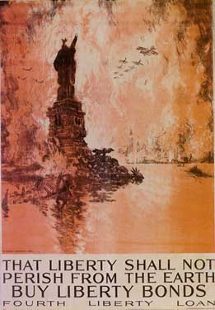

- Describe the picture above. What famous landmark is shown?
__________________________________________________________________________________________________________________________________________
- In what way is liberty being threatened?
__________________________________________________________________________________________________________________________________________
- What is this poster trying to convince people to do?
__________________________________________________________________________________________________________________________________________
Use the selection to answer the questions below.

“The nurse goes to get a man who understands Morse code. This man taps onto Joe's forehead the words "WHAT DO YOU WANT?" Joe spends some time thinking about the inappropriateness of the question and then tries to think about what in fact it is that he wants. Joe asks in Morse code to be taken around the outside world as an educational exhibit on the realities of war. The man listens to his response and returns a while later to tap into his head, "WHAT YOU ASK IS AGAINST REGULATIONS."

The man continues tapping other messages, but Joe is no longer paying attention. He is still trying to process this betrayal on the part of the people for whom he fought a war when he feels the hospital staff sedating him again. Joe taps the question "why? why? why?"—wondering why they will not let him talk or acknowledge that there is still a person inside his mangled body. Joe suddenly realizes that they are afraid to let him out, to let other men see him as the "new messiah of the battlefields." If other men see Joe, they would no longer agree to fight in wars—especially wars ordered by the upper classes, but fought only by the lower classes of peaceful, working men.”
- Johnny Got His Gun by Dalton Trumbo

- What does Joe want?
__________________________________________________________________________________________________________________________________________
- What does the doctor say to Joe’s request?
__________________________________________________________________________________________________________________________________________
- Why does Joe believe the doctor’s are denying his request?
__________________________________________________________________________________________________________________________________________
Use the picture to answer the questions below.

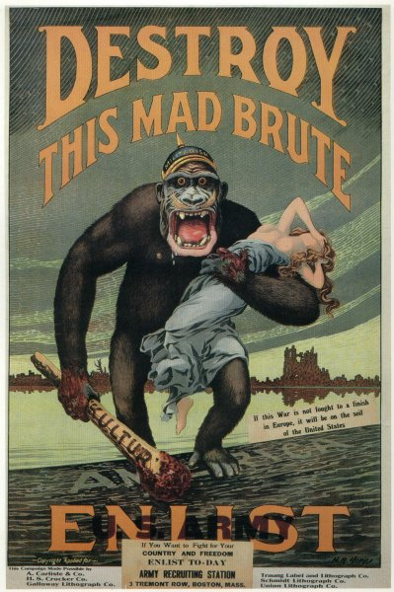

- Who does the gorilla represent?
__________________________________________________________________________________________________________________________________________
- Who does the girl represent?
__________________________________________________________________________________________________________________________________________
- What is this poster trying to convince people to do?
__________________________________________________________________________________________________________________________________________
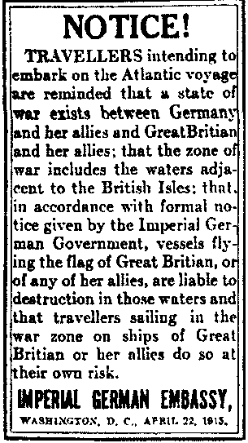

- Who is this notice addressed to?
____________________________________________________________________________________________________________________________________________________________________________________

- What is it alerting people to?
______________________________________________________________________________________________________________________________________________________________________________________________________________________________________________________________________________
- What important event that led to the U.S. becoming involved in World War I happened shortly after this notice was received?
______________________________________________________________________________________________________________________________________________________________________________________________________________________________________________________________________________
Use the picture to answer the questions below.

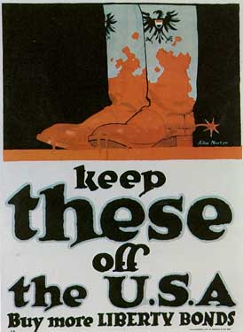

- Who do the boots belong to? How do you know?
__________________________________________________________________________________________________________________________________________
- What are the boots covered in? Whose is it?
__________________________________________________________________________________________________________________________________________
- How is this poster supposed to make someone feel?
__________________________________________________________________________________________________________________________________________
- What is this poster trying to convince people to do?
__________________________________________________________________________________________________________________________________________
Essay

Directions: Write a well-organized essay that includes an introduction, several paragraphs, and a conclusion.
Use evidence from at least four documents in the body of the essay. Support your response with relevant facts, examples, and details. Include additional related information.

Historical Context
World War I was fought from 1914 until 1918. The U.S. did not join the war until 1917. There are many reasons why the U.S. decided to participate in the war effort. Allied propaganda was one of the ways in which the U.S. government gained support from the American people for the war.

Task:
Using information from the documents and your knowledge of social studies, write
an essay in which you:

- Discuss at least two goals the U.S. government had in using propaganda. Was it necessary that the U.S. use propaganda? Why or why not?

4 | - Discusses, by mentioning at least two of the documents, the two goals of propaganda – support the war financially (liberty bonds), and enlisting  - State whether it was necessary that the U.S. use propaganda  - Use evidence from at least three of the documents to support your claim about the necessity of propaganda
3 | - Discusses, by mentioning at least two of the documents, the two goals of propaganda – supports the war financially (liberty bonds), and enlisting  - State whether it was necessary that the U.S. use propaganda  - Use evidence from less than three of the documents to support your claim about the necessity of propaganda
2 | - States, but does not discuss the two goals of propaganda – supports the war financially (liberty bonds), and enlisting  - State whether it was necessary that the U.S. use propaganda  - Use evidence from less than three of the documents to support your claim about the necessity of propaganda
1 | - States, but does not discuss the two goals of propaganda – supports the war financially (liberty bonds), and enlisting  - State whether it was necessary that the U.S. use propaganda  - Does not use evidence from any documents to support your claim about the necessity of propaganda

