8th Grade
Assessment One:
(This project will end the first mini-unit dealing with industry.)
The students are going to create a monopoly game. The game pieces will represent the key figures in early American industry. The spaces on the board should represent their industries and the resources they own to control those industries. The community chest and chance cards should be a mix of the positives and negatives of assembly lines and factory work. The games should include instructions. The instructions should include mini-biographies of the game pieces, making sure to explain how they relate to monopolies. The instructions should also explain the point of the game as a means of explaining how the game is played. When explaining the directions the students should use and define at least 5 vocabulary terms discussed throughout this unit.

Assessment Two:
(This DBQ/DBE exam, taken directly from the 2006 state exam, will end the second mini-unit dealing with immigration.)

The New York State Social Studies Exam 2006 can be found at this website:

http://www.nysedregents.org/testing/scostei/gr8bk2606.pdf

Assessment Three:
(This DBQ exam will end the third mini-unit dealing with reformers.)

- What are muckrakers?
______________________________________________________________________________________________________________________________________________________________________________________________________________________________________________________________________________
- Name at least two muckrakers we have discussed.
_______________________________________________
_______________________________________________
- Name at least one area muckrakers worked to change.
__________________________________________________________

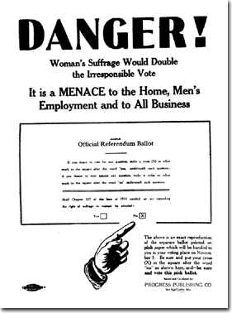

- What is women’s suffrage?
____________________________________________________________________________________________________________________________________________________________________________________
- According to the poster why is women’s suffrage a “danger?”
____________________________________________________________________________________________________________________________________________________________________________________

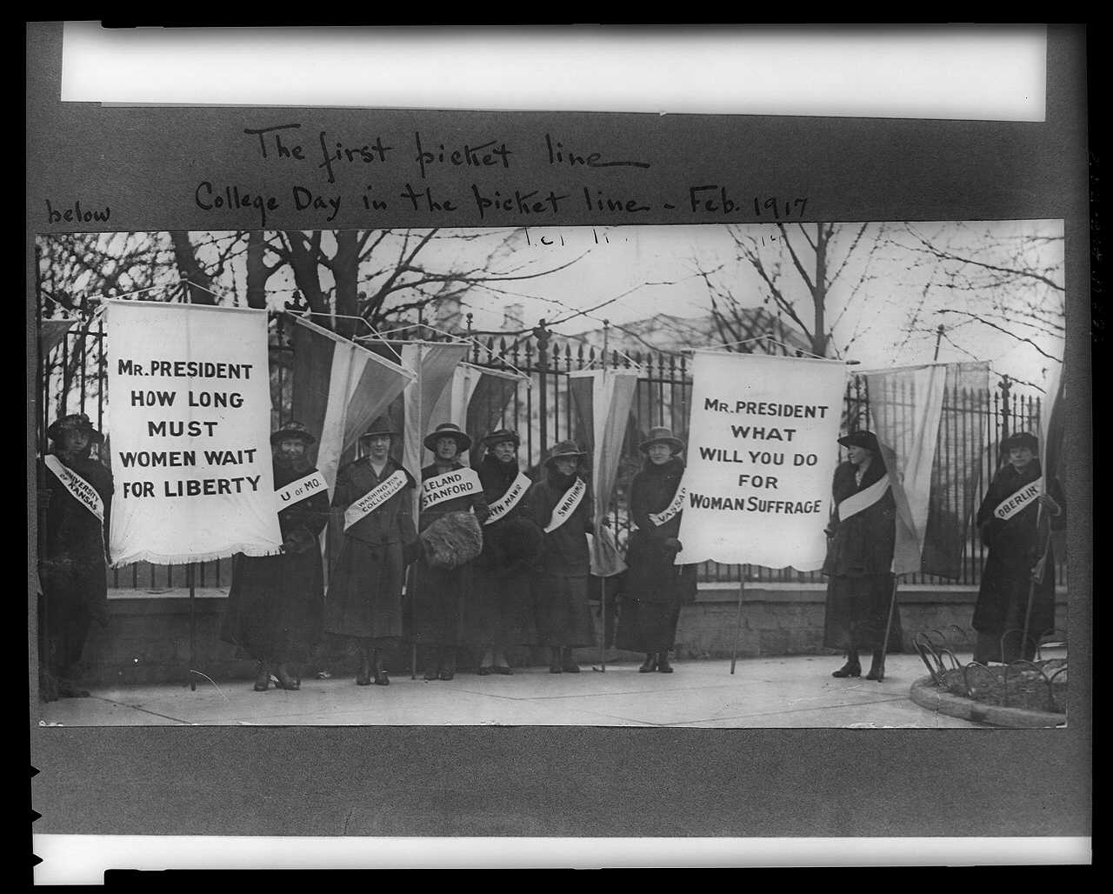

- What do these women want?
____________________________________________________________________________________________________________________________________________________________________________________
- What president are these women protesting?
_________________________________________________________________
- Name at least one suffragist we discussed in class.
_________________________________________________________________
- When did women get the right to vote?
__________________________________________________________________
- How did women get the right to vote?
____________________________________________________________________________________________________________________________________________________________________________________

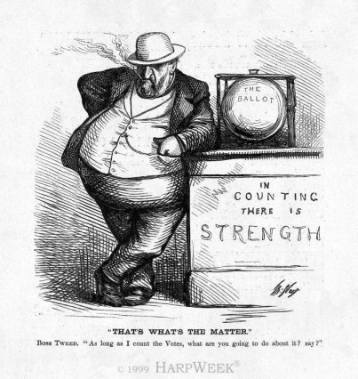
- Who is the man in Thomas Nast’s cartoon?
___________________________________________________________________
- What is there strength in counting?
___________________________________________________________________

- Who is counting it?
___________________________________________________________________
- Who has the strength?
___________________________________________________________________
- According to the title of the cartoon, “That’s What’s the Matter,” what’s the matter?
______________________________________________________________________________________________________________________________________________________________________________________________________________________________________________________________________________

