7th Grade
Assessment One:
(End of Unit Assessment)

- What is a conquistador?
______________________________________________________________________________________________________________________________________________________________________________________________________________________________________________________________________________
- What is the Columbian Exchange?
______________________________________________________________________________________________________________________________________________________________________________________________________________________________________________________________________________
- Name at least two reasons Europeans settled in the new world.
_______________________________________________________
_______________________________________________________
- Who controls the 13 colonies?
____________________________________________________________________________________________________________________________________________________________________________________
- What are the three colonial regions? What colonies are included in each region?
Region: Colonies:
_____________________ ____________________________________________________________
____________________________________________________________
_____________________ ____________________________________________________________
____________________________________________________________
_____________________ ____________________________________________________________
____________________________________________________________

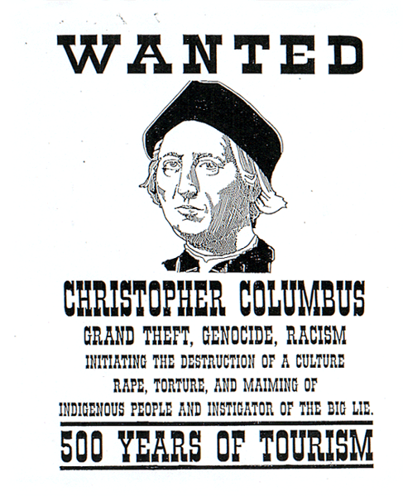
- What crimes is Christopher Columbus accused of committing?
______________________________________________________________________________________________________________________________________________________________________________________________________________________________________________________________________________
- Who did he commit these crimes against?
______________________________________________________________________________________________________________________________________________________________________________________________________________________________________________________________________________
- Why did Christopher Columbus commit these crimes? What did he gain?
______________________________________________________________________________________________________________________________________________________________________________________________________________________________________________________________________________

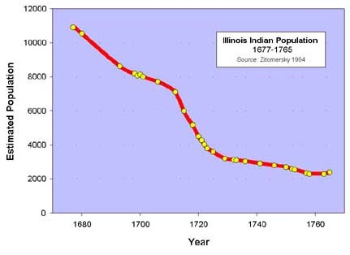

- Approximately how much did the population of the Illinois Indians decline from 1680 to 1760?
____________________________________________________________________________________________________________________________________________________________________________________
- Name two reasons for this rapid decline in the population of the Illinois Indians.
____________________________________________________________________________________________________________________________________________________________________________________

