Directions: Fill the appropriate choice on the answer form with a number 2 pencil. NH means that the correct answer is not among the choices presented.

1. How is two hundred six million, thirty-eight thousand, four written as a numeral?

A 26,038,400

B 206,038,004

C 206,038,400

D 206,380,004

2. How is the number 805,000 written in words?

A Eight hundred five

B Eight thousand, five hundred

C Eighty-five thousand

D Eight hundred five thousand

3. Which group lists the numbers in order from greatest to least?

A 3,608,702 3,086,702 3,068,702 3,068,072

B 3,068,072 3,068,702 3,086,702 3,608,702

C 3,608,702 3,086,702 3,068,072 3,068,702

D 3,086,702 3,608,702 3,068,702 3,068,072

4. Which number on the number line does point Q best represent?
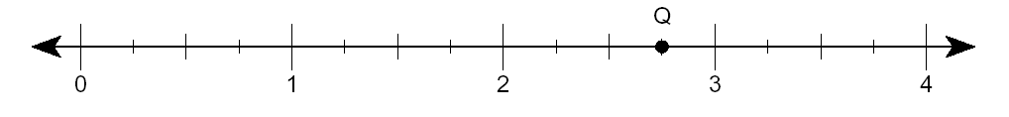
A $2\frac{1}{2}$ B $2\frac{3}{4}$ C $3\frac{1}{4}$ D $3\frac{1}{2}$

5. The models are shaded to show two fractions.

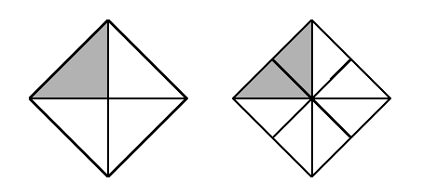

The models show that –

A $\frac{1}{3}=\frac{2}{8}$ B $\frac{1}{2}=\frac{2}{6}$ C $\frac{1}{4}=\frac{2}{6}$ D $\frac{1}{4}=\frac{2}{8}$

6. Kelly’s puppy weighed $6\frac{3}{4}$ pounds. During the next month the puppy gained $1\frac{1}{2}$ pounds. How much did the puppy weigh then?

A $7\frac{3}{8}$ lb B $7\frac{2}{3}$ lb C $8\frac{1}{4}$ lb D NH

7. Bryan rode his bike $2\frac{2}{5}$ miles on Saturday and $4\frac{3}{4}$ miles on Sunday. How much farther did he ride on Sunday than on Saturday?

A $2\frac{1}{5}$ mi B $2\frac{1}{4}$ mi C $2\frac{3}{\text{10}}$ mi D $2\frac{7}{\text{20}}$ mi

8. Mark had $\text{12}\frac{1}{2}$ feet of rope. He cut it into 4 equal lengths. How long was each piece of rope?

A $3\frac{1}{8}$ ft B $4$ft C $3$ft D NH

9. Keisha needs $\frac{3}{4}$ cup of sugar to make 1 batch of muffins. How much sugar does she need in order to make 5 batches of muffins?

A $2$ cups B $3\frac{3}{4}$ cups C $4\frac{1}{4}$ cups D $6\frac{2}{3}$ cups

10. $0\text{.}\text{60}−0\text{.}\text{38}=$

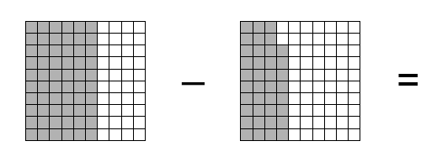
A $0\text{.}\text{22}$ B $0\text{.}\text{32}$ C $0\text{.}\text{38}$ D $0\text{.}\text{98}$

11. A mechanic measured the gap in inches on each of 6 spark plugs.
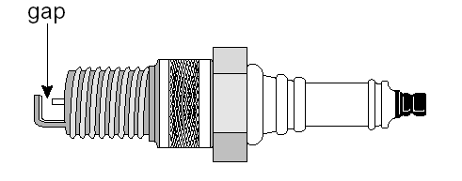

Which list shows these measurements in order from greatest to least?

A 0.060 in., 0.057 in., 0.051 in., 0.045 in., 0.112 in., 0.103 in.

B 0.112 in., 0.103 in., 0.060 in., 0.057 in., 0.051 in., 0.045 in.

C 0.057 in., 0.045 in., 0.103 in., 0.112 in., 0.051 in., 0.060 in.

D 0.045 in., 0.051 in., 0.057 in., 0.060 in., 0.103 in., 0.112 in.

12. $\text{89}÷3=$

A 23 B 29 R2 C 30 R1 D NH

13. Which group contains only numbers that are multiples of 15?

A 30, 45, 60
B 15, 55, 70
C 45, 50, 75
D 60, 75, 80
14. Which of the following fractions is not equivalent to $\frac{1}{4}$?

A $\frac{5}{\text{20}}$ B $\frac{2}{8}$ C $\frac{4}{8}$ D $\frac{3}{\text{12}}$

15. Ms. Williams announced that 40% of the students at Lincoln Middle School had helped with the school food drive. What fraction of the student helped?

A $\frac{1}{4}$ B $\frac{2}{5}$ C $\frac{2}{3}$ D $\frac{4}{5}$

16. Desmond recorded the colors of the 287 cars in the school parking lot. There were 68 red cars, 87 green cars, and 103 blue cars. The rest of the cars were white. Which is the best estimate of the percent of the cars in the parking lot that were white?

A 10% B 20% C 30% D 40%

17. What is the least common multiple of 17 and 9?

A 153 B 108 C 72 D 54

18. What are the common factors of 12 and 18?

A 1, 2, 3, 4
B 1, 2, 3, 9
C 1, 2, 3, 6
D 1, 3, 6
19. A Recipe calls for 40 grams of sugar and 60 grams of flour. What is the ratio of sugar to flour in this recipe?

A 1 to 2 B 2 to 3 C 3 to 4 D 4 to 3

20. Darren’s class has 18 girls and 12 boys in it. Yesterday $\frac{2}{3}$ of the girls completed their research papers. How many girls completed their research papers?

A 9 B 12 C 18 D 20

21. Leslie wants to enlarge a photograph to make a poster. The photograph has a width of 4 inches and a length of 6 inches. If the poster is to be 30 inches wide, how long will it be?

A 20 in. B 32 in. C 40 in. D 45 in.

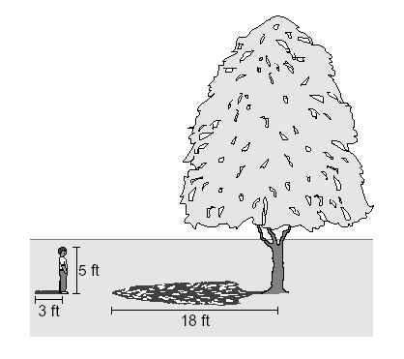
22. A boy who is 5 feet tall casts a shadow 3 feet long. A tree that he is standing beside casts a shadow 18 feet long.

What is the height of the tree?

A 20 ft B 30 ft C 45 ft D 75 ft

23. What is the value of the expression $3(7×8−4)$?

A 55 B 84 C 156 D 164

24. What is the value of the expression $3^{2}×4(5−2)$?

A 72 B 108 C 162 D 178

25. Which factors represent $4^{3}×5^{2}$?

A $2⋅2⋅2⋅2⋅2⋅3⋅3⋅3⋅3$

B $4⋅4⋅4⋅5⋅5$

C $\text{12}⋅\text{10}$

D $2⋅3⋅4⋅5$

26. Which expression is equal to $(a+b)c$?

A $a+\text{bc}$

B $\text{ab}+\text{bc}$

C $\text{ac}+\text{ab}$

D $\text{ac}+\text{bc}$

27. Which expression is equal to $5(2x+1−x−4)$?

A $9x−3$

B $5x−\text{15}$

C $5x−3$

D $5x+\text{25}$

28. Orlando looked up the day’s record low temperatures in 5 cities where some of his relatives lived. Which list shows the temperatures in order from warmest to coldest?

A $−8\text{.}5^{∘}C$, $5^{∘}C$, $−2\text{.}2^{∘}C$, $1\text{.}7^{∘}C$, $−0\text{.}6^{∘}C$

B $5^{∘}C$, $1\text{.}7^{∘}C$, $−0\text{.}6^{∘}C$, $−2\text{.}2^{∘}C$, $−8\text{.}5^{∘}C$

C $−0\text{.}6^{∘}C$, $1\text{.}7^{∘}C$, $−2\text{.}2^{∘}C$, $5^{∘}C$, $−8\text{.}5^{∘}C$

D $5^{∘}C$, $1\text{.}7^{∘}C$, $−8\text{.}5^{∘}C$, $−2\text{.}2^{∘}C$, $−0\text{.}6^{∘}C$

29. Elsa had 4 entries on her spreadsheet. What is the sum of these entries?

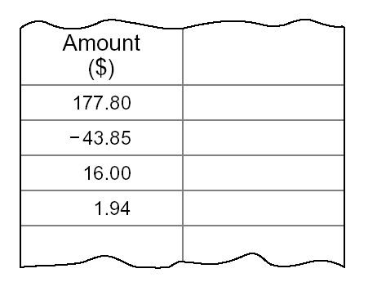

A $\$\text{239}\text{.}\text{59}$ B $\$\text{151}\text{.}\text{89}$ C $\$\text{136}\text{.}\text{05}$ D $\$\text{116}\text{.}\text{01}$

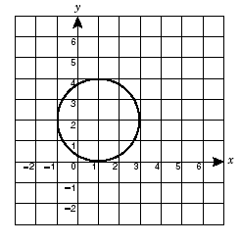
30. The circle shown passes through points ( 1 , 4 ), ( 3 , 2 ),
( 1 , 0 ), and ( - 1 , 2 ). The center of the circle is at which point?

A ( 1 , - 2 )

B ( 1 , 2 )

C ( 2 , - 1 )

D ( 2 , 1 )

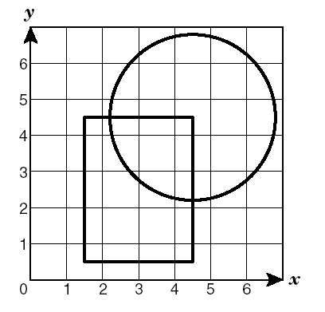
31. A circle and a rectangle are shown on the grid. Which coordinate pair is located inside the circle and outside the rectangle?

A ( 2 , 5 )

B ( 3 , 4 )

C ( 4 , 4 )

D ( 5 , 3 )

32. Which point on the grid below satisfies both conditions: $x<0$and $y>2$.

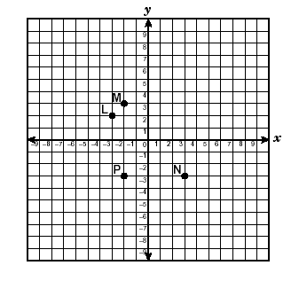

A P B N C M D L

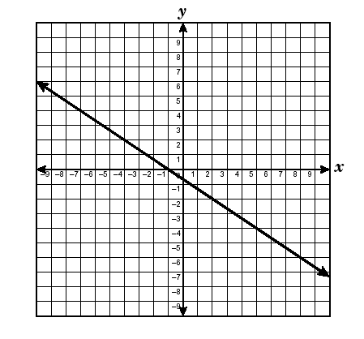
33. Which set of data appears to have all of its points on the line graphed on the right?

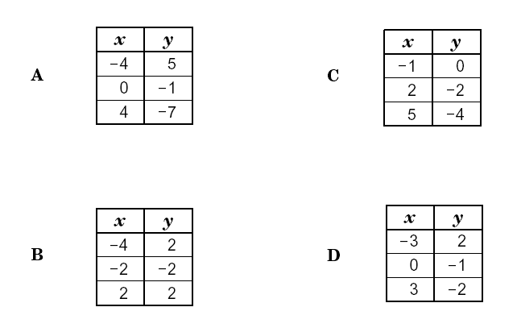

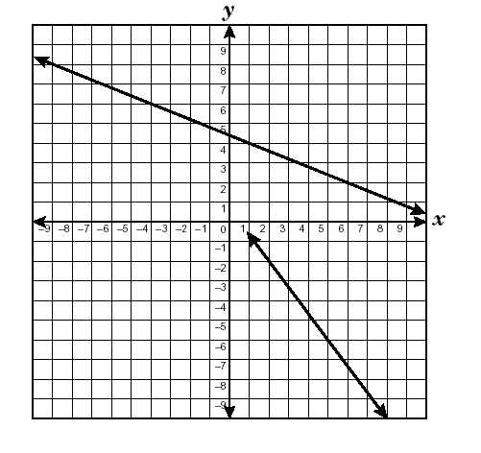
34. Which best represents the point of intersection of these two lines?

A ( 0 , 0 )

B ( 4 , - 5 )

C ( - 4 , 6 )

D ( - 6, 8 )

35. Which is a right angle?
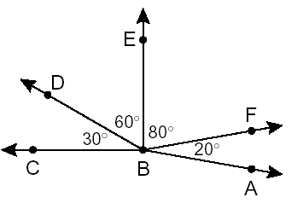
A $∠\text{ABF}$

B $∠\text{DBE}$

C $∠\text{CBE}$

D $∠\text{CBF}$

36. The drawing shows Wendy’s bedroom and her family’s living room.

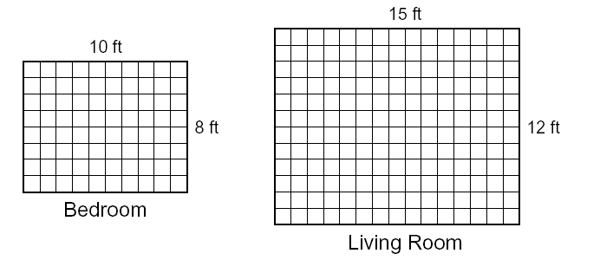
What is the difference in area between Wendy’s bedroom and the living room?

A 20 square feet

B 60 square feet

C 100 square feet

D 180 square feet

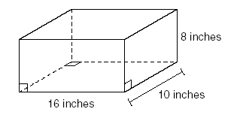
37. Nancy filled a cardboard box with shredded paper. The measurements of the box are shown in the drawing. What was the volume of the box?

A 640 in.³ B 736 in.³ C 1152 in.³ D 1280 in.³

38. Jane planted a rectangular garden that is 8 feet wide by 13 feet long. What is the perimeter of Jane’s garden?

A 21 ft B 42 ft C 84 ft D 104 ft

39. Parallelogram LMNO is shown below.

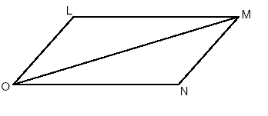
Line segment LO is congruent to line segment ____.

A LM B ON C OM D MN

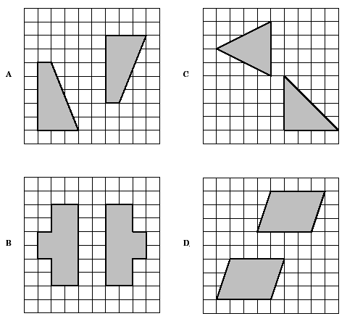
40. Which grid does NOT contain a pair of congruent figures?

41. A telephone pole is 24 feet tall. The support wire that is attached to the top of the pole is 30 feet long.
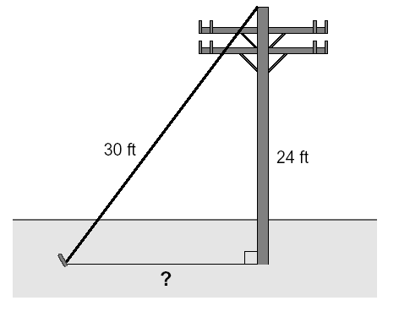
What is the distance from the base of the telephone pole to the bottom of the support wire?

A 54 ft B 27 ft C 18 ft D 12 ft

42. Which term is NOT associated with a circle?

A Pi

B Circumference

C Hypotenuse

D Radius

43. Which measurement of a circle is $\frac{1}{2}$ the length of its diameter?

A Radius

B Area

C Circumference

D Arc

44. A triangle has a perimeter of 36 centimeters. If the length of each side is increased by 50%, the new perimeter will be ____

A 18 cm B 24 cm C 54 cm D 72 cm

45. Sasha’s swim team consists of 6 sophomore members, 15 junior members, and 9 senior members. If 1 member is selected at random to act as captain, what is the probability that the captain will be a senior?

A $\frac{1}{4}$ B $\frac{3}{\text{10}}$ C $\frac{3}{7}$ D $\frac{7}{\text{10}}$

46. The bar chart below shows the results of a survey distributed among the students in a high school.

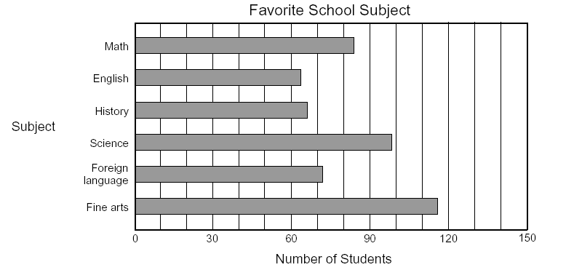

According to the survey results, what is the estimated probability that the favorite subject of a student chosen at random is math?

A 84% B 30% C 17% B 75%

47. To calculate C, the total cost of a repair, a plumbing company uses the equation
$$C=\text{24}h+p$$
where 24 is the plumber’s hourly rate in dollars, $h$is the number of hours of labor, and $p$is the cost of the parts for the repair. If the work for Mr. Jackson took 2 hours and the parts cost $45, what was the total cost of the plumbing repair?

A $48 B $69 C $71 D $93

48. Ray’s Electrical Company charges $25 for a service call, plus $15 per hour for labor after first hour. Materials for the job are additional. The cost to the customer, C, is found by the formula
$$C=\text{25}+\text{15}(h−1)+m$$
where $h$is the total number of hours required for the job and $m$ is the cost of materials. What is the cost of the materials if the total cost of a job is $91 and takes 3 hours?

A $21 B $36 C $49 D $146

