Name: ___________________ Class:_____________
Date: ____________________

UNIT 9 TEST: Algebra Revisited

OBJECTIVE: 8.G.20 Distinguish between linear and nonlinear equations.
1 | Circle the graphs below that represent linear equations.  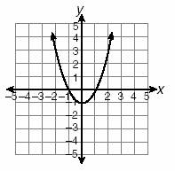  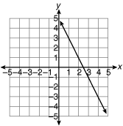  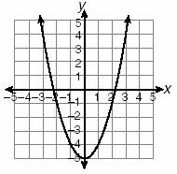  A) B) C)  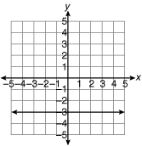  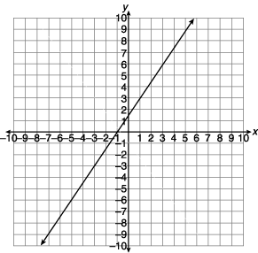  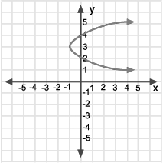  D) E) F)
OBJECTIVE: 8.G.21 Recognize the characteristics of quadratics in tables, graphs, equations, and situations
2 | What will the shape of the graph of the equation y = x² + 4 look like?  ______________________________________________________________  ______________________________________________________________  ______________________________________________________________
3 | Fill in the table of values below for the equation y = -x² – 1. Then plot the points on the x-y axis below and draw the line that represents the equation.  What is this type of a graph called? _________________________________
  x | Y
  -2
  -1
  0
  1
  2
OBJECTIVE: 8.G.18 Solve systems of equations graphically
4 | Solve the system of linear equations below by drawing a graph.  y = 2x + 3  y = 5x – 3
5 | Solve the system of linear equations below by drawing a graph.  y = $\frac{x}{2}−2$  y = 2x + 1
6 | Solve the system of linear equations below by drawing a graph.  y = -3x + 4  y = x – 4
OBJECTIVE: 8.G.13 Determine the slope of a line from a graph and explain the meaning of slope
7 | Select the graph that shows a line with a slope of –2.  A) B)  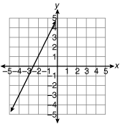  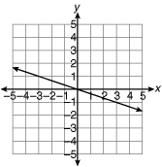  C) D)
8 | 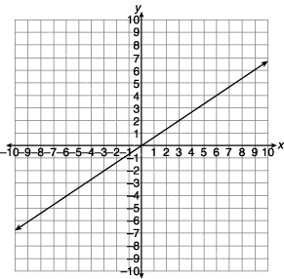  What is the slope of the line shown below?
9 | Describe in your own words what the slope of a line tells you about the graph of that line. You may give examples if it helps.  ______________________________________________________________  ______________________________________________________________  ______________________________________________________________  ______________________________________________________________  ______________________________________________________________  ______________________________________________________________  ______________________________________________________________
10 | What is the slope of the line shown below?  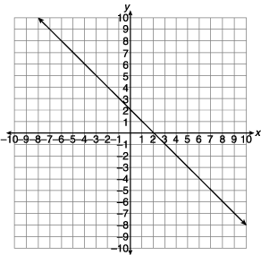
OBJECTIVE: 8.G.14 Determine the y-intercept of a line from a graph and be able to explain the y-intercept
11 | 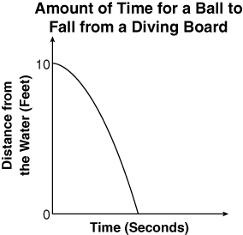  Lucy made a graph to show the amount of time it took for a ball to drop from the top of a diving board into the water. What does the y-intercept of the graph represent?  A) The rate of the ball as it dropped into the water  B) The distance the ball was from the water  before it dropped  C) The size of the ball that was dropped  D) The time it took for the ball to reach the water
12 | What is the y-intercept of the graph below?  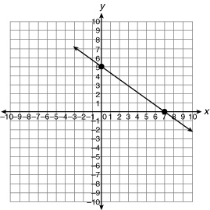
13 | 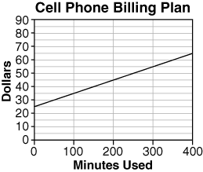  Your cell phone contract has a $25 flat fee every month and charges $0.10 per minute. A graph of this billing plan is shown below.  On the graph, what number correlates with the y-intercept?  A) 100 min. B) $25  C) 400 min. D) $65
14 | What is the y-intercept of the equation y = 5?  A) (5, 0) B) (0, 5)  C) (0, 10) D) Not enough information
OBJECTIVE: 8.G.15 Graph a line using a table of values
8.G.17 Graph a line from an equation in slope-intercept form ($y=\text{mx}+b$)
15 | Fill in the table of values and draw a graph of the line given by the equation:  y = 3x – 5
  x |  |  |  |  | y
16 | Fill in the table of values and draw a graph of the line given by the equation:  y = ½(x) + 1
  x |  |  |  |  | y
17 | Fill in the table of values and draw a graph of the line given by the equation:  y = $−\frac{3}{2}x+2$
  x |  |  |  |  | y
OBJECTIVE: 8.G.16 Determine the equation of a line given the slope and the y-intercept
18 | If the slope of a line is m = –5, and it intersects the y-axis at (0, –1), what is the equation of the line in slope-intercept form?  __________________________________________________
19 | If the slope of a line is m = -½, and it intersects the y-axis at (0, 3), what is the equation of the line in slope-intercept form?  __________________________________________________
20 | If the slope of a line is m = 4, and it intersects the y-axis at (0, –4), what is the equation of the line in slope-intercept form?  __________________________________________________

