Name: ___________________ Class:_____________
Date: ____________________

UNIT 6 and 7 TEST: Linear Equations and Measurement

OBJECTIVE: 8.A.3 Describe a situation involving relationships that matches a given graph.
1 | Vanessa has a trampoline in her backyard. In 1 second, she jumps up to a height of 5 feet and back down again. If Vanessa makes 10 jumps in a row at the same speed and the same height, which of the following graphs would represent Vanessa’s jumps?  A) 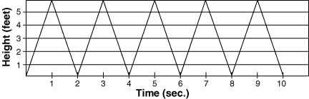  B) 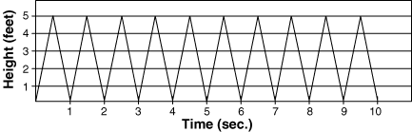  C) 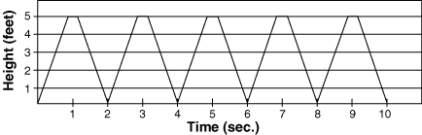  D) 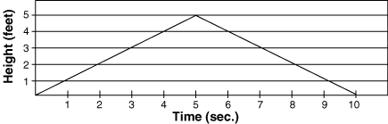
2 | 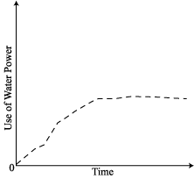  The use of water power has changed over the past several years. This change is reflected in the graph below. Describe in words how it has changed using the information from the graph.
3 | The graph below represents the change in temperature over the course of an average day. Use the graph to describe in words how temperature changes over the course of a day.  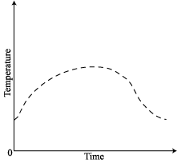
4 | A line graph shows the monthly rainfall in Syracuse. If the like is flat between April and May, what must be true about the rainfall in those months?  A) There was no rainfall in either month.  B) There was more rainfall in April than in May.  C) There was more rainfall in May than in April.  D) There was the same amount of rainfall in both April and May.
5 | A plant grows 3.5 inches between week 3 and week 4. On a graph, the point (3, 4.2) represents the height of the plant at the start of the third week. Which point represents the height of the plant at the start of the fourth week?  A) (4, 0.7) B) (4, 7.7)  C) (7, 7.4) D) (3, 7.7)
OBJECTIVE: 8.A.4 Create a graph given a description or an expression for a situation involving a linear or nonlinear relationship.
6 | Judy is traveling from Albany to New York. After getting on the highway, she travels at a constant speed of 60 miles per hour for 3 hours. Then she stops for an hour to get lunch at a diner. After lunch, she drives for 2 more hours at 30 miles per hour on a country road. Fill in the table and then draw a graph to show the total distance Judy drives.
  Time (hours) | Distance (miles)
  1
  2
  3
  4
  5
  6
7 | Nadeem is training for a bicycle race. On Monday, he bicycled for 30 minutes at 30 miles per hour. He rested 10 minutes and then bicycled for 20 minutes at 36 miles per hour. Complete the table below and draw the distance-time graph.
  Time (minutes) | Distance (miles)
  10
  20
  30
  40
  50
  60
OBJECTIVE: SWBAT write an algebraic rule for a table of values.
8 | Write an algebraic rule for the table of values below:
  x | y
  0 | 2
  1 | 5
  2 | 8
  3 | 11
9 | Write an algebraic rule for the table of values below:
  x | y
  1 | 5
  2 | 9
  3 | 13
  4 | 17
10 | Write an algebraic rule for the table of values below:
  x | y
  3 | 9
  4 | 14
  5 | 19
  6 | 24
11 | Write an algebraic rule for the table of values below:
  x | y
  0 | 7
  2 | 11
  4 | 15
  6 | 19
12 | Write an algebraic rule for the table of values below:
  x | y
  -1 | -3
  0 | -2
  1 | -1
  2 | 0
OBJECTIVE: 8.A.16 Find a set of ordered pairs to satisfy a given linear numerical pattern, then plot the ordered pairs and draw the line.
13 | Consider the equation y = 2x + 3. Fill in the table of values below then graph the equation on the graph provided and draw the line.
  x | y
  -1
  0
  1
  2
14 | Consider the equation y = ½x + 3. Fill in the table of values below then graph the equation on the graph provided and draw the line.
  x | y
  -1
  0
  1
  2
15 | Consider the equation y = -3x – 1. Fill in the table of values below then graph the equation on the graph provided and draw the line.
  x | y
  -1
  0
  1
  2
16 | Consider the equation y = -x² + 2. Fill in the table of values below then graph the equation on the graph provided and draw the line.
  x | y
  -1
  0
  1
  2
17 | Consider the equation y = 2x² – 3. Fill in the table of values below then graph the equation on the graph provided and draw the line.
  x | y
  -1
  0
  1
  2
OBJECTIVE: 8.M.1 Solve equations/proportions to convert to equivalent measurements within metric and customary measurement systems.
18 | A playground measures 20 yards by 25 yards. Find its area in square feet.
19 | How many cubic inches are there in one cubic foot?
20 | A penny has a diameter of about 2 cm. How many pennies would you need to line up end-to-end to reach the length of one city block (about 1 kilometer)?
21 | Convert 20˚C to Fahrenheit using the formula F = $\frac{9}{5}C+\text{32}$.
22 | Jenny is filling up a shoebox with her marble collection. The shoebox can hold 360 cubic inches of material. Each marble takes up 2 cubic inches of space and weighs 8 grams. When the shoebox is totally full with marbles, how much will it weigh in kilograms?

