Name: ___________________ Class:_____________
Date: ____________________

UNIT 5 TEST: Geometry

OBJECTIVE: 8.G.1 Identify pairs of vertical angles
8.G.6 Calculate the missing angle measurements when given two intersecting lines and an angle
1 | 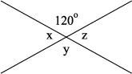  a) Which angle above is congruent to angle x?  b) In the figure above, x equals:  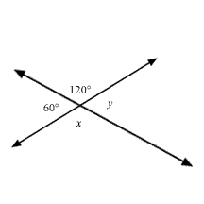
2 | Find the measure of the missing :
3 | If two angles are vertical angles and one is 8º, what is the measure of the other angle?  A) 82˚ B) 172˚  C) 8˚ D) 119˚
4 | List two pairs of vertical angles in the figure below.  B  A C  D
5 | In the figure below, the measure of 3 is 45°. What is the measure of 1?  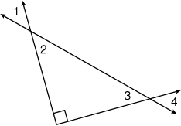
OBJECTIVE: 8.G.2 Identify pairs of supplementary and complementary angles
8.G.3 Calculate the missing angle in a supplementary or complementary pair
6 | If 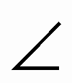ABC and DEF are supplementary, which must be true?  A) The sum of the measures of the angles is 90º.  B) Both angles are greater than 90º.  C) The sum of the measures of the angles is 180º.  D) The sum of the measures of the angles is greater than 180º.
7 | 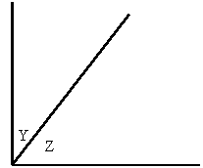  The drawing shows two angles Y and Z. Which of the statements below best describes the relationship between angle Y and angle Z?  A) Angle Y and angle Z are complementary angles.  B) Angle Y and angle Z are supplementary angles.  C) Angle Y and angle Z are congruent.  D) Angle Y and angle Z are right angles.  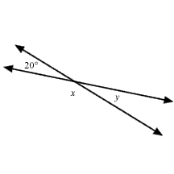
8 | What is the relationship between and in the figure above?  A) They are complementary B) They are equal  C) They are supplementary D) They are vertical angles
9 | 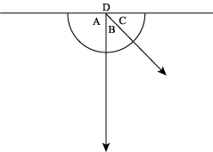  Based on the diagram to the right, which angles are complementary?  A) A and B B) B and C  C) C and D D) D and A
10 | 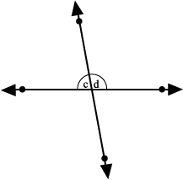  Which of the following statements best describes the relationship between angles C and D?  A) Angle D is an acute angle.  B) Angle C is vertical to Angle D  C) Angles C and D are complementary angles.  D) Angles C and D are supplementary angles.
OBJECTIVE: 8.G.4 Determine angle pair relationships when given two parallel lines cut by a transversal
8.G.5 Calculate the missing angle measurements when given two parallel lines cut by a transversal
11 | What is the measure of angle D?  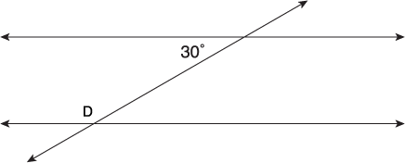
12 | What is the measure of angle H?  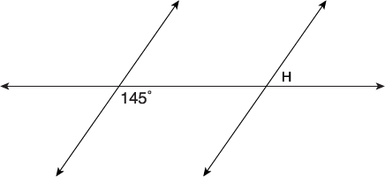
13 | If lines m and n are parallel, then what is the relationship between angle 1 and angle 2?  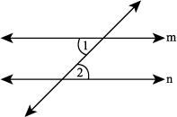  A) They are congruent.  B) They add up to 180°.  C) They add up to 90°.  D) Their difference is 90°.  E) There is not way to tell from the information given.
14 | 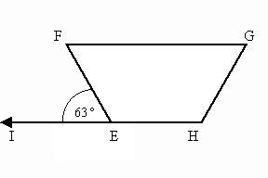  The drawing below depicts trapezoid EFGH. If IEF measures 63º, what is the measure of GFE?
15 | 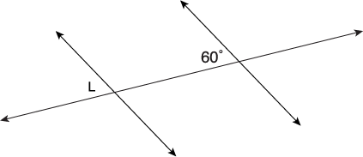  Fill in all the missing angles in the figure below:  ?  ?  ? ? ?  ?
OBJECTIVE: 8.G.7 Describe and identify transformations in the plane, using proper function notation
16 | 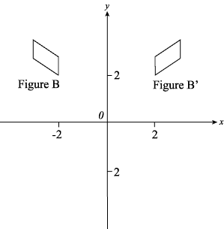  What transformation would have to occur to Figure B to create Figure B’?  A) A translation of Figure B across the y-axis.  B) A reflection of Figure B across the y-axis.  C) A translation of Figure B across the x-axis.  D) A reflection of Figure B across the x-axis.
17 | 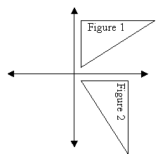  What is this an example of?  A) Dilation  B) Rotation  C) Line reflection  D) Translation
18 | 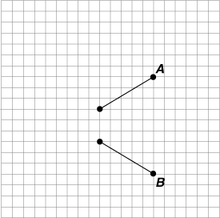  In the graph below, what transformation occurred from line segment A to line segment B?  A) Dilation  B) Reflection  C) Rotation  D) Translation
19 | 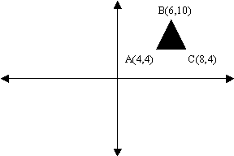  What would point B look like after being reflected in the x-axis?  A) (–6,10)  B) (–6, –10)  C) (10,6)  D) (6, –10)
20 | 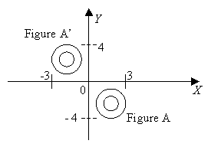  A series of transformations have been applied to figure A. The placement of figure A’ is the result of these transformations. Which of the following statements does NOT describe a correct possible sequence of transformations?  A) A reflection across the y-axis followed by a reflection across the x-axis.  B) A rotation of 90 degrees around the origin followed by reflection across the y-axis.  C) A rotation of 360 degrees followed by reflection through the origin.  D) A reflection across the y-axis followed by a translation of 4 units to the right.
OBJECTIVE: 8.G.8 Draw the image of a figure under rotations of 90 and 180 degrees
21 | Draw rectangle RSTV after it is rotated 180˚ around the origin.  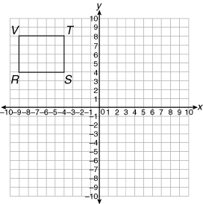
22 | Draw the image of triangle STR after it is rotated 90 degrees clockwise around the origin.  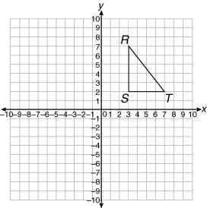
OBJECTIVE: 8.G.9 Draw the image of a figure under a reflection over a given line
23 | 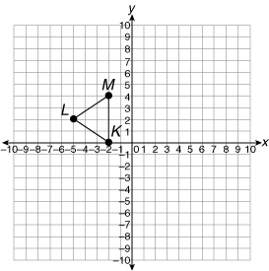  Draw triangle KLM reflected across the x-axis.
24 | Draw a reflection of the dark shape below across the y-axis.  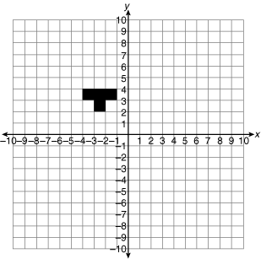
OBJECTIVE: 8.G.10 Draw the image of a figure under a translation
25 | Draw a translation of rectangle RSTV after it is moved 12 units to the right and 3 units down.
26 | Draw a translation of triangle MPR after it is moved 8 units down and 2 units to the left.  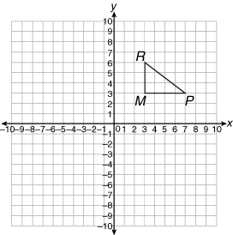
OBJECTIVE: 8.G.11 Draw the image of a figure under a dilation
27 | Draw a dilation of the circle below, dilated by a factor of 2.  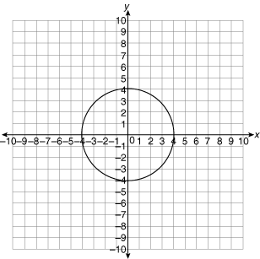
28 | Draw a dilation of rectangle KLMN, dilated by a factor of 4.  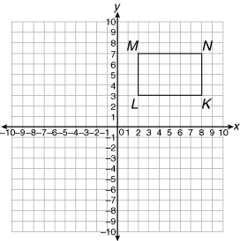
OBJECTIVE: 8.G.12 Identify the properties preserved and not preserved under a reflection, rotation, translation, and dilation
29 | 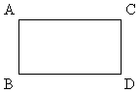  How will the size of quadrilateral ABCD above change after a rotation?  A) The size will not change. B) It will be 2 units longer.  C) It will be half the size. D) It will be twice as large.
30 | A rotation transforms an image by turning it around a point. What property is changed in the rotated image?  A) length of sides B) measure of angles  C) location of figure D) shape of figure
31 | Which of the following transformations does not result in a congruent figure?  A) reflection B) dilation  C) rotation D) translation
32 | A figure is dilated using the origin as the center of dilation and a scale factor of 4. Which property of the original figure has been changed?  A) size B) location  C) shape D) orientation
33 | Figure A is reflected over the x-axis, translated 6 units in the positive x direction, and rotated 90 degrees clockwise to produce figure B. What is the relationship between figures A and B?  A) congruent but not similar B) similar but not congruent  C) both similar and congruent D) neither similar nor congruent
OBJECTIVE: 8.A.12 Apply algebra to determine the measure of angles formed by or contained in parallel lines cut by a transversal and by intersecting lines
34 | In the figure below, the measure of angle 4 is (x + 30)˚ and the measure of angle 8 is given by (2x + 10) ˚. Solve for x, then find the measure of angle 6.  1 2  4 3  5 6  8 7
35 | In the figure below, the measure of angle 1 is x˚ and the measure of angle 2 is (2x + 30) ˚. Find the measure of angle 1.  2  1 3  4
36 | In the figure below, the measure of angle 2 is (2x)˚ and the measure of angle 7 is (3x – 30)˚. Find the measure of angle 6.  1 2  4 3  5 6  8 7
37 | In the figure below, the measure of angle 2 is (5x – 40)˚ and the measure of angle 4 is  (2x + 80)˚. Find the measure of angle 4.  2  1 3  4
38 | In the figure below, the measure of angle 2 is (x + 70)˚ and the measure of angle 4 is  (4x – 20)˚. Find the measure of angle 1.  2  1 3  4
OBJECTIVE: 8.G.0 Construct the following using a straight edge and compass: Segment congruent to a segment; angle congruent to an angle; perpendicular bisector; and angle bisector
39 | Draw a segment that is congruent to the line segment shown below.
40 | Draw an angle that is congruent to the angle shown below.
41 | Use a compass and ruler to draw a perpendicular bisector to line AB shown below.  A B
42 | Use a compass and ruler to construct an angle bisector for the angle shown below.

