Name: ___________________ Class:_____________
Date: ____________________

UNIT 7 TEST: Probability

OBJECTIVE: 5.S.5 List the possible outcomes for a single-event experiment
1 | John’s jellybean jar has 20 jellybeans left in it: 5 of them are green, 6 of them are yellow, and 9 of them are orange. List the possible outcomes that could occur when John puts his hand into the jar and selects a jellybean at random.
2 | Tanner had a numbered cube. The six sides were numbered from 1-6. List the possible outcomes when he rolls the cube once.  What is the probability of him rolling a six?
3 | A sack contains 14 pieces of fruit. There are 4 oranges, 3 apples, and 7 bananas. List the possible outcomes you could get if you randomly pick one piece of fruit from the sack.
4 | List the possible outcomes when Sharon spins the spinner below:  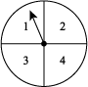  What is the probability of her spinning an even number?
5 | Jennifer will choose a slice of cheese at random from the cheese box. There are 20 slices of cheese in the box: 3 are muenster cheese, 2 are provolone cheese, and 15 are cheddar cheese. What are the possible outcomes she can pick?
OBJECTIVE: 5.S.6 Record experiment results using fractions/ratios
6 | Peter randomly selected 25 rubber bands from his desk drawer, which contained three different-colored rubber bands. He recorded the colors.  What fraction of rubber bands were blue? 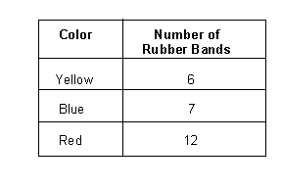  _____________________________________________
7 | In the above experiment, what fraction of rubber bands selected were yellow or red?  _____________________________________________
8 | The following is a list of items in a grab bag. Bernadette really wants to pull out a key chain. What fraction of items in the bag are key chains?
  Item | Quantity
  Ball | 7
  Playing Card | 44
  Key Chain | 16
  Pencil | 33
9 | What fraction of items in the above bag are not keychains?
10 | 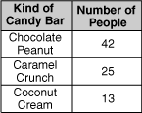  For a week, the Sweet Shop kept track of which kind of candy bars their customers bought. They tracked the sales of the first 80 people, and made a chart of the results. What is the ratio of people who liked chocolate peanut to the total number of people surveyed? Express your ratio in lowest terms.
OBJECTIVE: 5.S.7 Create a sample space and determine the probability of a single event, given a simple experiment
11 | A computer chooses a random number between 1 and 10. Create a sample space that shows all the possible outcomes.  Then find the probability of it choosing a number less than seven.
12 | Angela played a baseball board game using the fair spinner shown below.  Part A: Create a sample space that shows all the possible outcomes.  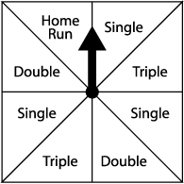  Part B: With one spin, what are the chances that Angela will get a home run?
13 | In the Annual Bowling Raffle, 5 tickets are Jimmy’s, 3 tickets are Lillian’s, 4 tickets are Bridget’s, and 1 ticket is Mark’s. If one winning ticket is chosen at random, which person has the least probability of having his or her ticket chosen?  A) Jimmy B) Lillian  C) Bridget D) Mark
14 | Alicia randomly chose a cookie from a bag. There were 36 cookies in the bag. 24 of them were chocolate chip cookies and 12 were oatmeal cookies. What is the probability that Alicia selected a chocolate chip cookie?
15 | A bag contains 26 cards. Each card has a different letter of the alphabet written on it. If someone picks a card from the bag at random, what is the probability that the letter on the card will be a vowel (either A, E, I, O, or U)?
OBJECTIVE: 6.S.5 Determine the mean, mode and median for a given set of data
16 | Greta gathered worms for a fishing trip. On different days, she collected 4, 3, 5, 8, 6, 10, 14, 11, and 14 worms. What is the median number of worms collected in a day?  ______________________________________
17 | Jim served 3 customers in his first hour at work, 4 during his second hour, and 8 during a third hour. What was the average number of customers Jim served per hour during his 3-hour shift?  ______________________________________
18 | A group of hummingbirds made several visits to flowers last week. They visited 8 times on Monday, 16 times on Tuesday, 27 times on Wednesday, 14 times on Thursday, 5 times on Friday, and 2 times on Saturday. What is the mean of visits made by the hummingbirds during this time?  ______________________________________________________
19 | After raking for days and days, Igmar decided to figure out how many leaves different trees dropped on the ground. She found that 1 tree dropped 2000 leaves, 3 trees dropped 3000 leaves each, 4 trees dropped 4000 leaves each, 6 trees dropped 5000 leaves each, 8 trees dropped 6000 leaves each, and 7 trees dropped 7000 leaves each. What is the mode number of leaves that were dropped by the 29 trees?  A) 5000 B) 5310  C) 6000 D) 7000
20 | Gregor made snowballs over several days for the big snowball fight. If he made 14, 26, 32, 45, 28, 39, 52, and 28 snowballs, what is the median number of snowballs he created?  _______________________________________
OBJECTIVE: 6.S.6 Determine the range for a given set of data
21 | This table shows Jocelyn’s test scores in math class this semester.  What is the range of her test scores for the semester?  _______________________________________
  Test 1 | 74
  Test 2 | 85
  Test 3 | 82
  Test 4 | 91
22 | What is the range of the following set of numbers?  3, 3, 7, 2, 3, 12  _______________________________________
23 | Ted recorded the heights of various trees in his neighborhood. What is the mean of the tree heights listed below?  19 feet, 10 feet, 5 feet, 5 feet, 7 feet, 6 feet, 5 feet, 7 feet  _______________________________________
24 | Preston plays basketball for his school team. In the last five games he has scored 15, 2, 10, 15, and 9 points. What is the range of his points scored?  _______________________________________
25 | Pauline plays volleyball for her high school. In the last five games she spiked the ball and scored 5, 3, 3, 3, and 7 times. What is the range of the number of times she scored on spikes?  _______________________________________
OBJECTIVE: 6.S.7 Read and interpret graphs
26 | The following graph shows the number of hours per day that Greg worked during one week.  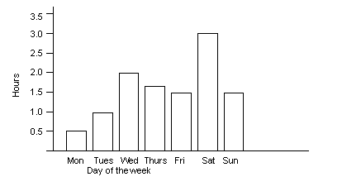  How many hours did he work on Friday, Saturday, and Sunday?  A) 1.5 B) 3.0  C) 4.5 D) 6.0
27 | The following graph shows the weight of a baby during its first year of life.  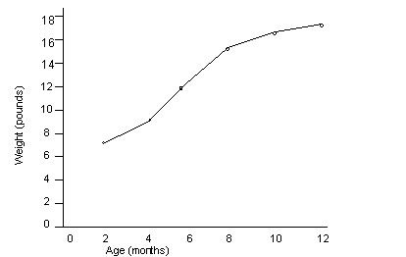  How much did the baby weigh at 9 months?  A) 12 B) 14  C) 16 D) 18
28 | Using the same graph from question 27 that shows the weight of a baby during its first year, about approximately what age did the baby double its birth weight?  A) 2 months B) 4 months  C) 6 months D) 8 months
29 | 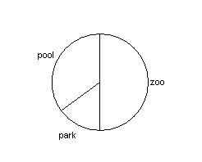  Students in the 6th grade at Washington Elementary School voted on where to go for a field trip. The results are shown in the chart below.  If 60 students participated in this vote, how many voted for the zoo?  A) 15 B) 20  C) 25 D) 30
30 | 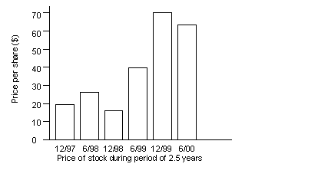  The following graph shows the stock prices for a certain company over a period of 2.5 years.  What was the difference in cost of the stock on 12/99 versus 6/99?  A) $30 B) $40  C) $70 D) $110
OBJECTIVE: 6.S.8 Justify predictions made from data
31 | For a week, the Sweet Shop kept track of which kind of candy bars their customers bought. They tracked the sales of the first 80 people, and made a chart of the results. Based on this information, which is the best estimate of the number of people who would buy Caramel Crunch bars if the Sweet Shop had 240 customers?  A) 39 B) 75  C) 100 D) 120
32 | Based on the results from question 31, how many people out of 240 would buy Coconut Cream bars?
33 | Based on the results from question 31, predict how many customers would buy Coconut Cream bars if 400 customers came to the store in one day.
34 | Maureen asked 50 people from the sports teams what color t-shirt they would like for their team and she recorded the results.  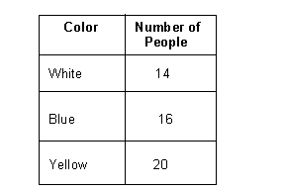  Based on this information, which is the best estimate of the number of people who will choose blue t-shirts if she asked 100 people?  A) 28 B) 32  C) 40 D) 50
35 | In a box of marbles that contains three colors, Karen counted 25 marbles and recorded them by color.  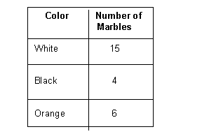  Based on this information, which is the best estimate of the number of orange marbles that she will find if she counted 75 marbles?  A) 12 B) 18  C) 45 D) 50

