Name: ___________________ Class:_____________
Date: ____________________

UNIT 5 TEST: Geometry

OBJECTIVE: 5.G.12 Identify and plot points in the first quadrant
5.G.13 Plot points to form basic geometric shapes (identify and classify)
5.G.14 Calculate perimeter of basic geometric shapes drawn on a coordinate plane
1 | 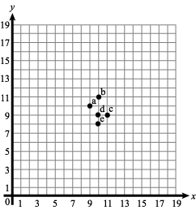  Write the ordered pair for point a. _____________________  Write the ordered pair for point b. _____________________  Write the ordered pair for point d. _____________________
2 | Graph and label the points given on the coordinate grid below. Then, connect them with straight lines to form a figure. Name the figure and find its perimeter.  Points: H (3, 2), J (8, 2), K (3, 10), L (8, 10)  Name: ____________________________  Perimeter: _____________________________
3 | Graph and label the points given on the coordinate grid below. Then, connect them with straight lines to form a figure. Name the figure and find its perimeter.  Points: W (5, 0), X (10, 0), Y (5, 5), Z (10, 5)  Name: ____________________________  Perimeter: _____________________________
4 | Graph and label the points given on the coordinate grid below. Then, connect them with straight lines to form a figure. Name the figure and find its perimeter.  Points: A (2, 2), B (2, 4), C (5, 4), D (5, 6), E (8, 6), F(8, 2)  Name: ____________________________  Perimeter: _____________________________
OBJECTIVE: 6.G.2 Determine the area of triangles and quadrilaterals and develop formulas
5 | 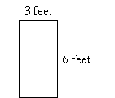  Coach Hawthorn wants a new team banner for the gym. The figure below is the size that he wants the new banner to be. How many square feet of fabric will be needed to make the banner?
6 | 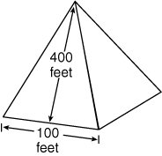  The base of this gigantic pyramid is 100 feet across, and the height of the side is 400 feet. What is the area of one side of this gigantic pyramid?
7 | Find the area of the triangle below.  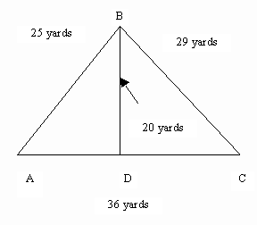
8 | What is the area of this trapezoid? A = ½ h × (b₁ + b₂)  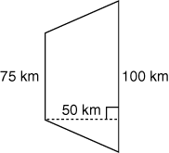
9 | What is the area of this parallelogram? A = bh  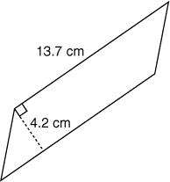
OBJECTIVE: 6.G.3 Use a variety of strategies to find the area of regular and irregular polygons
10 | Bottom of Form  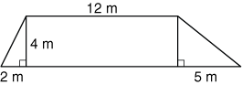  Which formulas could be used to determine the area of all the parts of the trapezoid below?  A) Area of triangle and area of rectangle B) Area of a triangle  C) Area of a rectangle D) Perimeter of a rectangle
11 | Find the area of the entire floor below. Show your work!  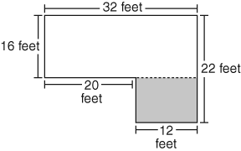
12 | Find the area of the figure below. Express your answer in square units.  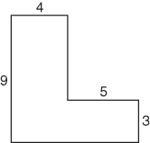
13 | What is the area of the trapezoid below?  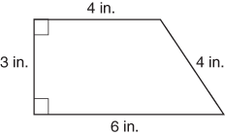
14 | 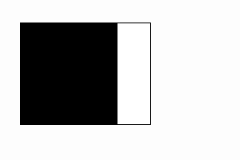  Mary colored in a square on a rectangular piece of paper.  Which procedure can be used to find the area of the unshaded region?  A) Find the perimeter of the shaded square and add the perimeter of the unshaded region.  B) Find the perimeter of the entire rectangle and subtract the perimeter of the unshaded square.  C) Find the area of the shaded square and subtract the area of the unshaded region.  D) Find the area of the entire rectangle and subtract the area of the shaded square.
OBJECTIVE: 6.G.5 Identify radius, diameter, chords and central angles of a circle
15 | Name the line drawn on the circle below:  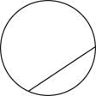  A) radius  B) diameter  C) chord  D) tangent
16 | Name the line drawn on the circle below:  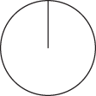  A) radius  B) diameter  C) chord  D) tangent
17 | Draw a central angle in the circle below:
18 | Draw a radius in the circle below:
19 | Draw a diameter in the circle below:
OBJECTIVE: 6.G.6 Understand the relationship between the diameter and radius of a circle
20 | 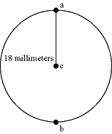  What is the diameter of the above circle?
21 | 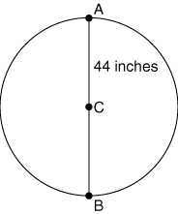  What is the radius of the above circle if line segment AB is 44 inches and passes through the center of the circle at point C?
22 | What is the diameter of a circle if its radius is 4cm?
23 | What is the radius of a circle if its radius is 10cm?
24 | 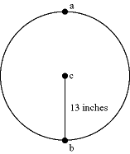  What is the diameter of the above circle?
OBJECTIVE: 6.G.7 Determine the area and circumference of a circle, using the appropriate formula
25 | Find the area of a circle with a radius length of 6.  A) 3π B) 6 π  C) 12π D) 36π
26 | Find the circumference of a circle with radius length of 6.  A) 3π B) 6 π  C) 12π D) 36π
27 | Find the circumference of a circle with a diameter of 4cm. Use 3.14 for π and round your answer to the nearest tenth.
28 | The diameter of a United States quarter is 24 millimeters. What is the area of one of its round surfaces? A = πr². Use 3.14 for π.
29 | The diameter of a pancake is 16 centimeters. What is the area of one side of the pancake? A = π r². Use 3.14 for π.
OBJECTIVE: 6.G.8 Calculate the area of a sector of a circle
30 | Find the area of this quarter of a circle if the radius is equal to 4 cm.  4cm.
31 | Find the area of the half-circle below.  r = 2 ft.
32 | Find the area of the figure shown below.  r = 4 cm
33 | Find the area of the sector of circle shown below. The central angle of the circle is 240˚ and its radius is 3 ft.
34 | Find the area of the compound shape below.  10 in  5 in.
OBJECTIVE: 6.G.9 Understand the relationship between the circumference and the diameter of a circle
35 | A wheel has a diameter of 12 inches. How does the diameter of the wheel compare to the circumference of the wheel?  A) The diameter is about the circumference.  B) The diameter is about the circumference.  C) The diameter is about 3 times the circumference.  D) The diameter is about 4 times the circumference.
36 | Martha planted her bushes in a ring like in the diagram shown below.  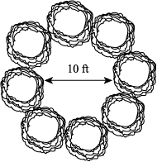  The diameter of the ring is 10 feet. How does the diameter compare to the circumference of the ring created by the bushes?  A) The diameter is about times the circumference.  B) The diameter is about the circumference.  C) The diameter is about the same as the circumference.  D) The diameter is about the circumference.
37 | The drawing shows 2 circles that share a common center point.  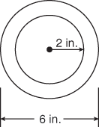  Which expression can be used to find the circumference of the outer circle in inches?  A) πr B) 2π  C) 6π D) 8π
38 | If the diameter of an automobile tire is 30 inches, what is its circumference?
39 | The drawing shows a figure eight.  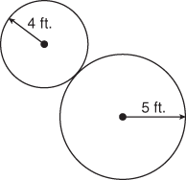  Which expression can be used to show how far you would walk if you walked around the entire outline of the figure eight?  A) 4 + 5 B) 2 (4 + 5)  C) (2 × 4) + 5 D) (2 × 4) + (2 × 5)
OBJECTIVE: 6.M.1 Measure capacity and calculate volume of a rectangular prism
6.G.4 Determine the volume of rectangular prisms by counting cubes and develop the formula
40 | 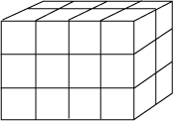  How many blocks are in the shape above?
41 | 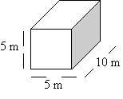  Find the volume of the above prism.
42 | 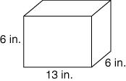  If the prism above were filled with water, how much would it hold?
43 | What is the volume of the solid cube shown below?  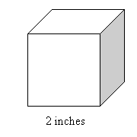
44 | 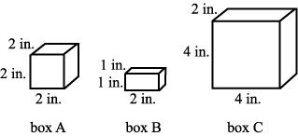  How many of box B could fit in box C?
OBJECTIVE: 6.M.7 Estimate volume, area, and circumference
45 | Estimate the volume of the rectangular prism below (length = 4.8 cm, height = 2.1 cm, width = 2.1 cm). Show your work.  2.1 cm  2.1 cm  4.8 cm
46 | Estimate the area of the triangle below. Show your work!  h= 5.2 ft.  b = 11.9 ft.
47 | Estimate the circumference of this circle.  d = 2.1 in.

