Name: ___________________ Class:_____________
Date: ____________________

UNIT 11 TEST: Geometry (part 2)

OBJECTIVE: 6.G.10 Identify and plot points in all four quadrants.
6.G.11 Calculate the area of simple polygons drawn on a coordinate plane.
1 | 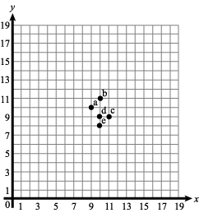  Write the ordered pair for point a. _____________________
2 | Graph and label the points given on the coordinate grid below. Then, connect them with straight lines to form a figure. Name the figure and find its area.  Points: H (8, -1), J (8, 3), K (3, 3), L (3, -1)  Name: ____________________________  Area: _____________________________
3 | Graph and label the points given on the coordinate grid below. Then, connect them with straight lines to form a figure. Name the figure and find its area.  Points: W (-2, 2), X (2, -2), Y (2, 2), Z (-2, -2)  Name: ____________________________  Area: _____________________________
4 | Graph and label the points given on the coordinate grid below. Then, connect them with straight lines to form a figure. Name the figure and find its area.  Points: A (-3, 4), B (4, 4), C (6, -3), and D, (-1, -3)  Name: ____________________________  Area: _____________________________

